1. [Burp Suite for Pentester: Web Scanner & Crawler](https://www.hackingarticles.in/burp-suite-for-pentester-web-scanner-crawler/)
2. [Burp Suite for Pentester – Fuzzing with Intruder (Part3)](https://www.hackingarticles.in/burp-suite-for-pentester-fuzzing-with-intruder-part-3/)
3. [Burp Suite for Pentester – Fuzzing with Intruder (Part2)](https://www.hackingarticles.in/burpsuite-for-pentester-fuzzing-with-intruder-part-2/)
4. [Burp Suite for Pentester – Fuzzing with Intruder (Part1)](https://www.hackingarticles.in/burp-suite-for-pentester-fuzzing-with-intruder-part-1/)
5. [Burp Suite for Pentester – XSS Validator](https://www.hackingarticles.in/burp-suite-for-pentester-xss-validator/)
6. [Burp Suite for Pentester – Configuring Proxy](https://www.hackingarticles.in/burp-suite-for-pentester-configuring-proxy/)
7. [Burp Suite for Pentester: Burp Collaborator](https://www.hackingarticles.in/burp-suite-for-pentester-burp-collaborator/)
8. [Burp Suite For Pentester: HackBar](https://www.hackingarticles.in/burp-suite-for-pentester-hackbar/)
9. [Burp Suite for Pentester: Burp Sequencer](https://www.hackingarticles.in/burp-suite-for-pentester-burp-sequencer/)
10. [Burp Suite for Pentester: Turbo Intruder](https://www.hackingarticles.in/burp-suite-for-pentester-turbo-intruder/)
11. [Engagement Tools Tutorial in Burp suite](https://www.hackingarticles.in/engagement-tools-tutorial-burp-suite/)
12. [Payload Processing Rule in Burp suite (Part2)](https://www.hackingarticles.in/payload-processing-rule-burp-suite-part-2/)
13. [Payload Processing Rule in Burp suite (Part1)](https://www.hackingarticles.in/payload-processing-rule-burp-suite-part-1/)
14. [Beginners Guide to Burpsuite Payloads (Part2)](https://www.hackingarticles.in/beginners-guide-burpsuite-payloads-part-2/)
15. [Beginners Guide to Burpsuite Payloads (Part1)](https://www.hackingarticles.in/beginners-guide-burpsuite-payloads-part-1/)
16. [Burpsuite Encoder & Decoder Tutorial](https://www.hackingarticles.in/burpsuite-encoder-decoder-tutorial/)
17. [Burp Suite for Pentester: Active Scan++](https://www.hackingarticles.in/burp-suite-for-pentester-active-scan/)
18. [Burp Suite for Pentester: Software Vulnerability Scanner](https://www.hackingarticles.in/burp-suite-for-pentester-software-vulnerability-scanner/)
19. [Burp Suite for Pentester: Burp’s Project Management](https://www.hackingarticles.in/burp-suite-for-pentester-burps-project-management/)

**Burp Suite for Pentester: Web Scanner & Crawler**

[December 18, 2020](https://www.hackingarticles.in/burp-suite-for-pentester-web-scanner-crawler/) By [Raj Chandel](https://www.hackingarticles.in/author/raaj/)

You might be using a number of different tools in order to test a web-application, majorly to detect the hidden web-pages and directories or to get a rough idea about where the low-hanging fruits or the major vulnerabilities are.

So today, in this article, we’ll discuss how you can identify the hidden web-pages or determine the existing vulnerabilities in the web application, all with one of the best intercepting tool **“Burpsuite”.**

**Table of Content**

* The Burp’s Crawler
  + What is Crawler?
  + Crawl with default configurations
  + Customizing the Crawler
* Vulnerability Scanning over BurpSuite
  + Auditing with default configurations.
  + Defining Audit options.
* Crawling & Scanning with an advanced scenario
* Deleting the defined Tasks

**The Burp’s Crawler**

**What is Crawler?**

The term **web-crawler** or **web-spider**is the most common and is been used a number of times while testing a web-application. So, what this crawler is ??

Carrying with its name we can depict that a crawler **surveys a specific region** slowly and deeply and then drops down the output with a defined format.

So is the Burp’s Crawler the same thing ??

According to port swigger “The crawl phase involves navigating around the application, following links, submitting forms, and logging in, to catalog the content of the application and the navigational paths within it.”

In simpler words, we can say that the burp crawler programmatically moves within the entire web-application, follows the redirecting URL’s, logs inside the login portals and then adds them all in a **tree-like structure** over in the Site Map view in the **Target tab.**

However, this crawler functions as similar to as the the “Dirb” or the “DirBuster” tools – the web content scanners, which brute-force the web-server such in order to dump the visited, non-visited, and hidden URLs of the web-application.

Earlier over in the previous versions of burpsuite say **“1.7”,**we got this crawler termed as **“Spider”.** So why this happened, what new features did the burp crawler carries that it made the spider vanishes off ??

**Let’s dig it out !!**

**Crawl with default configurations !!**

If you’re familiar with the spider feature, then you might be aware, that, the spider holds up a specific tab within the burpsuite’s panel. But with the enhancements, the burp’s crawler comes pre-defined within the **dashboard section**. However, it thus helps us to monitor and control the burp’s automated activities in a single place.

So, in order to initiate with the crawler, let’s turn ON our burpsuite and redirect to the Dashboard section there.

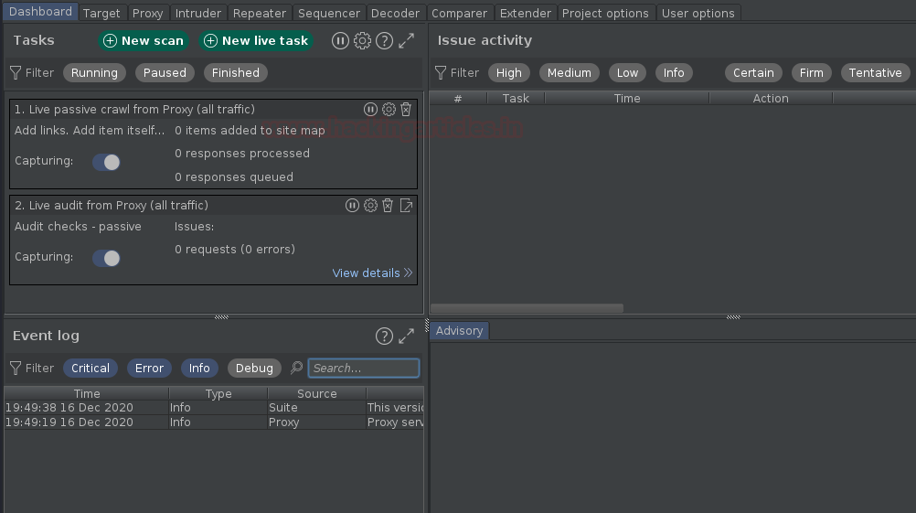

As soon as we land at the dashboard panel, we can see the number of subsection specified. Let’s explore them in details :

1. **Tasks –** The “Tasks” section carries the summary of all the running crawls and scans, whether they are user-defined or the automated ones. Here, we can pause and resume the individual tasks, or all tasks together, and even we can view the detailed versions of a specific crawl or audit too.
2. **Event log –**The Event log feature generates all the events that the burpsuite follows like if the proxy starts up the event will be generated for it, or a specific section is not working properly, then an event log with the will be generated.
3. **Issue Activity –**This section drops out the common vulnerabilities within the application that the burpsuite scans up and further we can segregate them all by applying the defined filters according to their severity and destructiveness.
4. **Advisory –** This is one of the most important section of the burp’s dashboard as it demonstrates the selected vulnerability in the expanded form such by defining the payload with a Request & Response, mentioning the cause of its existence, defining the mitigation steps and dropping the reference and the CVSS Scores for our review.

Thereby, to dig web-application we need to hit the **“New Scan”** button placed at the top of the **Tasks** section.

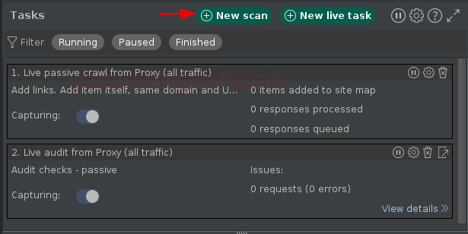

As soon as we do so, we’ll be redirected to a new popped-up window stating **“New Scan”.**

There we’ll be welcomed with two options –

* Crawl & Audit
* Crawl

However, for this section, we’ll make it to **“Crawl”**only. And the other one, we’ll discuss later in this article.

As we’re heading with the default configurations thus we’ll simply type the **testing URL**i.e. “http://testphp.vulnweb.com/” and will hit the **“OK”**button.

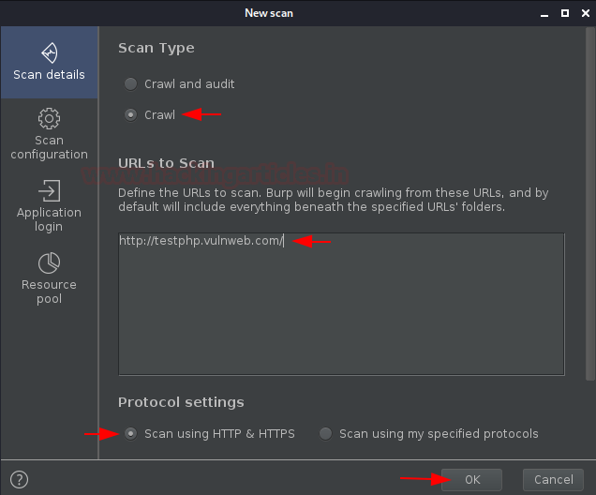

As we do so, the window will get disappeared and over in the dashboard we’ll get our new task aligned as **“Crawl of test.vulnweb.com”,**and in the event log, we can see that we got the event **“Crawl started”.**

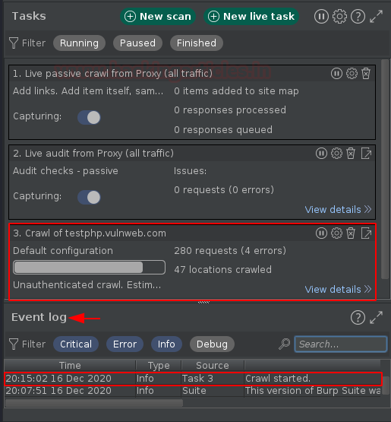

Within a few minutes, the crawling task will get finished up and we’ll get the notification there. But where’s the result ??

As defined earlier the crawler, dumps the result in a **tree-like format** in the **Site Map view** in  the **Target tab,**let’s move there.

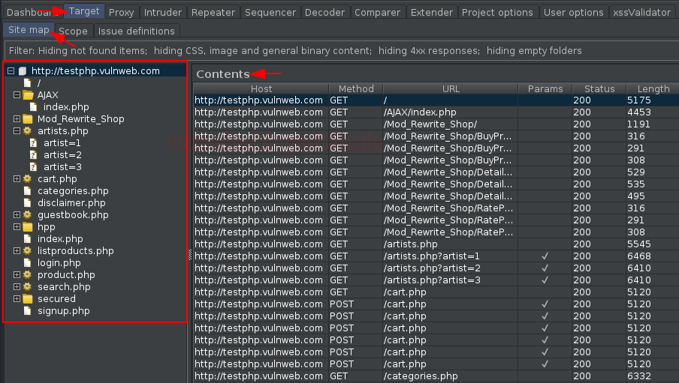

Great !! We got what we desire for. Over in the right panel we’re having about almost **every URL of the webpage**, along with that, it carries up the **HTTP method**s and a **parameter section** that defines which URL requires a Params value within it.

A number of major vulnerabilities exist due to the unsanitized input fields thereby with this dumped data we can simply **segregate the URL’s that contains the Input values** which thus can be further tested on. And for this simply double click the **“Params”** field.

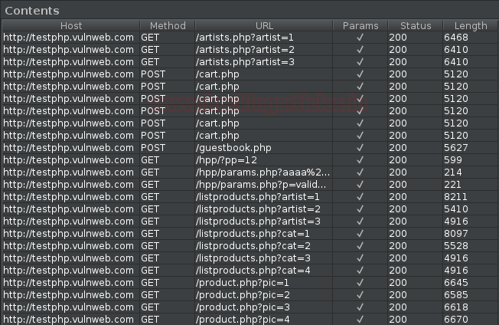

However, if we want to check the pages or a specific directory, we can simply navigate the left side and select our desired option there.

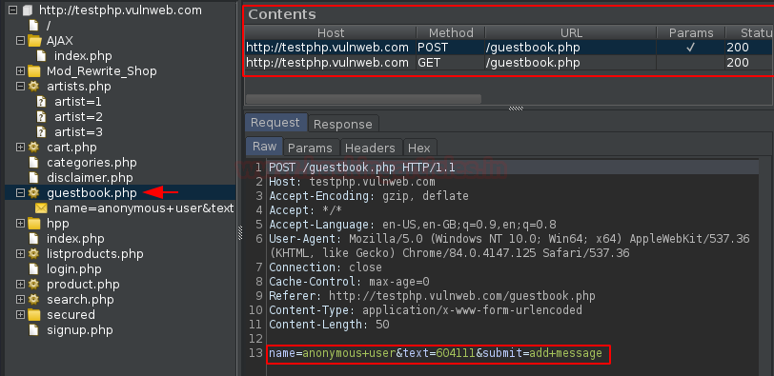

**Customizing the Crawler**

What, if some specific webpages are **Out of Scope** ?? Or the website needs some **specific credentials** to surf the restricted web-pages?

Therefore, in such cases, we need to configure our crawler, such that, it could work as we want it to. So, to do this, let’s get back to the dashboard and select the **“New Scan”** option again. But for this time we won’t hit **“OK”** after setting the URL.

**Configuring Out of Scope URL’s**

Below at the protocol setting, there is an option for the **Detailed Scope Configuration,**where we’ll simply navigate to the **“Excluded URL prefixes”**and will **enter the Out of Scope URL** i.e. <http://testphp.vulnweb.com/signup.php>

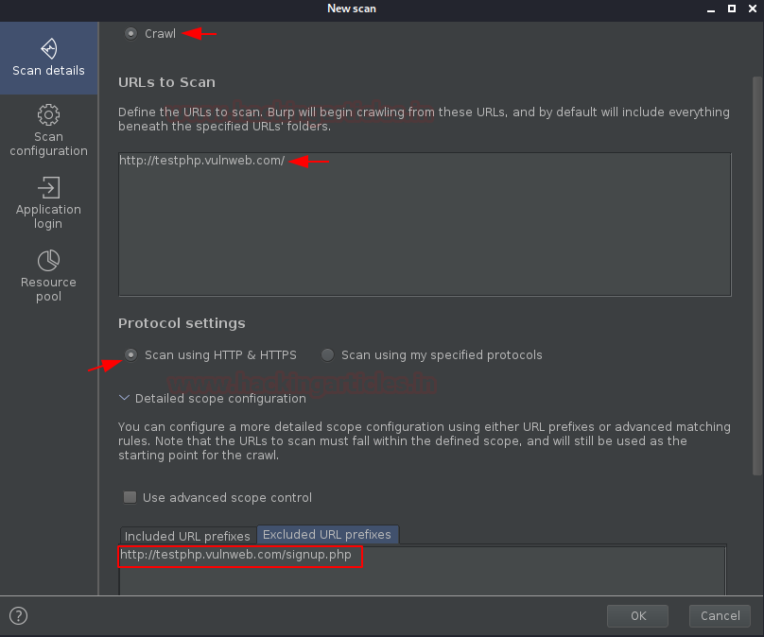

For further customization, we’ll thus move to the **Scan Configuration**option. And there we’ll hit the **“New ”** button to set up a new crawler.

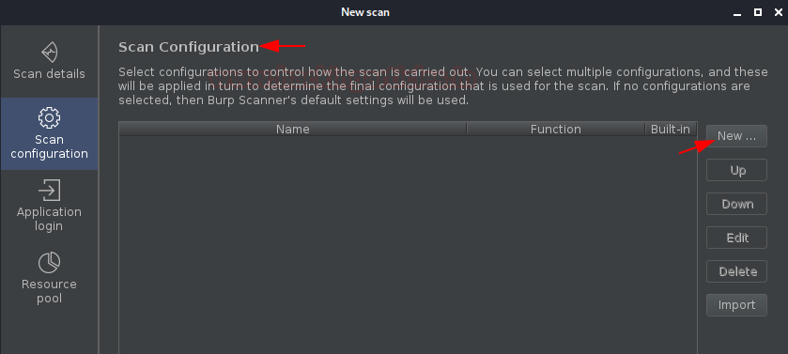

As soon as we do so, we’ll thus get **another window open** with **the configuration options**. Let’s keep the configuration name as the default, however, you can change if you wish so.

Further, the Crawl optimization option segregates within the **“Fastest to the Deepest”,**thereby we’ll thus change it according to our requirement.

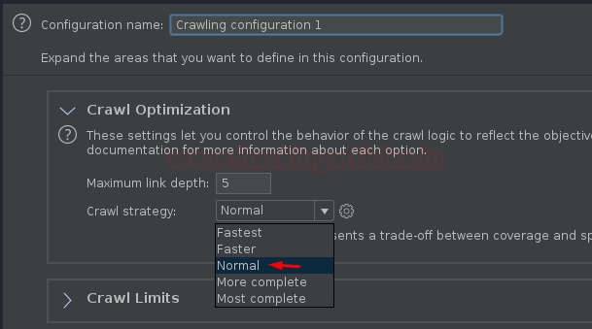

Crawl Limit is considered to be an important factor as it determines the time required and the depth to crawl an application. Thereby we’ll set the **maximum crawl limit** to **50 minutes** and the **Maximum unique locations discovered** to **5000**.

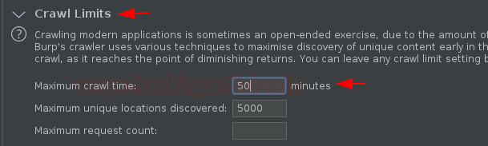

There are applications that carry **user registration or login portals**, thus checking both the options will thus guide the burp’s crawler to **self-register** with some random values if encounters up with a signup portal and even use wrong credentials at the login portals such in order to determine the website’s behaviour.

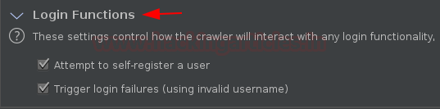

Now with all these configurations as soon as we hit the **“Save”** button we thus get our crawler listed at the **New scan dashboard.**

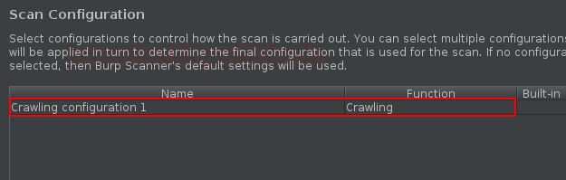

What, if the crawler encounters with the restricted pages? Or an admin portal? Thereby, for such situations, let’s feed up some default credentials so that the crawler can use them !!

Navigate to the **“Application login”** section and click on “New”.

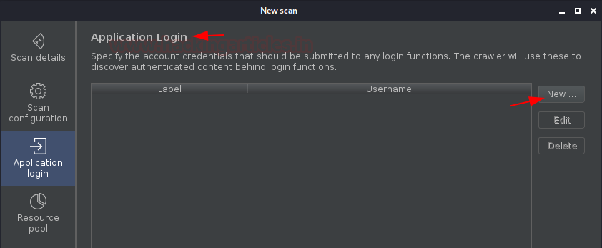

Over in the pop-up box, enter the desired credentials & hit the **“OK”**button.

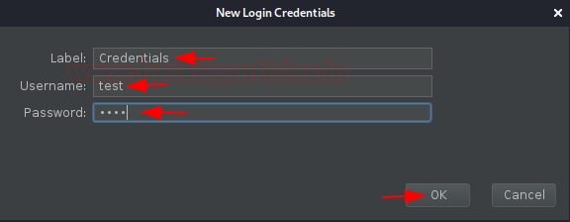

Along with all these things, we’re having one more option within the**“New Scan dashboard”,**i.e.**“Resource Pool”.**

A resource pool is basically a section defined for the **concurrent requests** or in simpler terms, we can say about how many requests the crawler will send to the application in one go, and what would be the time gap between the two requests.

Therefore, if you’re testing a fragile application which could get down with an excessive number of request, thus then you can configure it accordingly, but as we’re testing the demo application thereby we’ll set them to default.

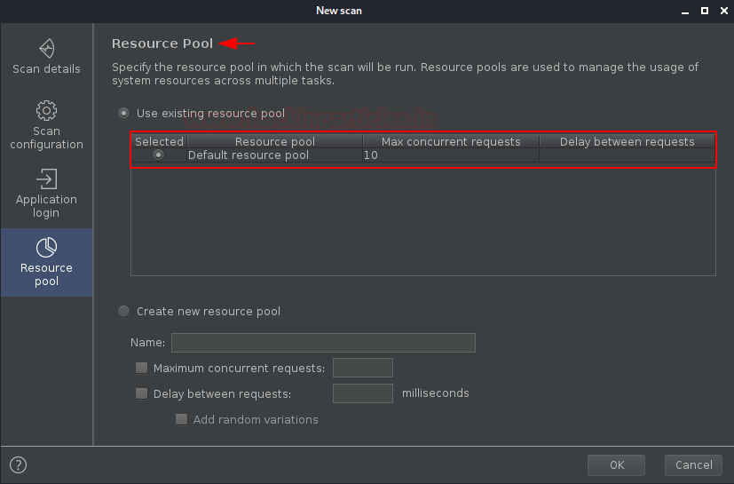

Now as we hit the **“OK”**button, our crawler will start which thus could be monitored at the dashboard.

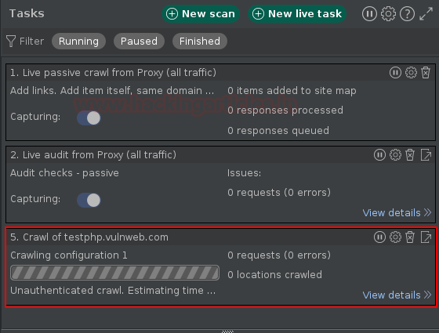

Now, let’s wait for it to get END !! As we navigate to the **Target tab** we’ll thus get our output listed, and there we can notice that the **signup page is not mentioned**, which states that our configuration worked properly.

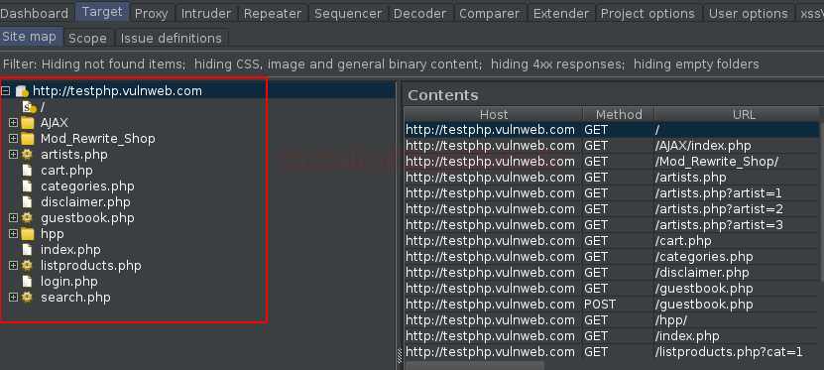

**Vulnerability Scanning Over Burpsuite**

Rather being an incepting tool, burpsuite acts as a vulnerability scanner too. Thereby, it scans the applications with a name as **“Audit”**. There are a number of vulnerability scanners over the web and burpsuite is one of them, as it is designed to be used by the security testers, and to fit in closely with the existing techniques and methodologies for performing manual and semi-automated penetration tests of web applications.

So let’s dig the **“testphp.vulnweb”** vulnerable application and check out what major vulnerabilities it carries within.

**Auditing with the default configuration**

As we’ve already crawled the application thus it would be simpler to audit it, however, **to launch a scanner all we need is a URL,** whether we get it by incepting the request, or through the target tab.

From the screenshot, you can perceive that we’ve sent the base URL by doing a right-click and opting the **“Scan”.**

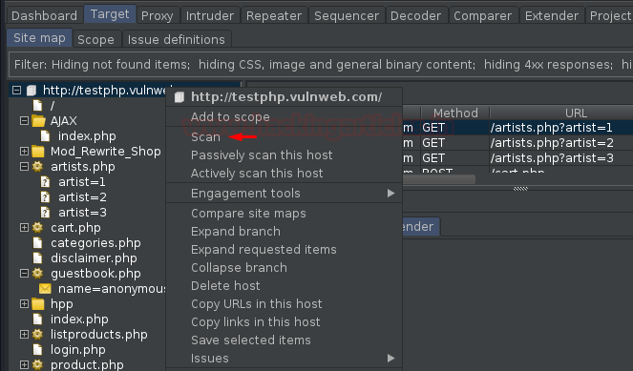

As soon as we do so, we’ll thus be redirected back to the **New Scan’s Dashboard.**But wait !! This time we’re having one more option i.e. **“Audit Selected items”,** as soon as we select it we’ll thus get all the URL’s within the **Item to Scan** box (This happens because we’ve opted the base request).

As we’re dealing with the default auditing, we’ll thus simply hit the **“OK”**button there.

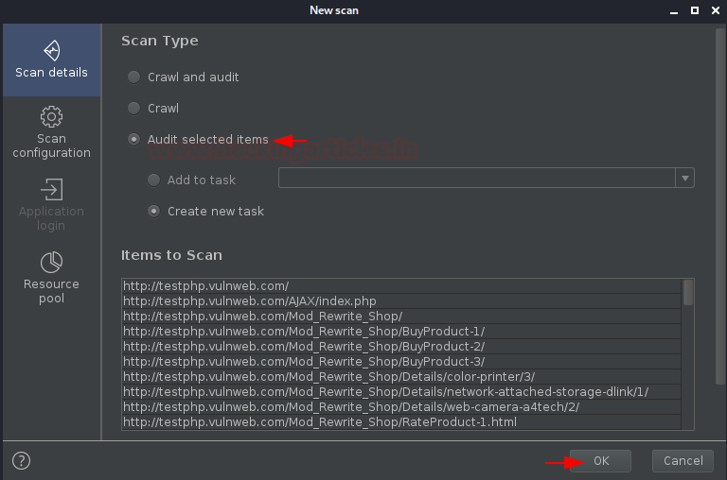

And now I guess you know where we need to go. Yes !! The **Dashboard tab.**

This time not only the **Tasks section** and **the Event log** is changed but we can see the variations in the **Issue activity** and the **advisory** sections too.

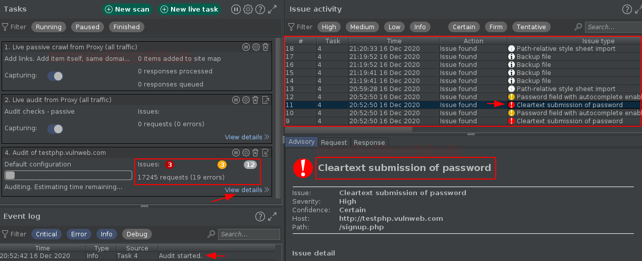

From the above image, we can see that within a few minutes our scanner has sent about 17000 requests to the web-application and even dumped a number of vulnerabilities according to their severity level.

What if we want to see the detailed version ??

In order to do so, simply click on the **View Details section** placed at the bottom of the defined task, and will thus get redirected to a new window will all the refined details within it.

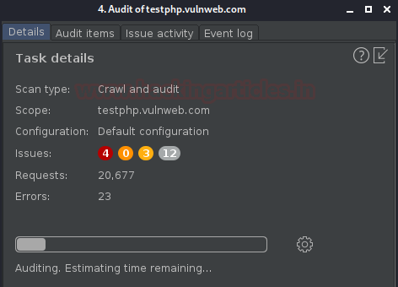

Cool !! Let’s check the Audited Items.

And as we hit the Audit Items tab, we’ll thus get landed up to the detailed version of the audited sections, where we’ll get the statues, Active & Passive phases, Requests per URLs and many more.

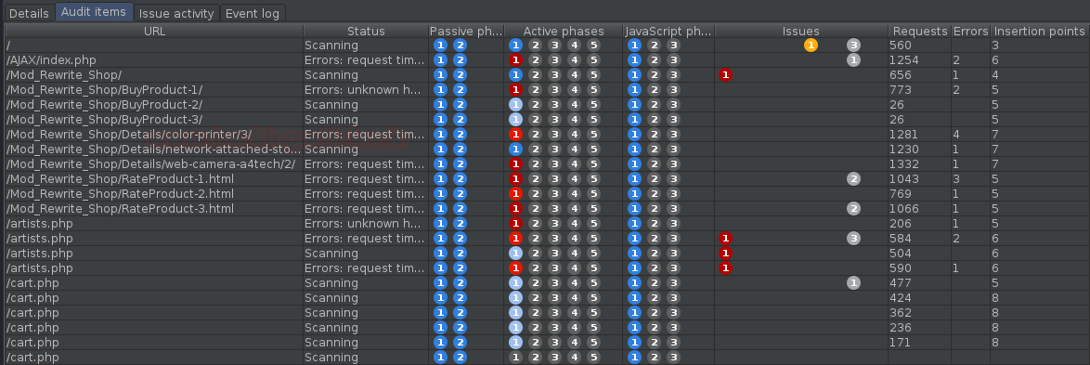

Further, we can even check the in-detailed Issues that have been found in the web-application.

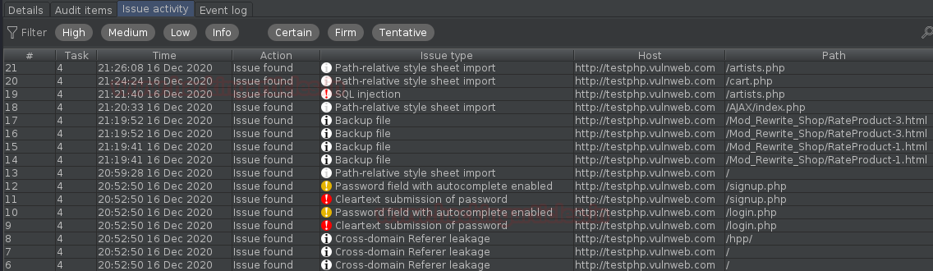

Although we can even filter them according to their defined severity levels.

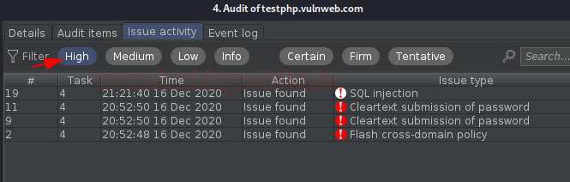

Not only these things, over in the **target tab**, something is waiting for us i.e. the Issues and the Advisory are also mentioned there, but if we look at the **defied tree** at the left panel we can see some colourful dots majorly **red and grey**indicating that these URL’s are having **high and informative existing vulnerabilities** respectively.

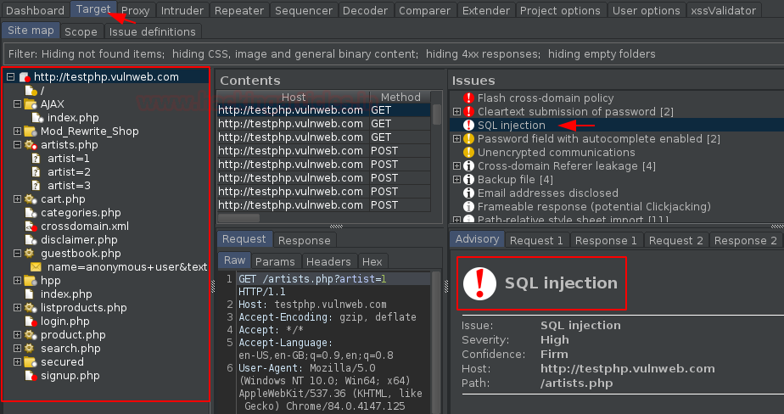

However, from the below image, with the **Advisory option of SQL Injection**, there is a specific panel for **Request & Response**, let’s check them and determine how the scanner confirms that there is an SQL Injection existing.

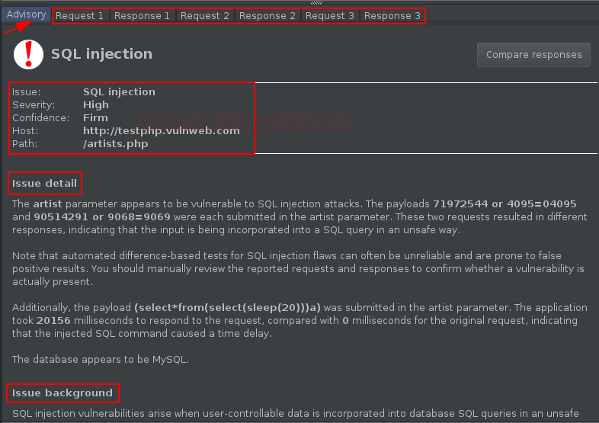

As we navigate to the 3rd Request, we got an SQL time-based query injected in the **“artist=”**field.

And as we **shared this request with the browser**, we got the **delay of about 20 seconds**, which confirms that the vulnerabilities dumped with the scanner are triggerable.

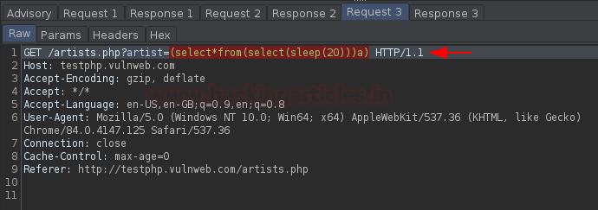

You might be wondering like okay I got the vulnerability, but I’m not aware of it – what more could I get with or how could I chain it to make a crucial hit.

Therefore, in order to solve this issue, we got an Issue definition section, where we can simply go through with the defined or captured vulnerability.

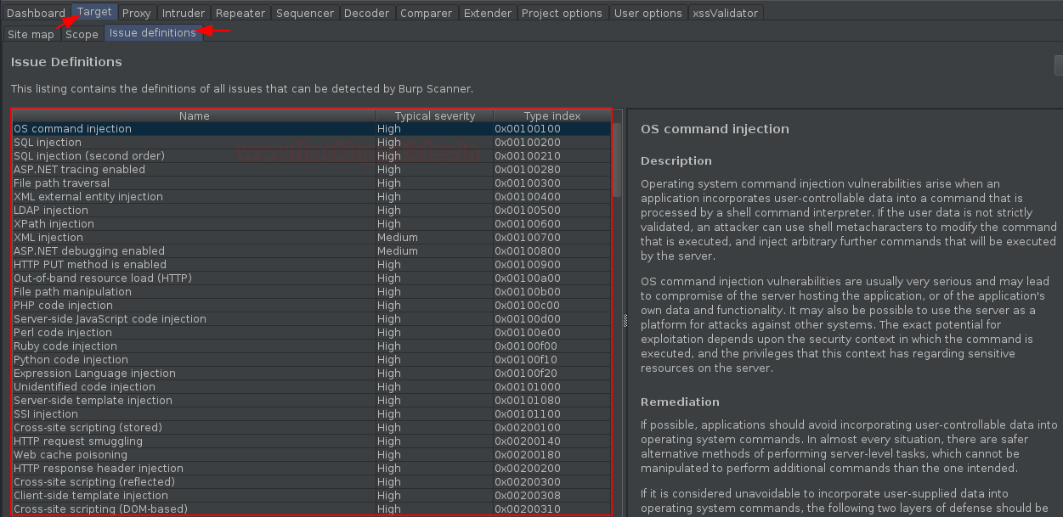

**Defining Audit Configurations**

Similar to the Crawling option, we can simply configure this Audit too, by getting back to the **“New Scan”**dashboard with a right-click on the defined URL & hitting Scan.

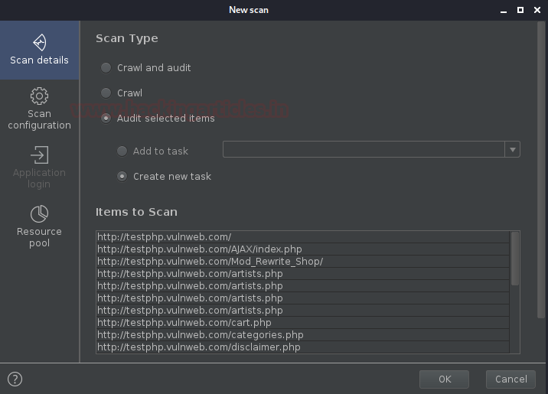

Here, in the above image, if we scroll down, we’ll thus get the same option to set the **Out Of Scope** URL as was in the Crawl section.

Now, moving further with the scan configurations, hit the **“New”**button as we did earlier.

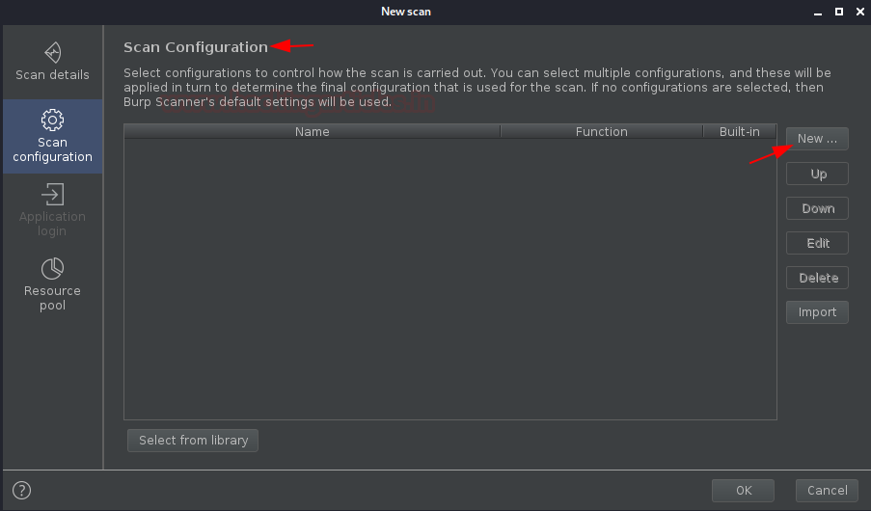

Setting the configuration name to default and manipulating the audit accuracy to normal, you can define it according to your need.

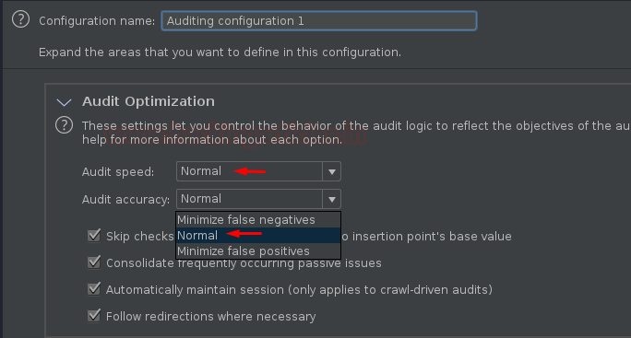

Now comes to the most important section to **define the Issues reported** by selecting the **“Scan Type”.**Here in order to complete the scan faster, I’m simply taking the **Light active scan** option, but you can opt any of the following –

* **Passive –** These issues are detected simply by inspecting the application’s behavior of requests and responses.
* **Light active –** Here this detects issues by making a small number of benign additional requests.
* **Medium active –** These are issues that can be detected by making requests that the application might reasonably view as malicious.
* **Intrusive active –** These issues are detected by making requests that carry a higher risk of damaging the application or its data. For example, SQL injection.
* **JavaScript analysis –** These are issues that can be detected by analyzing the JavaScript that the application executes on the client-side.

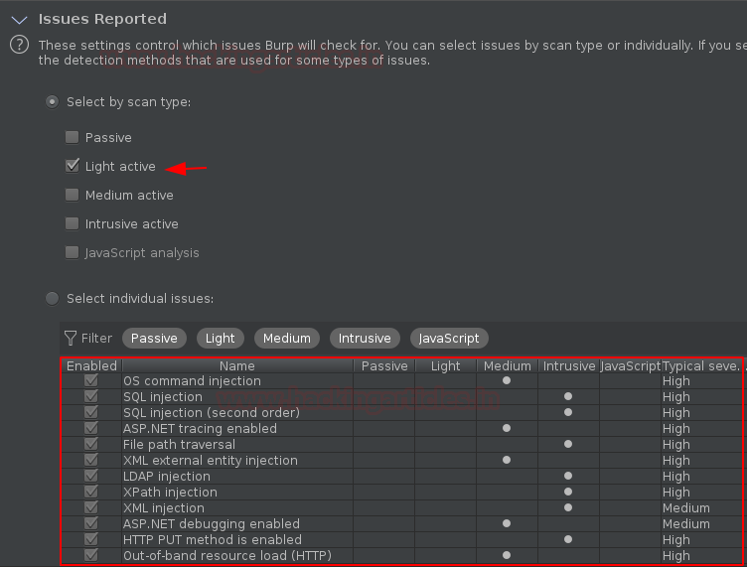

You might be aware of the concept of insertion points, as they are the most important sections to the vulnerability to get hit. They are basically locations within the requests where the payloads are injected. However, the burp’s scanner even audits the insertion points too, and thus could also be manipulated in this phase.

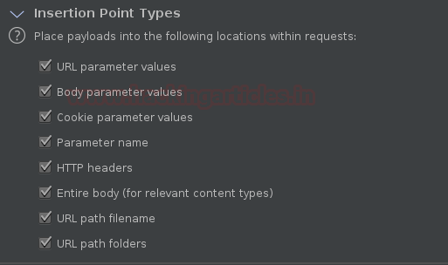

Now as we’re done with the configuration and we hit the **“Save”**button, our customized audit is thus gets listed up in the **New Scan’s dashboard.**

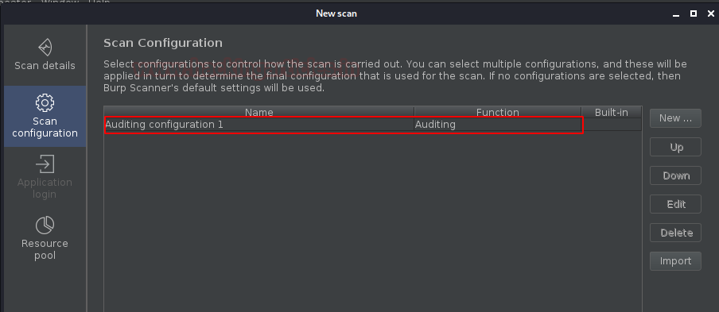

However, the option of Application login is disabled in this section as there is no specific need to log in an application just for vulnerability testing.

Therefore, now we know what’s next, i.e. **hitting the OK button** and **moving to the dashboard**. And as soon as we reach there, we’ll get the result according to our configuration with about **2700 request.**

But this time, the major issue is only **“1”**

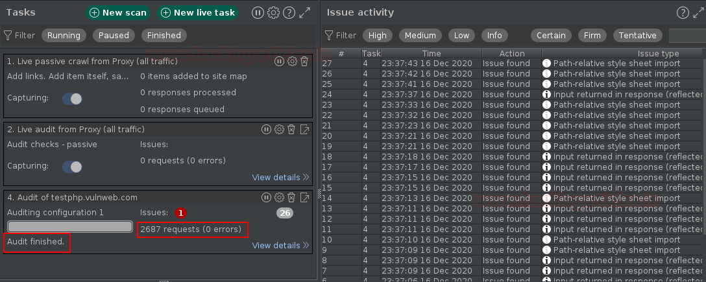

Now, if we move back to the Target tab and select any request from the left panel and do a right-click over there, we’ll get **2 options rather than “1”,**i.e. the **last customization we configure** will thus get into this field and if we share any request within it, it will start auditing accordingly.

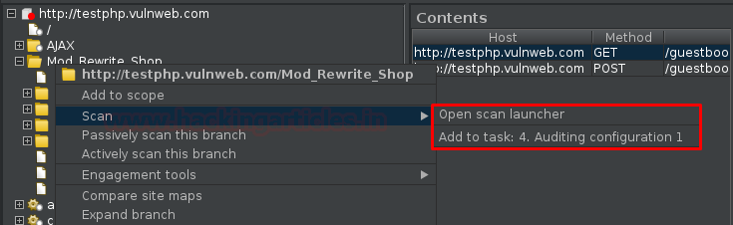

Thereby, we’ll opt the Open scan launcher again to check the other features too. As we head back, we’re welcomed with our previous customized audit, but at the bottom, there is a **“Select from library”**option, click there and check what it offers.

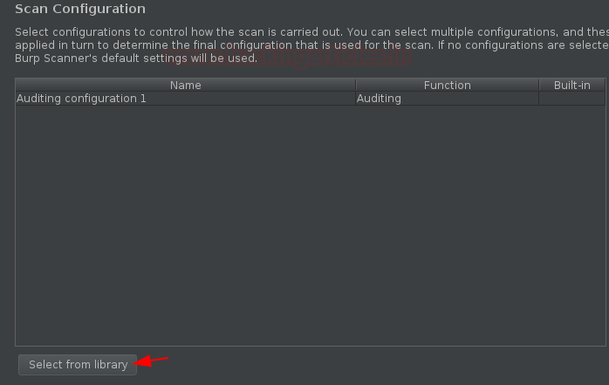

So, wasn’t it a bit confusing to configure the audit by manipulating every option it has ??

Thereby, to get rid of this, burpsuite offer one more great feature to opt a **built-in Audit check**, where we simply need to select any and continue.

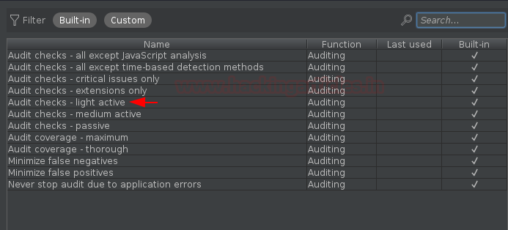

And as we select one, we’ll thus get our option listed back into the New Scan dashboard.

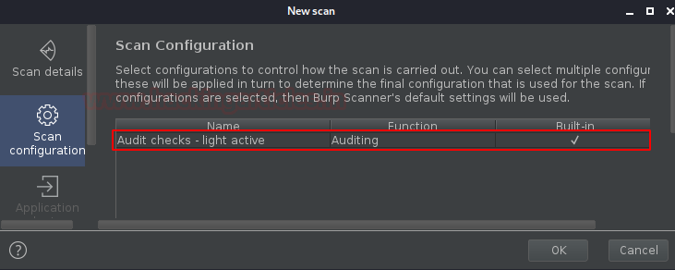

Hit **“OK”**and check the result in the dashboard !! Further, now if we navigate to **Target tab** and do a right-click on any request we’ll thus **get 3 option rather than 2.**

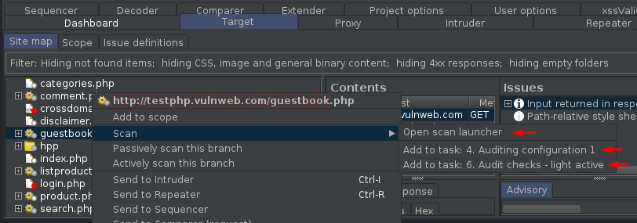

**Crawling & Scanning with an Advanced Scenario**

Up till now, we’ve used the scanner and the crawler individually, but what if we want to do both the things together. Thereby in order to solve this problem too, the burpsuite creators gives us an End-to-End scan opportunity, where our burpsuite will –

1. First Crawl the application and discover the contents and the functionalities within it.
2. Further, it will start auditing it for the vulnerabilities.

Thereby, to do all this, all it needs a **“URL”.**

**Let’s check how we can do it.**

Back on the dashboard, select **“New Scan”,**and now this time opt **“Crawl & Audit”,**further mention the URL within it.

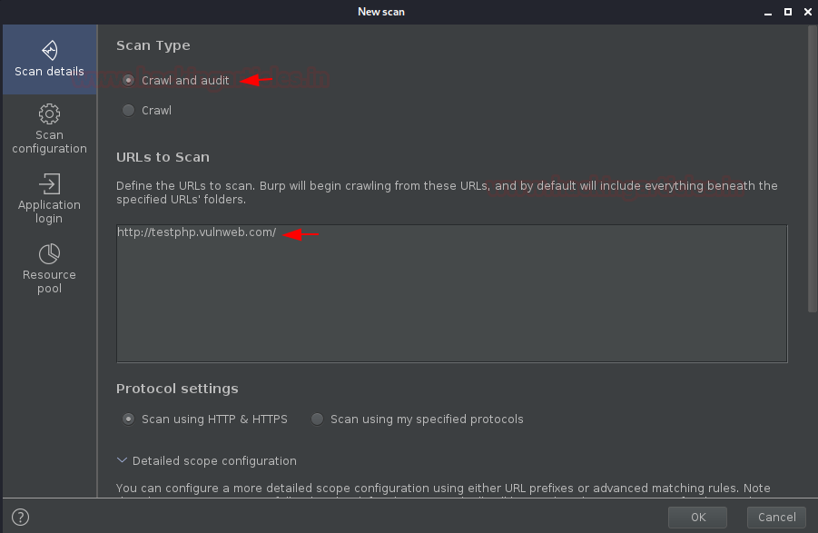

Great !! Now let’s check the **Scan Configuration options**, as we move there and when we click on the **“New”**button, rather than redirecting us to the customization menu it asks us about where to go, for crawl optimization or audit configuration.

However, all the internal options are the same.

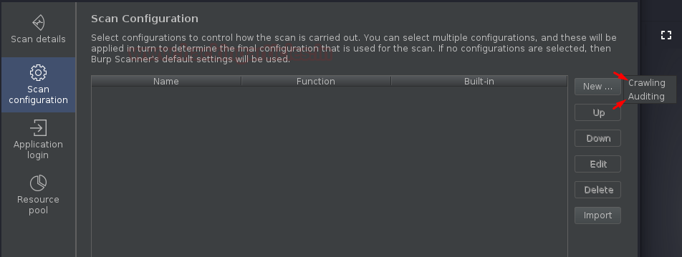

**Deleting the Defined Tasks**

Rather not only knowing how to start or configure the things up, but we should also be aware of how to end them all. Thereby let’s click on the Dustbin icon defined up as a Task option, in order to delete our completed or incompleted tasks.

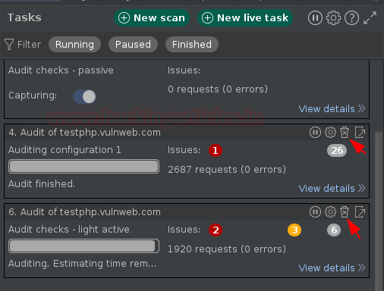

And as we do so, we got the confirmation pop-up as

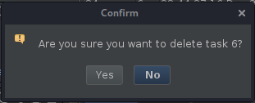

**Burp Suite for Pentester – Fuzzing with Intruder (Part 3)**

[November 8, 2020](https://www.hackingarticles.in/burp-suite-for-pentester-fuzzing-with-intruder-part-3/) By [Raj Chandel](https://www.hackingarticles.in/author/raaj/)

After reading both of our [**previous articles**](https://www.hackingarticles.in/?s=Fuzzing+with+Intruder), you might be wondering, “What about the other features or sections that **Burpsuite’s Intruder** offers us?” or “How can we use the other **payload options** rather than the Simple list only?”

So today, in this article, you’ll get all of your questions answered, whether it’s regarding the payload option, the attack type or even the grep match or grep extract values.

**Table of Content**

* Fuzzing with the Attack Type
  + Cluster Bomb
  + Battering ram
  + Pitchfork
* Fuzzing with the Payload Types
  + Brute forcer
  + Character Frobber
  + Case Modification
  + Numbers
  + Username Generator

**Fuzzing with the Attack Type**

Up till now, you might have seen that over in all the attacks scenarios, we’ve used **Sniper**as an attack type. We did this because sniper uses a **single set of payloads** and targets a **single position** in turn with it. But, with this, we can’t set multiple payload positions over in the same Request.

Thereby for such situation, where we need to set different input parameters as injection points, we can use the other attack types offered by Burpsuite.

So, let’s dig somewhat deeper and explore one of the most common attack types i.e. **Cluster Bomb**, here we’ll try to fuzz the username and password of the users by injecting **two different payload** lists respectively at the different injection points.

**Cluster Bomb**

Back with the similar way, let’s capture the ongoing HTTP Request and share it with the Intruder.

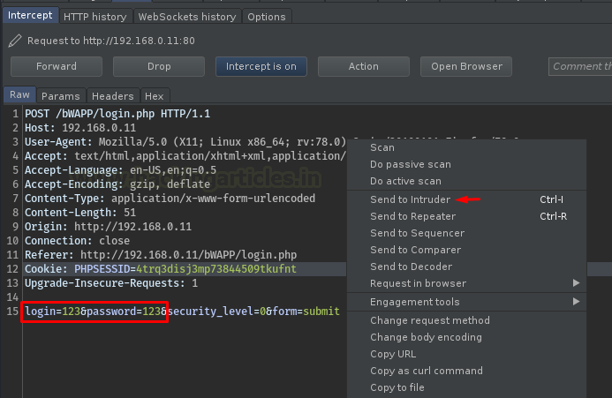

Now, let’s configure the payload positions by selecting the input values of login and password fields with the **Add $**button. Therewith it, opt the Attack type to **Cluster Bomb.**

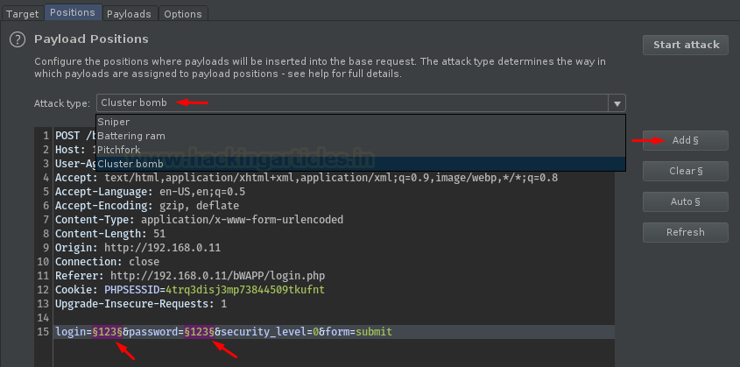

Time to fill the empty box with a list of all possible usernames.

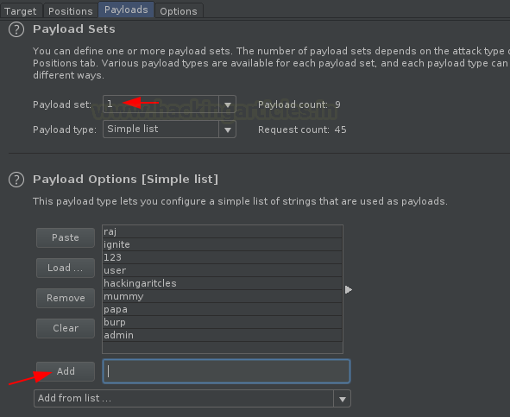

Now, with the usernames, we need some passwords too. So, let’s configure **payload 2** positions with all the possible password that can exist for a username.

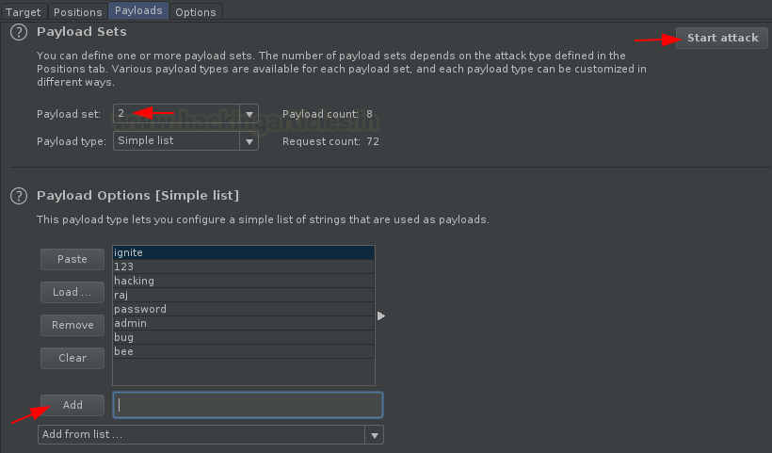

As soon as we hit the **“Attack”**button, the fuzzer will start, and we’ll get the output screen having all the combinations of the usernames and passwords.

But wait, let’s first clear the background concept behind this, like how the two different payload lists will work such in order to give a successful **302 Redirection**.

Here, in this attack, the first password from the payload list 2 will fuzz all the usernames from payload list 1, similarly, then the second password will fuzz all the usernames again and the attack goes on…. i.e. the next payload(password) from the payload list 2 will fuzz all the payloads(usernames) from payload list 1.

Therefore, the total number of requests generated in this attack is the product of the number of payloads in all defined payload sets.

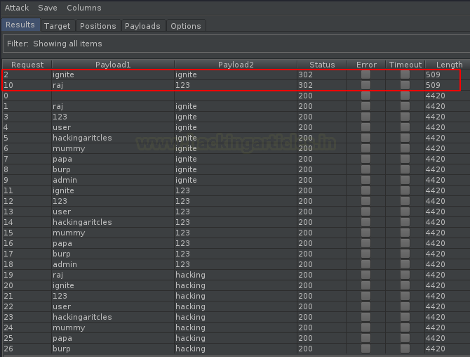

**Battering ram**

The Battering ram attack type is most favourite of Bug Bounty Hunters, as it requires a **single set of payload lists** to hit the vulnerability at multiple positions within the request.

Here, a single list is injected at different payload positions i.e. it used where the same input is to be inserted in multiple places within the request.

Let’s make it more clear by manipulating the attack type to **Battering ram**within the captured request. Here, we’ll try to find out the accounts that are having their **passwords as similar to their usernames**.

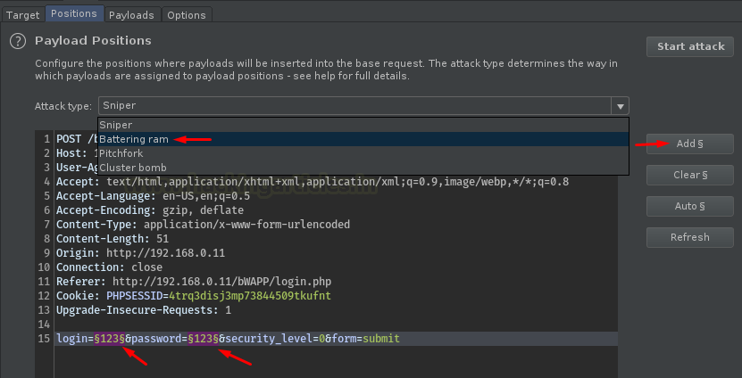

Now, let’s inject some payloads by typing them at the input field. And then further, let’s start the attack by hitting the **“Attack”**button.

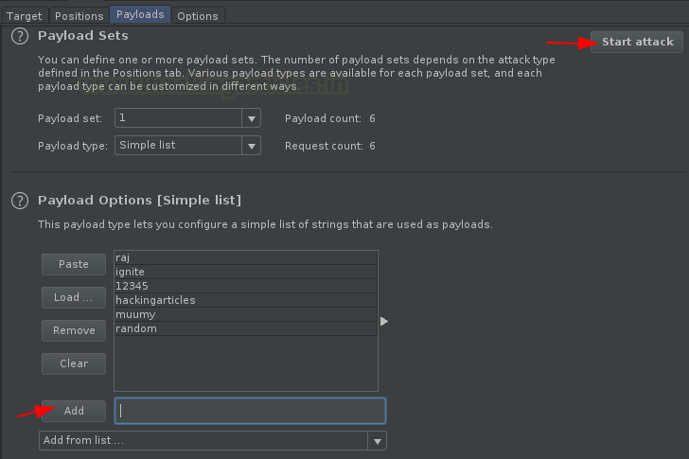

And there we go, we’re back with an output list. From the below image you can see that the total number of requests are equal to the number of payloads we injected. And with this, I don’t think so, that there is a need to sort the length or the status bars, as the output as **“ignite”** with **302**Redirection is clear.

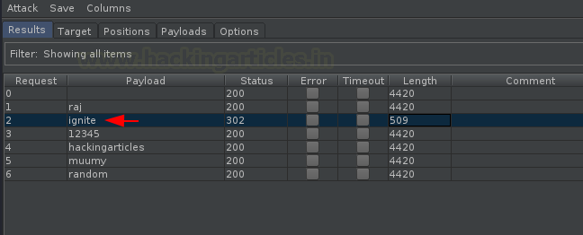

**Pitchfork**

This attack type is completely different from all the other three, although it carries **multiple payload sets and different injection points**. But, it does not fuzz up the things, i.e. it simply checks the first payload from payload list one with the first payload from the payload list 2, and if they found to be the correct credential, it passes a success.

Let’s try it too, for the above-captured request that we’ve used. Simply manipulate the attack type to **“Pitchfork”** and mark the payload positions by selecting them and hitting the **“Add”**button.

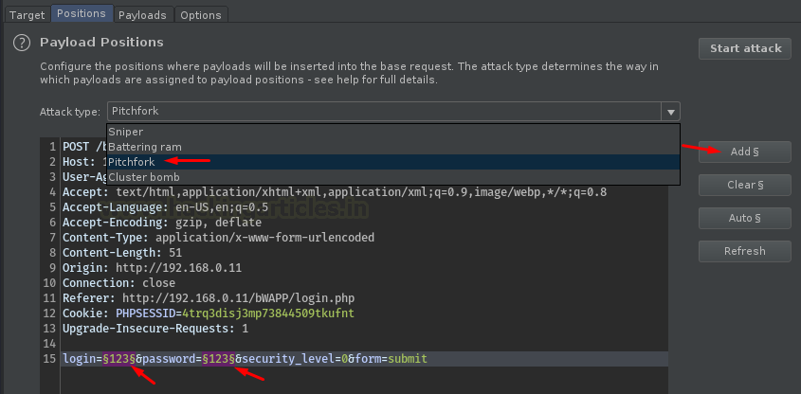

Let’s do the same as we did it for **Cluster Bomb,**select the payload set and inject the payload lists.

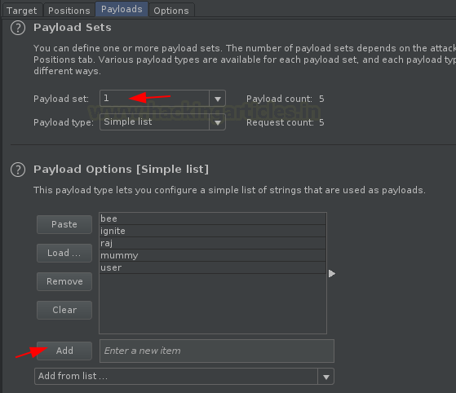

In a similar manner, set the corresponding payloads in Payload set 2 for the payloads of list 1 i.e.

|  |  |
| --- | --- |
| 1  2  3  4  5 | bee : 12345  ignite : ignite  raj : 123  mummy : hacking  user : raj |

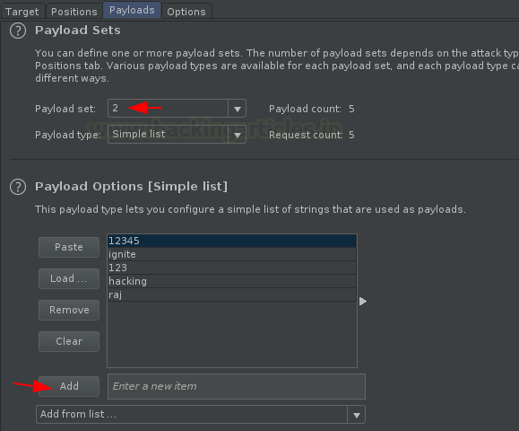

Now as soon as we hit the **Attack**button, in order to start the fuzz, we’ll be redirected to a new window, where we’ll have the successful login credentials.

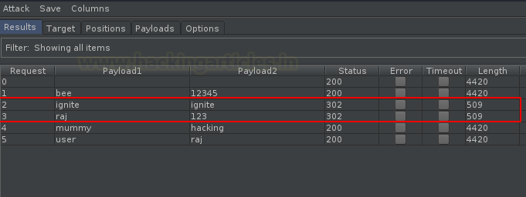

**Fuzzing with Payload Type**

As we’re aware of this fact that the **payload type** in Burpsuite’s Intruder tab is designed to **manage and create payloads** as per our convenience. Although we’ve only used the **Simple list**option within it, there are a number of other lists too that are still hidden from our eyes. Let’s explore them one by one.

**Brute forcer**

Sometimes, people confuse up with the two terms fuzzing and brute-forcing, thereby in order to segregate the two, burpsuite has an inbuilt payload type as **brute forcer,**which takes the **input string** and **generates payloads** of specified lengths that contain all permutations of a specified input character set.

So, this time, we won’t specify any payload list, but rather we’ll configure burpsuite to make its own payloads and inject them at the mentioned payload positions.

Turn **ON** your burpsuite monitor and capture the **HTTP request** made by the Mutillidae’s login portal, and thereby share it to the **intruder**.

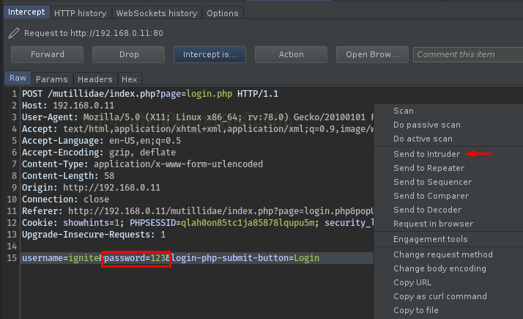

Now with this, we’ll fuzz the password field, as we did earlier select **123**as the**injection point** and set the attack type to **Sniper**.

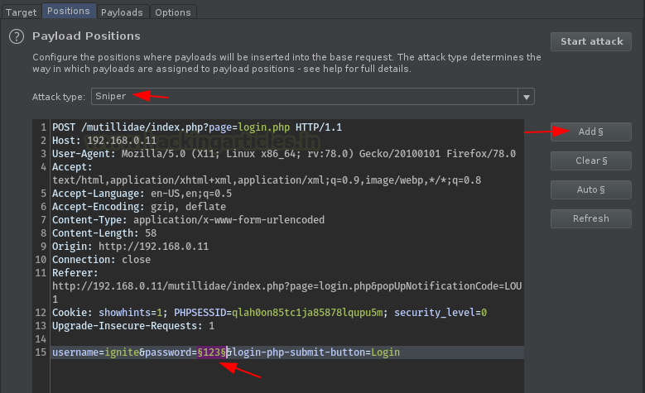

Time to configure the most important thing, from the **payload type** option select Brute forcer and therewith it, fill up the empty input field.

**Character Set –**The set of characters that are to be used in payloads.

**Min Length –**The length of the shortest payload

**Max Length –**The length of the longest payload

**Note :**

The total **number** of **payloads** will be **increased up** with the size of the character set and the maximum length.

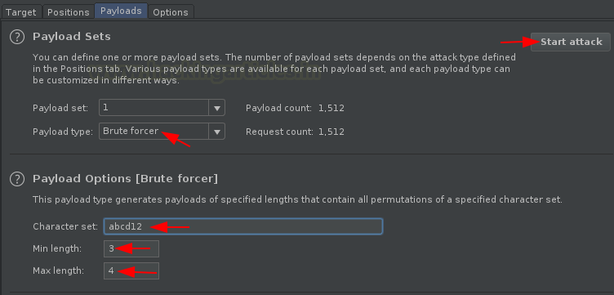

And at last, hit the **Attack**button. Sit back and relax because now the burp suite will do its work, it will create and match the payload with the username provided for the correct password.

Great !! From the below image you can see that we got the payload as **“aa1”**with **302 redirections,**seems to be a successful one. Now, navigate at the top of the intruder tab and select **Attack,**there hit the pause button in order to **pause** the fuzzer.

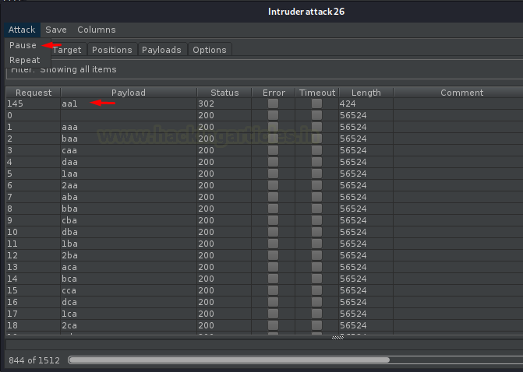

**Character Frobber**

During a penetration test, there are times when we get encountered with such situations where a string is responsible for the application’s response, i.e. if we manipulate the string value with a valid one then the response will get altered. Such situations normally occur when we do an account takeover, where we try to manipulate the user ID with one of a genuine user.

But, if we try to manipulate the characters of the string manually, it may take up to weeks and months to find out a valid request, thereby in order to make our work easy, burpsuite offers an amazing payload type i.e. **Character Forbber** which modifies the value of each character position on the existing base string by **incrementing** the **ASCII code** of a specific **character by one**.

Now, back into the Mutillidae application, over at the left side of the dashboard, select **OWASP 2017 > Broken Authentication & Session Management > Privilege Escalation > Via CBC- Bit Flipping**and capture the request.

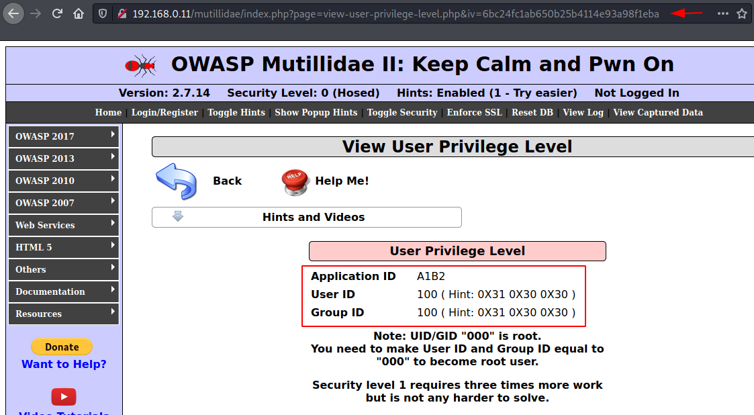

From the above image, we can see that a string is passing over into the URL, seems like its responsible for the user to have an **application ID, User ID and group ID**

Now, as soon as we capture the passing HTTP Request, we’ll directly share it to the intruder for further processing.

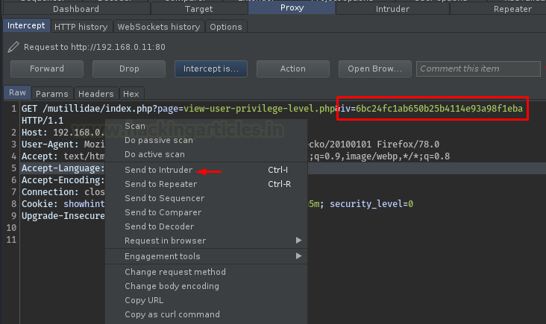

Let’s set our **payload position** to this passing string.

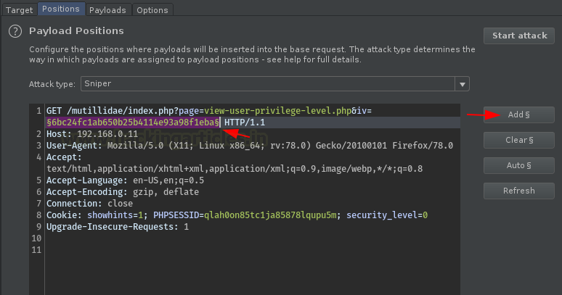

Time to opt, choose the payload type to **Character frobber** and select the **operate on** option to the **“Base value of payload position”**

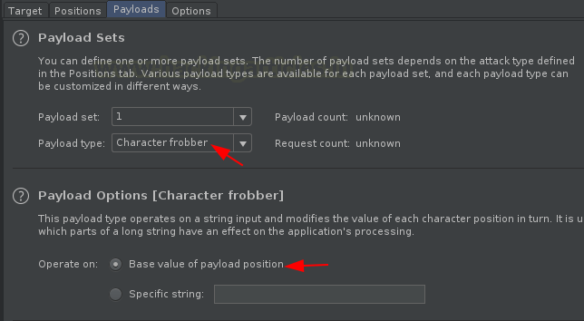

Now, let’s make this attack somewhat more appealing with the use of the **“Grep Extract”** option, which will thereby help us in order to identify which payload sting is defined to which **application ID.**

Therefore, at the **Options** tab, scroll down to the **Grep – Extract**field, check the **“Extract the following items from responses”** and click on the**“Add”**button.

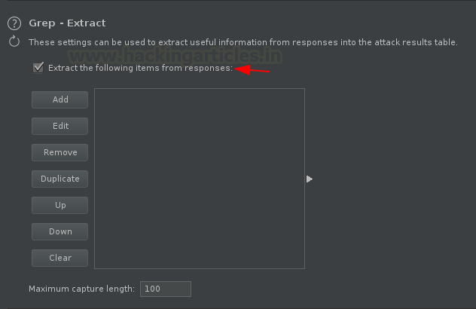

You’ll be redirected to a new window, click the **fetch response** button and the search for **“Application ID”**there, further select the output and hit **OK,**as in our case we’re having **“A1B2”.**

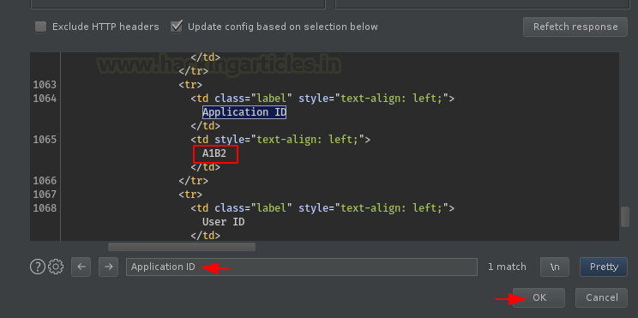

And there it is!! Hit the **“Attack”**button and initiate the fuzzer. (Rather than application ID, you can opt the User ID or the Group ID.)

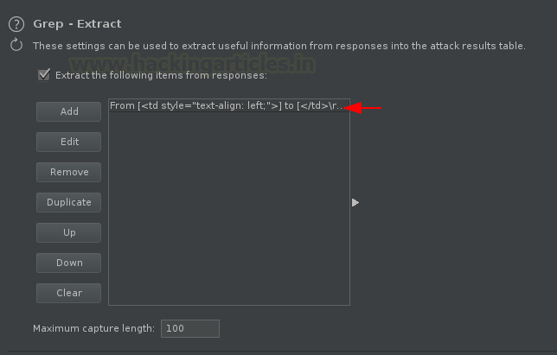

Cool!! From the below image, we can see that we’ve successfully captured all the strings that correspond to a specific application ID.

In the output, you can notice that the payloads are almost similar to one another but there is an increment in the characters one after the other.

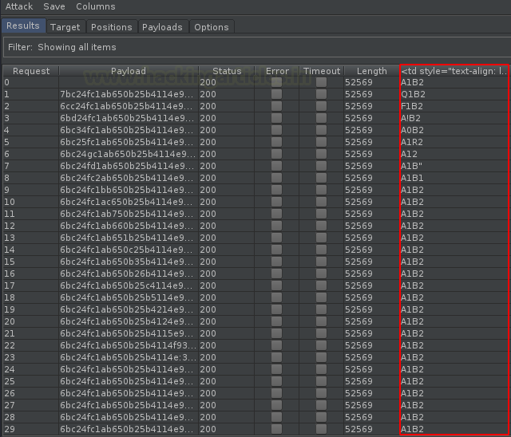

**Numbers**

Similar to the brute forcer, this payload type is specifically **designed for the numbers**part. Many bug hunters love this payload type as its acts as their helping hand majorly in the **OTP Bypass attacks**.

Although the method to use this payload is same, whether you use it for OTP bypass or login brute force.

So, let’s understand the working of this payload type by capturing the ongoing HTTP request of a login page.

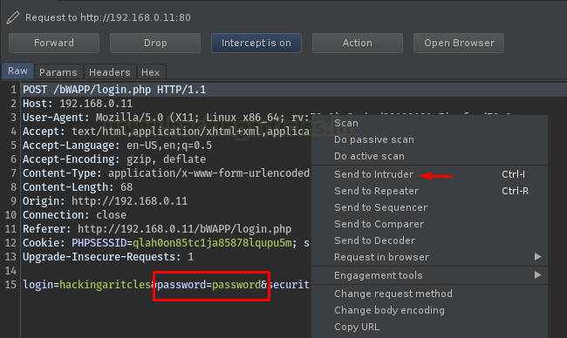

As soon as we share it to the Intruder, we’ll thus need to set the **positions** for it, here let’s mark the password field and set the attack type to **“Sniper”**.

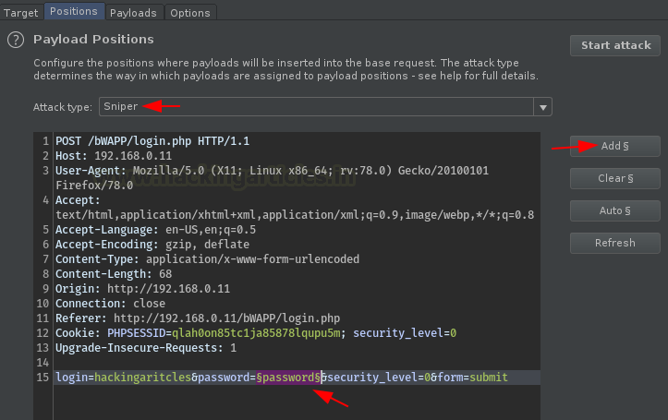

Choose **Numbers** from the payload type options provided and further configure the following as per your requirement.

**From –**The fuzzing will start from that payload.

**To –**The last Payload

**Steps –**This indicates the iteration, here I’ve set it to **“1”**i.e. the next payload after 100 will be 101, 102, 103 and so on. And if we set it “**2**”, then the next payload after 100 will be 102,104,106 with an increment of 2,

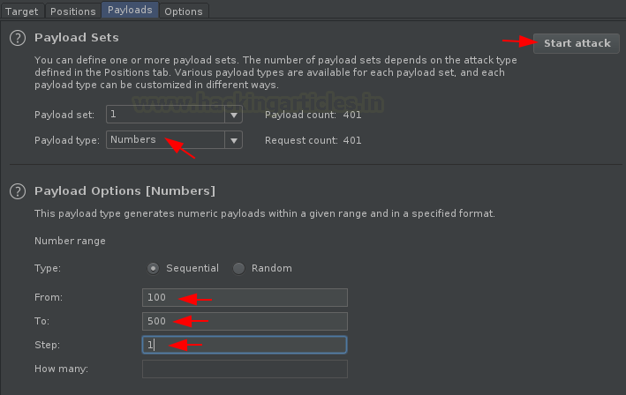

As soon as you set all these things, hit the **“Attack”**button and sit back and wait for the response. Within a few minutes, we’ll get a **302 Redirection**at 123.

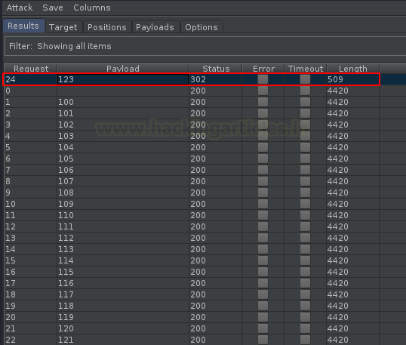

**Case Modification**

Sometimes it’s difficult to determine, that in which case the user has set his/her password. Thereby in order to solve this dilemma, burpsuite has a payload type integrated within itself, which adjust the cases (lower & upper) of the base value and create payloads within from that.

However, this is not for the passwords only, there are times when the developer blocks some specific cases for their input field, thereby in order to determine such, we can use this too.

Let’s capture the request and check its practical exposure.

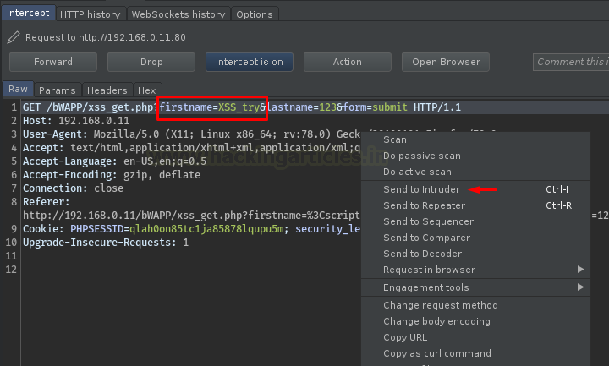

You know what we need to do next, select the payload position and opt Sniper as an **Attack type** for it.

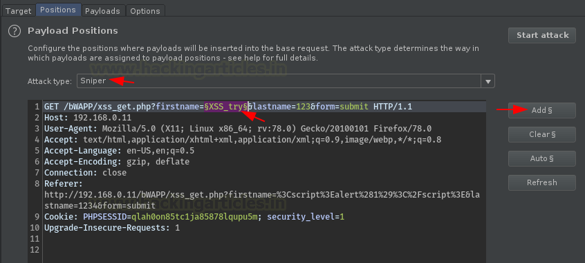

Now, here comes the best past. Opt **Case modification** from the provided list and configure the same.

Fill the empty box with an XSS script and hit the **Attack**button. (Here we’re testing for the **XSS** vulnerability as many times the developer blocks up “SCRIPT” or “script” keyword. )

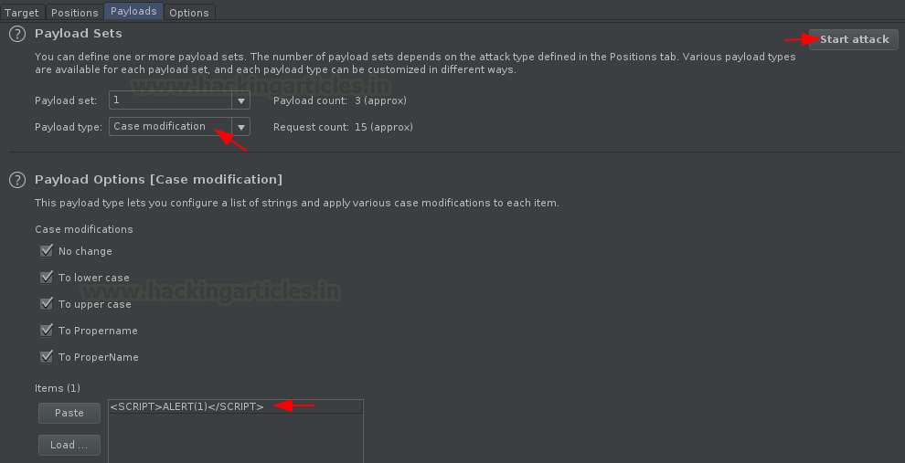

Cool!! We got our payload injected at the correct place. Do a right-click, opt **“Show Response in Browser”** to check the same where Javascript is enabled.

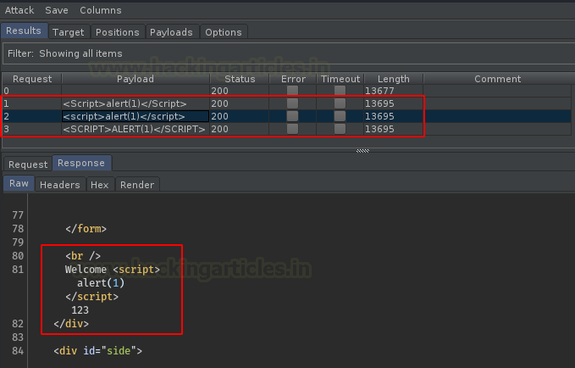

And there we go, we got the pop up reflected with **“1”**.

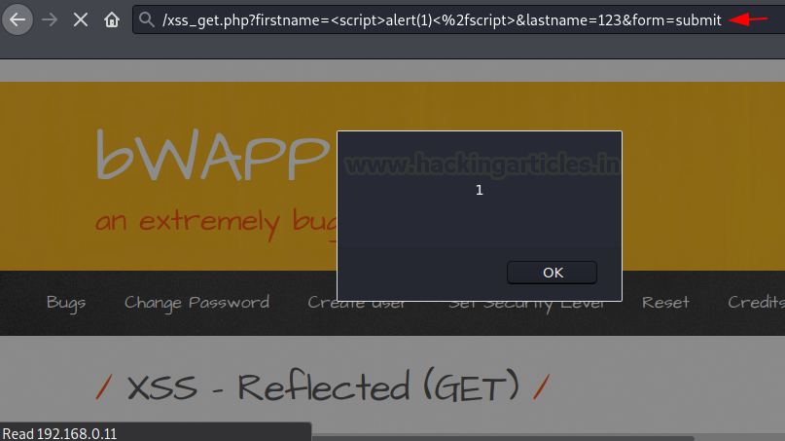

**Username generator**

During a social engineering attack, its simple to gather information about the user whether it is his name or contact number, even there are times we can even guess up the password too, but the most difficult thing is to identify the username he set.

Therefore in order to get out of such situations, burpsuite offers one more great **payload type**, where we just need to **give a specific name** and it itself will generate all the possible usernames and check them according to the injected password.

Wonder, how this could be done?? Check out the following scenario.

Capture the Request with a random username and correct password and share it all to the Intruder.

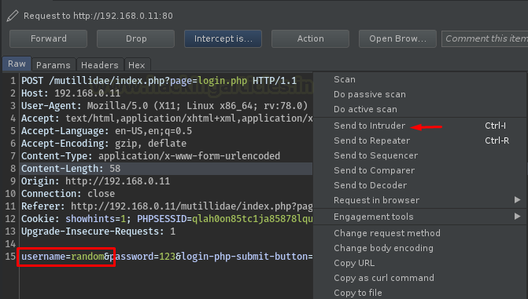

Now, time to set our payload position, select **“random”** and click the **Add**button, further opt the attack type to **Sniper.**

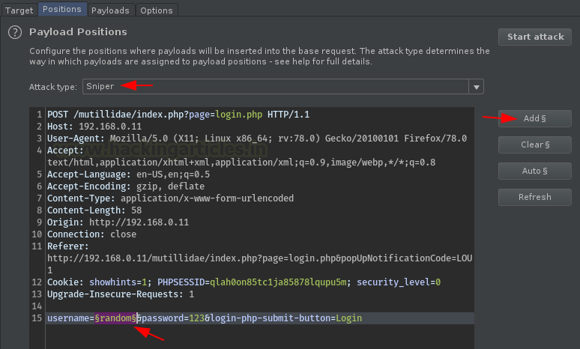

And there we are, select **“Username generator”,**from the payload type and enter the name you wish for, for the usernames. Here, in our case, we’ve used **“Ignite Technologies.”**

We can even select the maximum number of payloads i.e. the usernames, here we’ve also set that to 50.

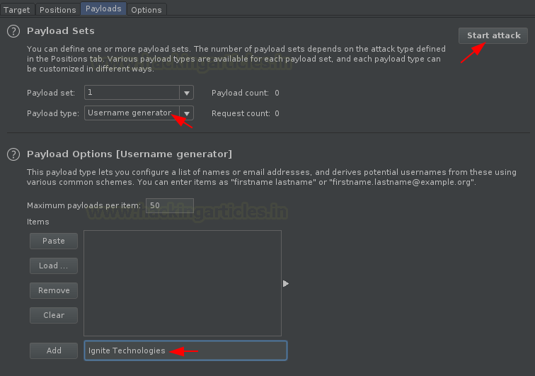

As soon as we hit the **Attack**button, our fuzzer will starts up and with this, we can see a huge number of usernames are there enrolled into the list, and we got ours as **Ignite** !!

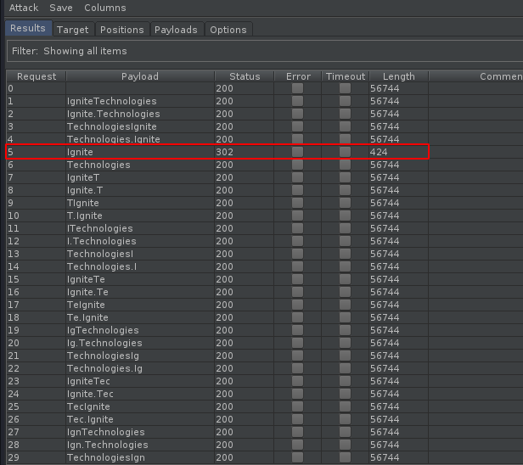

**Burp Suite for Pentester – Fuzzing with Intruder (Part 2)**

[November 7, 2020](https://www.hackingarticles.in/burpsuite-for-pentester-fuzzing-with-intruder-part-2/) By [Raj Chandel](https://www.hackingarticles.in/author/raaj/)

Over in the [**previous article**](https://www.hackingarticles.in/burpsuite-for-pentester-fuzzing-via-intruder-tab/), we learned about what fuzzing is and how the burpsuite helps us to fuzz a web-application, along with all these things we had even explored some great fuzzing payload lists that are offered by the burpsuite’s Intruder tab.

So, today, in this article we’ll investigate some other amazing pre-defined burpsuite’s payload lists that could thereby hit a crucial vulnerability.

**Table of Content**

* Fuzz with Burp’s built-in Payload lists
  + Fuzzing for Cross-Site Scripting
  + Fuzzing for OS Command Injection
  + Fuzzing for Hidden Directories
  + Fuzzing for HTTP Verb Tampering
  + Fuzzing for SQL Injection
* Fuzzing with Customized Lists.
  + Manipulate Burp Suite’s pre-defined payloads
  + Injecting our customized payload lists.

**Fuzz with Burp’s built-in Payload lists**

As we’re aware that burp suite comes with some pre-defined payload lists that can thereby help us in order to fuzz an application. However, we have already used a number of them in our previous article, so let’s make our hands wet again, by exploiting some more vulnerabilities with the remaining payload lists.

**Fuzzing for Cross-Site Scripting**

**C**ross-**S**ite **S**cripting often abbreviated as **“XSS”**is a client-side code injection attack where malicious **scripts** **are** **injected** **into** **trusted** **websites** where the input-**parameters** are **not** **properly** **sanitized** or validated. You can learn more about Cross-Site Scripting from [**here**](https://www.hackingarticles.in/comprehensive-guide-on-cross-site-scripting-xss/).

However, such attacks are quite difficult when we try to exploit them with the bare hands, as they were secured up with some validations. Therefore, in order to exploit such validated applications, we need some fuzzing tools and thus for the fuzzing thing, we can count **on BurpSuite’s Intruder tab**.

**Turn ON your Proxy service**and capture the ongoing HTTP request with Burp Suite’s **Intercept** option, therewith it, share it all to the **Intruder.**

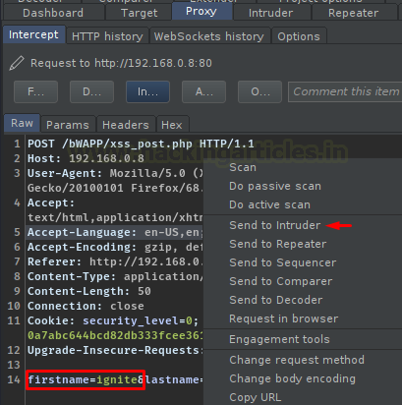

Let’s now configure the input parameters, hit the **“Add”**button to set the **payload position**with**“ignite”** and set the **Attack type** to **“Sniper”.**

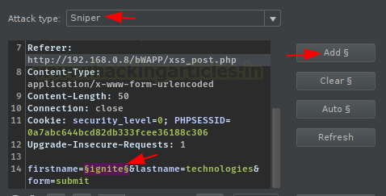

Time to customize the most important thing i.e. the payload list, click on **Add from list..**button and**scroll**until you get the **“Fuzzing – XSS”** option. Further, hit the **“Attack”** button to initiate the fuzzer.

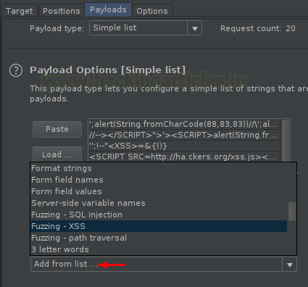

And there we go, within a few minutes we’ll get the output list with all the success hits and drops. Double click on the **length** **section** to sort them out in the **descending order**.

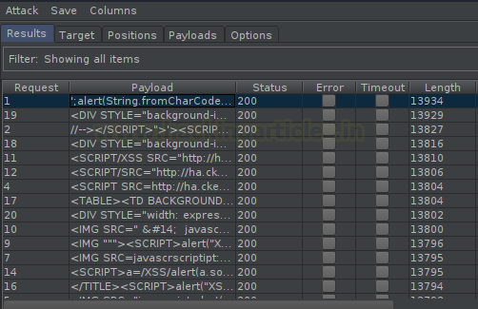

Cool !! Now, share any of them to the browser in order to check the response is made.  And there it is, the browser hits our payload and showed up the response embedded within it as **“XSS”**

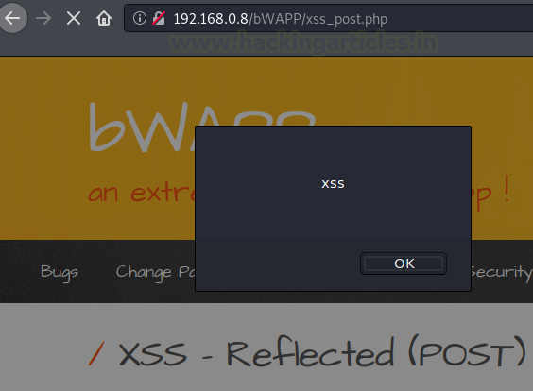

**Fuzzing for OS Command Injection**

OS Command Injection or Shell Injection is that vulnerability where the attacker tries to executes**arbitrary commands** directly through a vulnerable application, there in order to retrieve information of the webserver or try to**make unauthorized access**into the server. You can surf the complete vulnerability from [**here**](https://www.hackingarticles.in/comprehensive-guide-on-os-command-injection/).

However, there is no such pre-defined list for this OS Command Injection but still, we can exploit it with the all-in-one fuzzing list i.e.  with **“Fuzzing – quick**”

As we did earlier, capture the request again and share it with the Intruder.

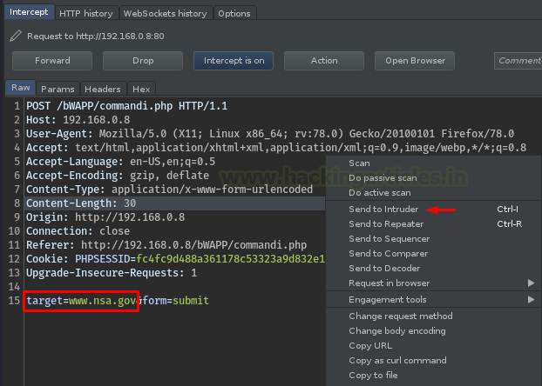

Further, lets set the injection point to **“www.nsa.gov”**by hitting the **Add**button and set the attack type to **Sniper.**

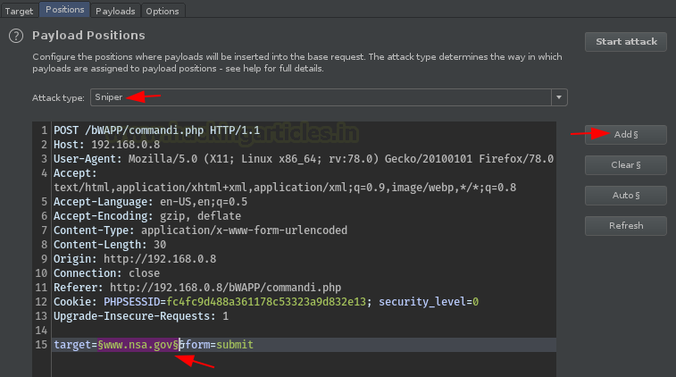

Let’s now opt the smallest and deadliest list to fuzz this injection point. And therewith that hit the**“Attack”**button to initiate the attack.

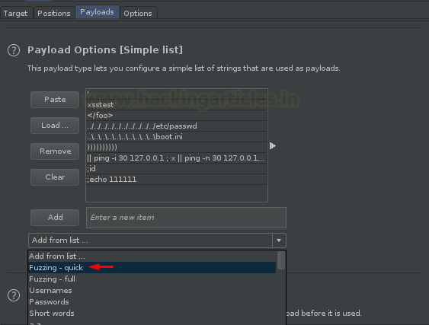

Within a few seconds, we’ll get our output. Alter the length section as in Descending order in order to analyse the responses.

There we go, the **“;id”**payload is working perfectly here.

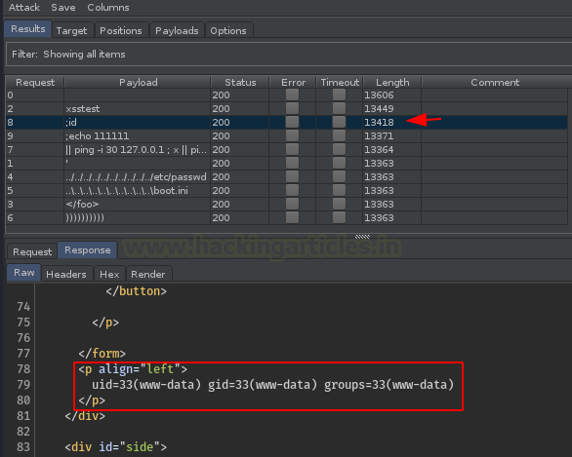

Let’s check the same in the browser too. From the below screenshot you can see that our payload has been triggered out by the web-server.

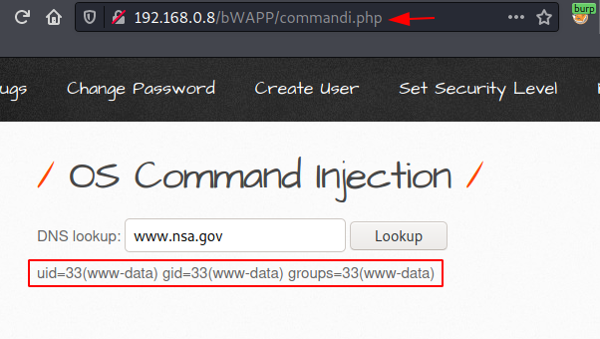

**Fuzzing for Hidden Directories**

Similar to the web pages, there are some directories too that are hidden from the normal users, but yes they exist over the application.

However, it’s about to impossible to find these directories with the naked eyes. Therefore, to make our work easy and to make this task possible, burpsuite offers an amazing payload list that will drop out all the hidden directories within a few seconds. Thereby, this attack is also known as Web Directory Bruteforcing, you can check the same from [**here**.](https://www.hackingarticles.in/5-ways-directory-bruteforcing-web-server/)

Over at the application, place a **random keyword** so that it would be easy to set out **an injection point**. As in our case, we’ve injected **“abc”**after the web application’s URL. Further, capture the Request and share the same to the intruder.

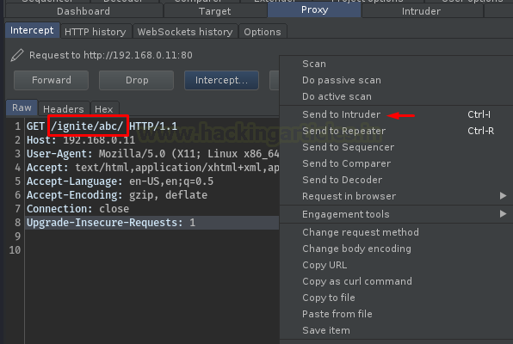

Now, here comes the role of our keyword**,**select it and hit the **Add** button.

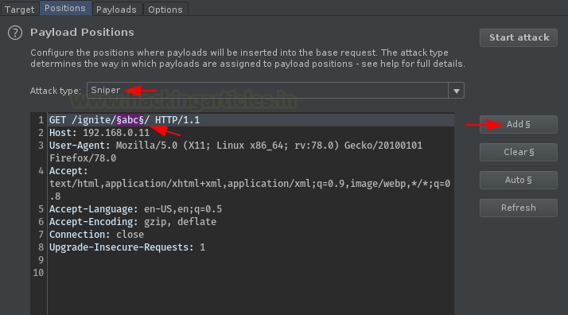

Time to move further at our favourite step, select the **Dictionary – short** payload list from the **Add from list…**option.

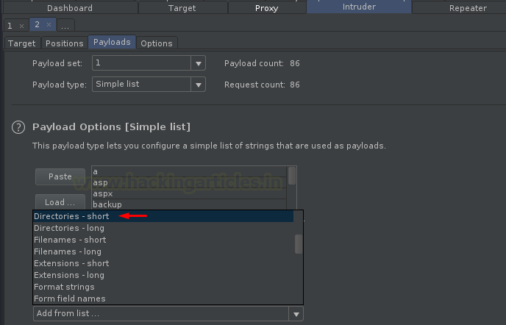

As soon as we hit the **Attack**button, our fuzzing will get starts up and within a few minutes, we’ll be presented with a list of **hidden files**.

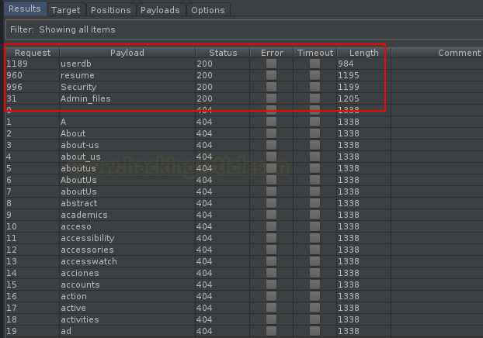

Seems like the **Admin_files** is having some juicy content, let’s check it out in the browser.

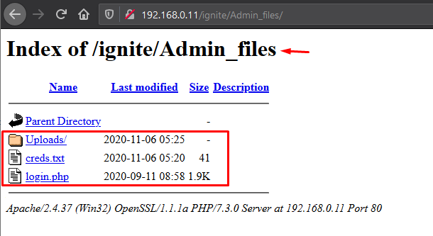

**Fuzzing for HTTP Verb Tampering**

HTTP Verbs are majorly used by web-developers while developing an application, during this phase they use the most common verb methods i.e. **GET & POST**. But rather than these two, there are **a number of HTTP methods exists up**, that if injected at a wrong place could thus lead to some drastic results.

However, in such attacks, the attacker **manipulates** **up the HTTP method** that was set up by the developer with an unwanted method, and if the output with the other HTTP method drops out with**“200” Success**, then the application might face some defacements.

Thereby in order to make this attack much simpler, burpsuite drops out an **in-built payload list** with all the **HTTP Methods integrated within it**. So let’s check it out about what it offers.

In a similar way, we did earlier, **capture the ongoing HTTP Request** and thus share it with the **Intruder**.

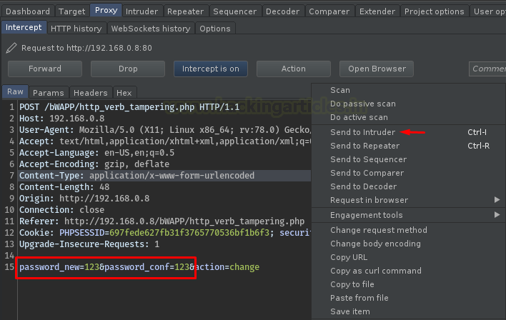

Now, this time we won’t set the payload position at the input values, but rather, we’ll set them up to the HTTP Request i.e. the **“POST”**method.

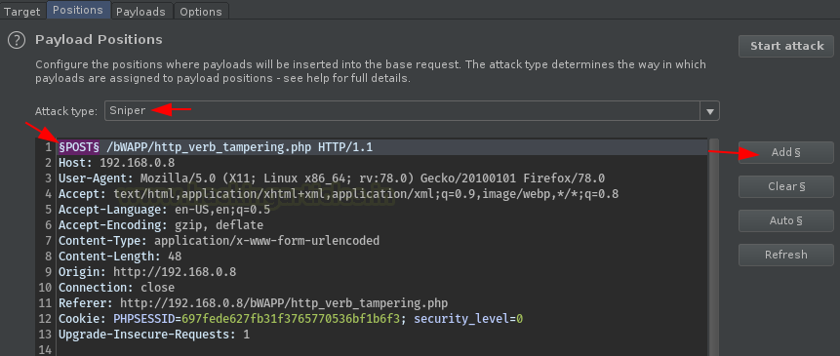

In the most simpler way, choose the payload list as **“HTTP verbs”,**and hit the **Attack**button.

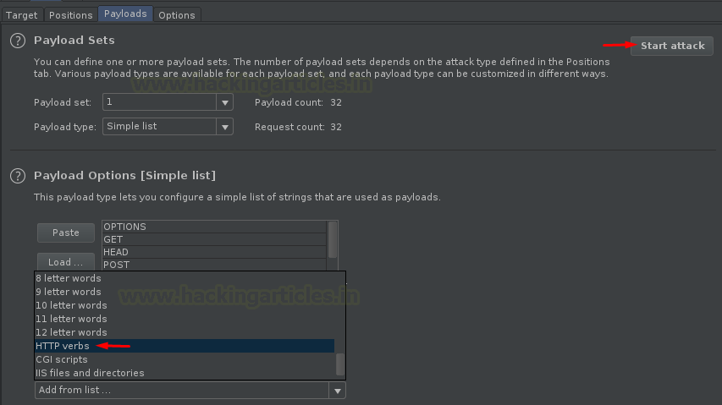

Time to analyse, here we’ll see the **“Status”**section. We are testing the most vulnerable website, as the **200 success** is with almost every HTTP method we set out.

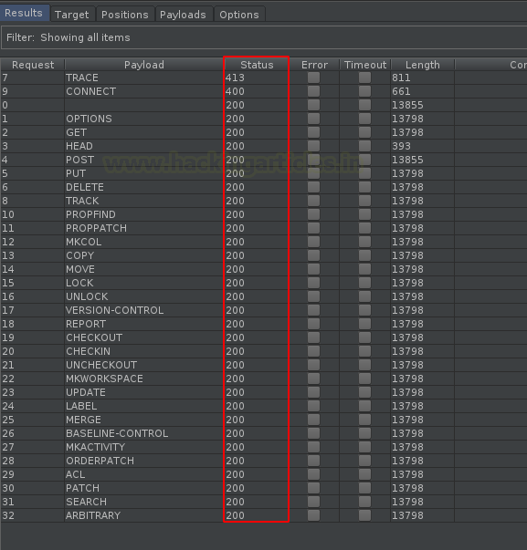

Now, let’s check the response from the **HEAD method,**as we’re aware that a request with this method only shows up the Header part and hides up all the HTML code within it.

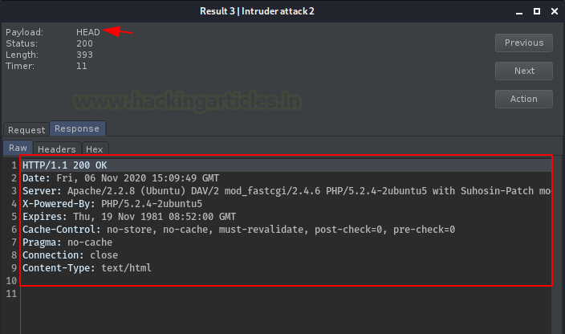

**Fuzzing for SQL Injection**

Over in our previous article, we had exploited an SQL suffering **acuart’s login portal**, there we used the Fuzzing – full list to accomplish the task, but Burp Suite is having a **separate payload list** specially designed to encounter an SQL vulnerability. So let’s try to use it here in this section.

Back with the similar way, **intercept the request** and share it with the **Intruder**.

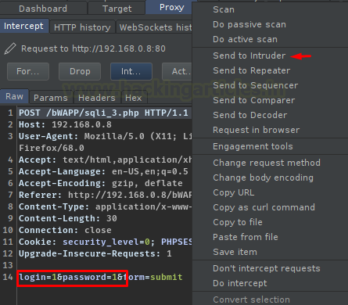

Now, with this, let’s configure the injection points. Select “1” and “1” and then hit the **Add**button to set them as**payload 1** and**payload 2** respectively. But with all these things, don’t forget to change the Attack type to **“Cluster** **Bomb”** as there are 2 payloads.

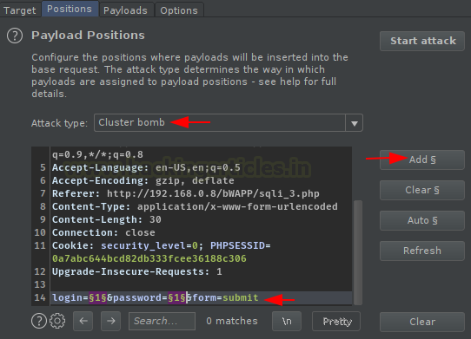

I hope you know what we need to do next. Select the **Fuzzing – SQL Injection** for payload 1 from the options provided.

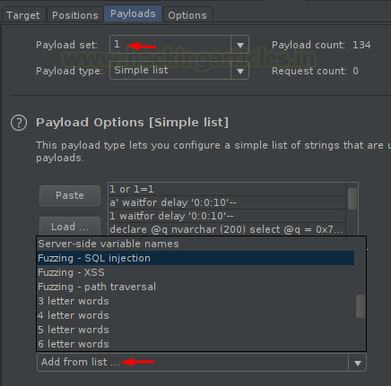

And then opt the **same for** **Payload 2**.

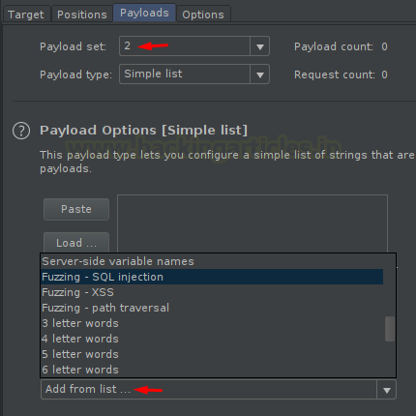

Before hitting the **“Attack”** button, let’s make this fuzz more appealing by setting up the **Grep Match** value.

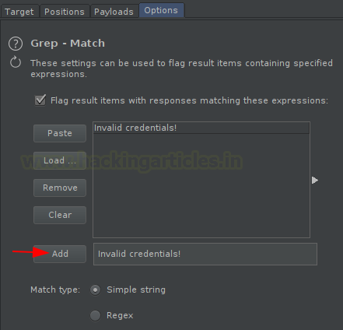

**Note –**

Here, we’ve used the phrase **“Invalid credentials!”** intentionally, as this is the error generated at when some wrong credentials are entered. So rather than **“Invalid credentials!”**, you have to set the one that displays as a part of an error message when you fails to get logs in.

Now, hit the **“Attack”**button in order to initiate the attack. And with that, we’ll get a list of all the payloads that can give a successful login.

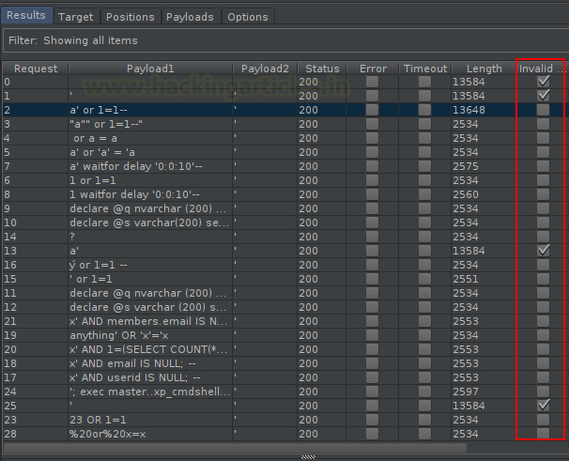

Opt one and check its response in the browser.

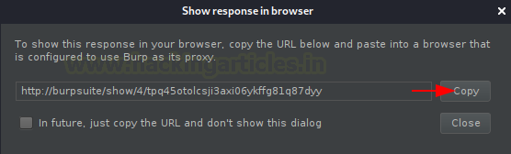

Great !! And there we go, **”I wish I could have seriously taken that BLACK Pill !!”**

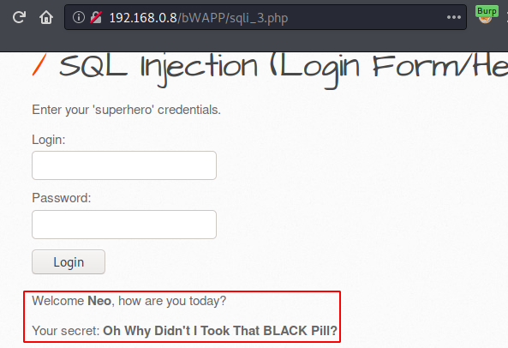

**Fuzzing with Customized Lists.**

**Manipulating Burp Suite’s pre-defined payloads**

You might be wondering about, what, if I want to fuzz with my own payloads but along with that I also want the pre-defined lists.

However, the Burp suite developers might also have experienced the same thing too, thereby they designed a button called **ADD**with an **input field** where we can type and inject our payload along with the predefined lists.

So, let’s make it more clear by capturing an HTTP Request and sharing it with the Intruder.

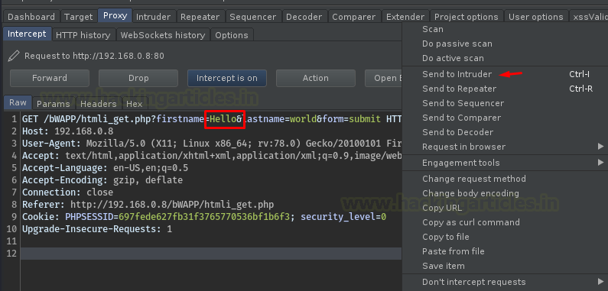

Now, we know all the best things that we need to do next… Hit “**Add $”** at the selected text in order to set the **injection point**.

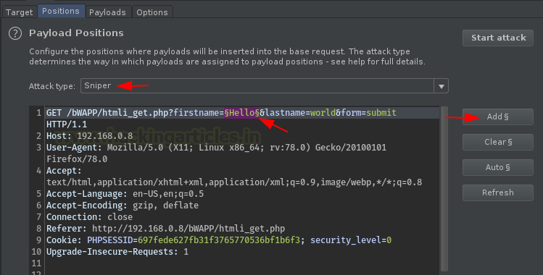

Let’s first select the predefined lists, here we’re using the most favourable list i.e. **“Fuzzing – XSS”.**

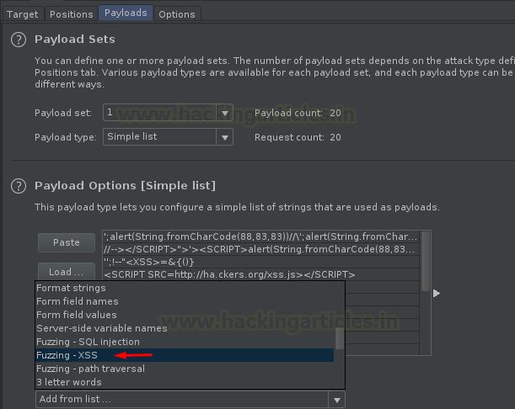

With this, let’s spice up the thing by injecting our customized payload as

<script>alert(“Ignite Technologies”)</script>

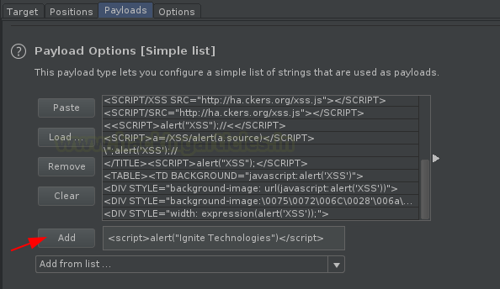

Time to find out our payload from the heap, and there it is, let’s give a right click and check its response in the browser.

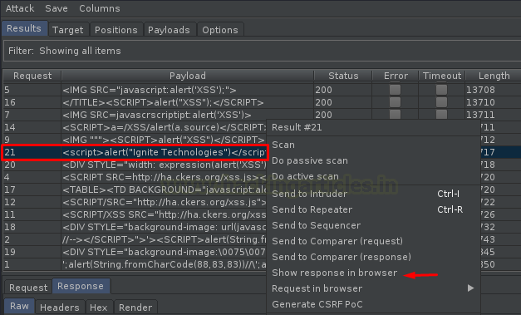

It’s working !! We got **“Ignite Technologies”** being popped-out from the screen.

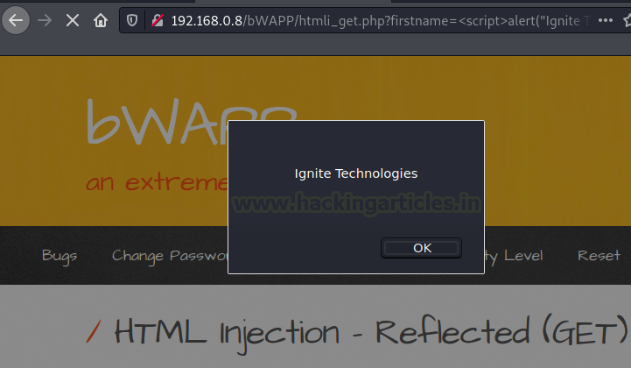

**Injecting our Customised Payload Lists**

We might have seen a number of payload lists all around over at the internet, so do we need to type the individual payload and hit the **Add** button in order to get that.

No !! As along with the pre-defined lists and the input field for the payloads, burp suite also provides an opportunity to take advantage of these things too.

Over at the left side above the **Add**button, we’re having one more button labelled as “**Load”.**This burp suite functionality helps us in the most amazing way it can, i.e. it allows us to **load any payload list for our fuzzing attack.**

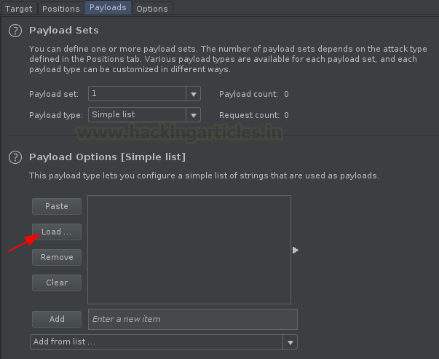

Click on the **Load** button and **select the payload list** that you want to fuzz with.

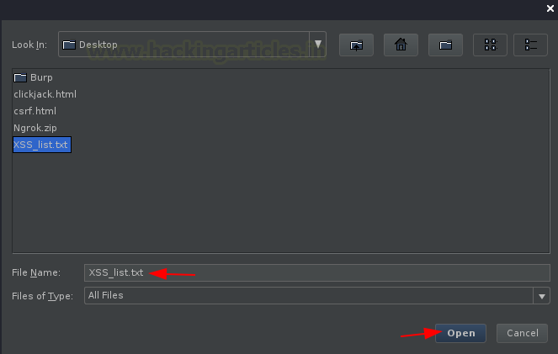

As soon as we do so, the empty box will get filled up with all the strings that are within the list.

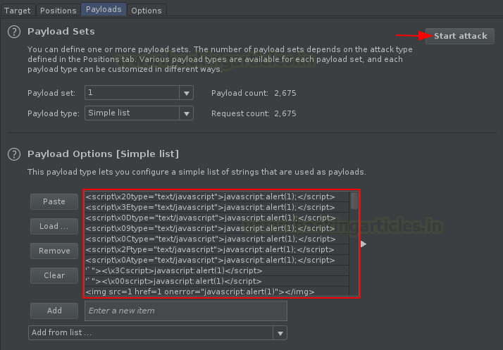

Time to start. Hit the **Attack** button and analyse the output it offers.

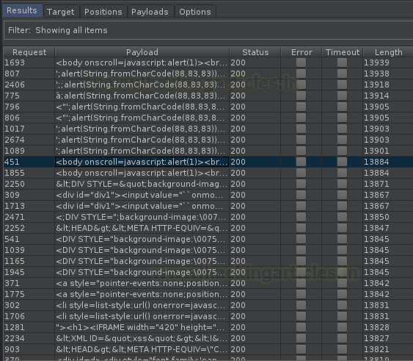

Let’s check the response for the **selected** one. Great !! From the below screenshot, we can see that **the payload is working**in the best way that it is designed to be.

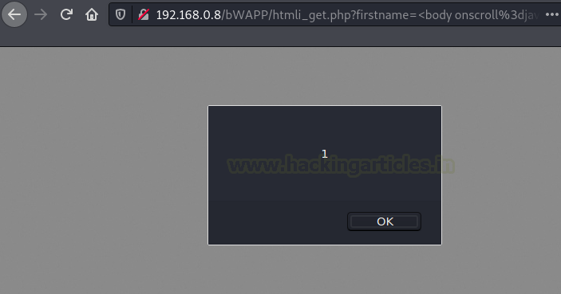

**Burp Suite for Pentester – Fuzzing with Intruder (Part 1)**

[November 5, 2020](https://www.hackingarticles.in/burp-suite-for-pentester-fuzzing-with-intruder-part-1/) By [Raj Chandel](https://www.hackingarticles.in/author/raaj/)

Whether it’s guessing up a login credential or opting a valid payload for a specific vulnerability, both of these things are time-consuming and require a number of permutation and combination to built up a dictionary for them, if done manually. But what, if all these things are done with some simple click and you just need to sit and analyze the outcome it drops out?

Today in this article, we’ll learn the most common technique i.e. **“fuzzing”** that has been used since decays in order to deface a web-application, by exploiting some vulnerabilities over at the web-application with a list of pre-defined payloads that are offered by the burpsuite’s intruder tab.

**Table of Content**

* Introduction to Fuzzing
  + What is Fuzzing?
  + How Burpsuite works as a Fuzzer?
* Fuzz with Burp’s built-in Payload lists.
  + Fuzzing for Login credentials.
  + Fuzzing for SQL Injection
  + Fuzzing to find Hidden Files
  + Fuzz to find Restricted File Upload Extensions

**Introduction to Fuzzing**

**What is Fuzzing?**

Fuzzing or Fuzz Testing plays a vital role in software testing procedures. It is a technique which is used for find bugs, errors, faults, and loophole by **injecting** a set of partially – arbitrary inputs called **fuzz** into the program of the application which is to be tested. A Fuzzer takes structure inputs in a file format to differentiate between valid and invalid inputs.

However, the **Fuzzer tools are best in identifying vulnerability** like SQL injection, buffer overflow, Cross-Site Scripting, OS command injection and many more.

**How Burp Suite work as a Fuzzer?**

Burp Suite comes with an integrated **HTML Fuzzer**, commonly termed as a**Burp Intruder.**This burp intruder gives us several opportunities to fuzz the injection points in the most customizable way we can.

In order to make a fuzzing attack possible, we need to add up a dictionary as a **payload list**. However, Burp Suite’s Professional Edition gives us an option to opt **the predefined lists** containing the most common fuzz strings according to the attack types.

You might be wondering about how the fuzzing works here, right??

Let’s clear it in some simple steps.

* First, we need to **intercept** the**HTTP Request**, therewith that we’ll thus **share** **it with the Intruder.**
* As soon as we do so, we’ll **define the parameters** or the injection points where the fuzzing needs to be done.
* Now, at last, the **attack type and payloads** **list** need to be defined up with that.

And as soon as we launch the fuzzing attack by hitting the **“Attack”**button, we’ll get the output screen stating up all the possible hits and drop. Therewith it, we can thus analyse them and find a crucial hit.

**Fuzz with the Burp’s built-in Payload Lists**

Up till now, you might be clear about what fuzzing is, and how the Burp Suite’s Intruder helps us to fuzz a web application. So let’s take a deep dive and intercept some request in order to fuzz an application with the **burp’s predefined payload lists.**

**Fuzzing for Login Credentials :**

Usernames and Passwords plays a major role within an application, thereby if we could fuzz them in the best way, we would be able to bypass the authentication phase. So let’s do it.

**1. The Password field Fuzzing using Password list & Short words list**

**Turn ON the burp suite** in order to intercept the request and then share the same to the **Intruder.**

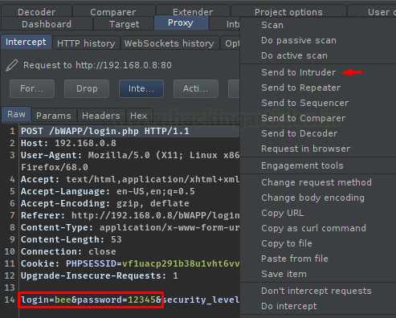

Now, configure the **Position**where the payload needs to injected by hitting the **Add**button. And even manipulate the **Attack Type** which determines how the payload will hit at the injection point (payload position).

**Payload position:** 12345 (User input as the password)

**Attack type:** Sniper (for one payload)

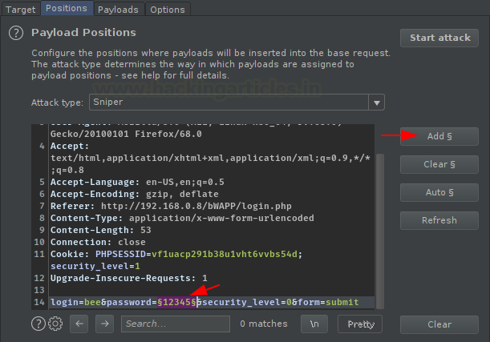

Choose the payload option to configure a **Simple list** of payload for the attack.

Burp suite Intruder contains fuzzing strings for testing a common Password, therefore let’s opt the **Password option there.**

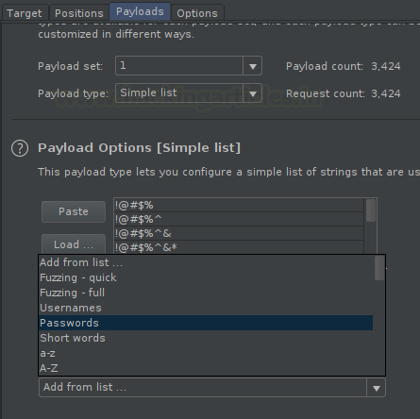

Hit the **“Attack”**button and initiate the attack.

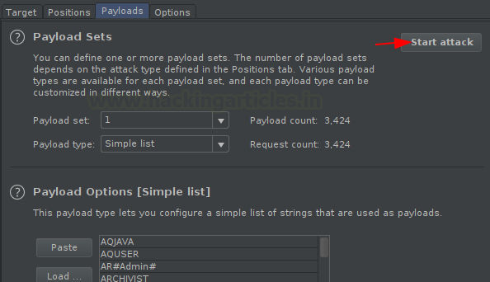

As soon as we do so, our burpsuite will start the attack by sending requests to hit the correct password for the respective username.

Now from a given list of applied strings, double click on the **length** section to sort them in the ascending order. Further, select the one which has the lowest length.

Cool !! From the below image, you can see that with the payload **“zombie”**we’re are getting a **302 success.**

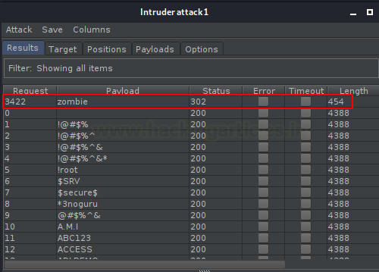

Let’s check the response is made, use **bee : zombie** over the login field. And there we go, we’ll are inside the application.

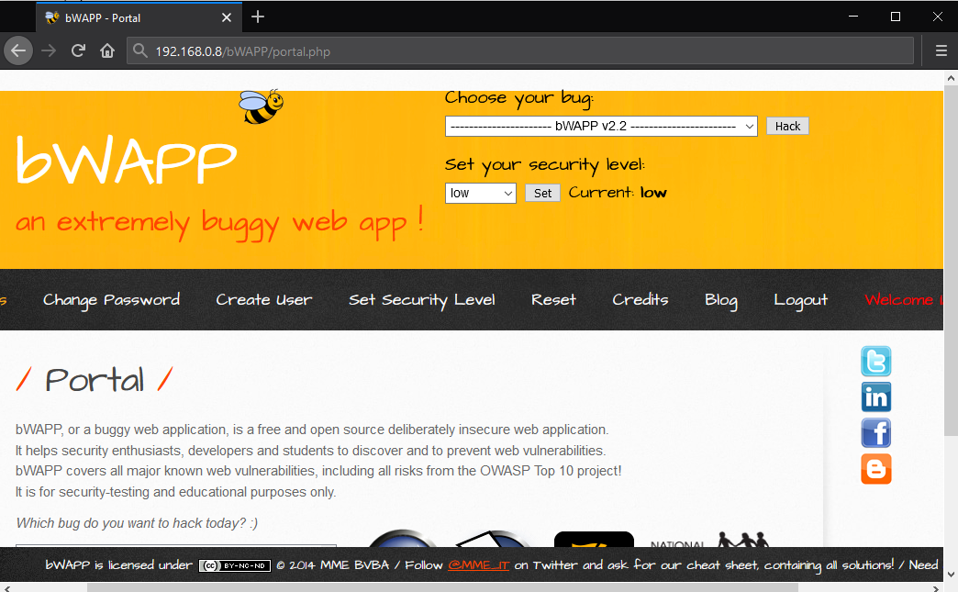

There are times, when the password that the user configured is not in the Password Payload list, therefore in such cases, we can use the other Burpsuite’s predefined list i.e. **“Short Words”**

Let’s capture the HTTP Request for the user **Raj,**and then, in the same way, we’ll share it to the intruder tab.

Over there, we’ll set the **Payload position** again i.e. 123 by hitting the **Add** button.

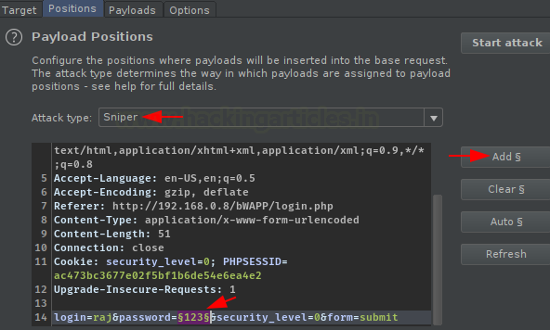

Now, for this time, rather than the Password option, we’ll opt the **Short words**payload list.

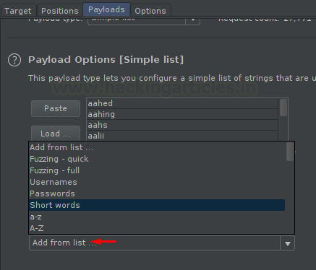

Time to go. Fire up the **Add**button and analyse the output response.

As soon as we sort the **length** option as in the ascending order, we’ll get our password as **“movie”**

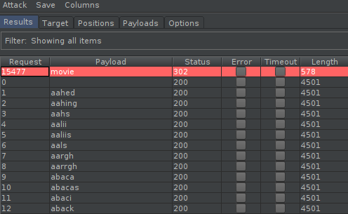

**2. The Username field fuzzing using Username list**

There are times, that we encounter such situations when there is a common password but we don’t know how many users are having the same, and if they are, then what are their usernames.

Therefore, in order to solve this dilemma, burpsuite offers one more great payload list that contains all the common **usernames**. let’s try to use that too.

Back into burpsuite and capture the **login request**, and share it with the intruder. Further, set the injection point to **“random”**.

**Note –**

Here we are guessing all the possible users with their **password as “admin”**.

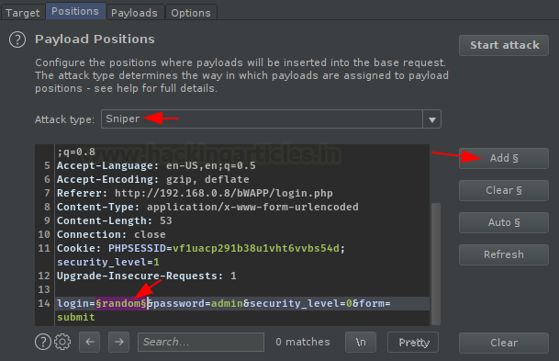

Now, after setting the payload position, its time to enroll for the payload type. Opt the **Usernames** payload list from the **Add from list…** option.

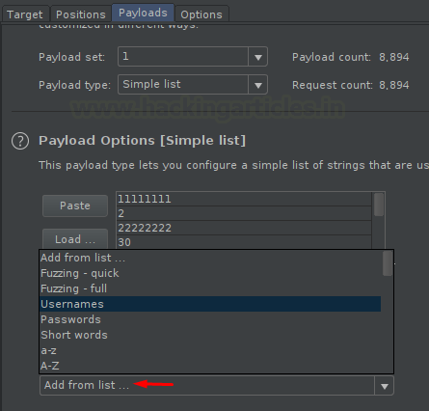

Hit the **“Attack”**button, and there we go. Great !! we got **“ADMIN” and “admin”** as the usernames for the most common password**admin** !!

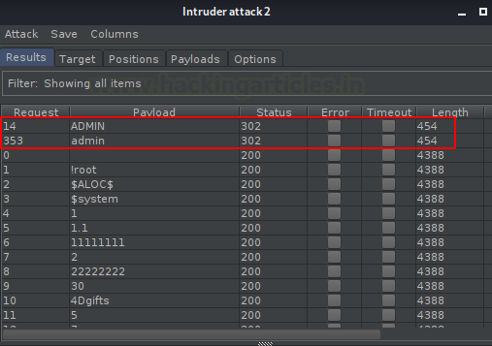

**Fuzzing for SQL Injection**

SQL Injection is one of the most crucial vulnerability one could find for. However, this vulnerability encountered majorly in **the user-input fields**. To learn more about SQL Injection, click [here](https://www.hackingarticles.in/beginner-guide-sql-injection-part-1/).

Burp Suite offers a separate Payload list for SQL Injection fuzzing, but the common fuzzing lists **the quick and the full** also contributes some payloads for SQL Injection, OS Command Injection, Cross-Site Scripting and many more. Therefore for this time, we’ll be using the **Fuzzing – full** list in order to bypass the login portal.

Over with the similar way, let’s capture the ongoing HTTP Request of the **test.vulnweb login portal**, and share it with the Intruder.

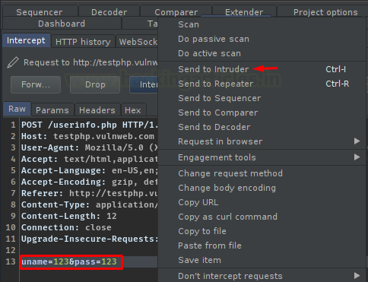

Time to set the positions and the attack type. Here, I’ve **added both the positions** i.e. uname and pass for fuzzing. Along with it, I’ve opted **Cluster Bomb** this time as we’re having two payload positions.

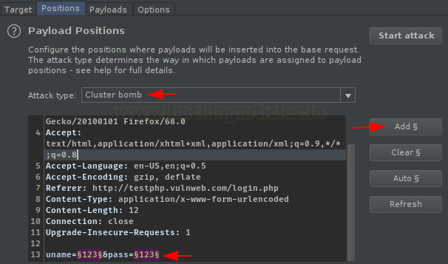

With all this, let’s select the **Fuzzing – full** list for payload **position 1** in order to find the SQL vulnerability within the application.

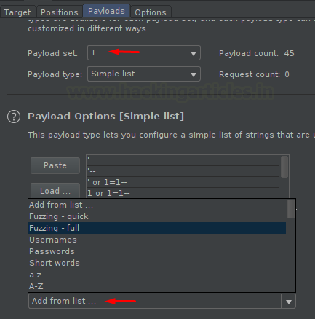

For **position 2** select the same.

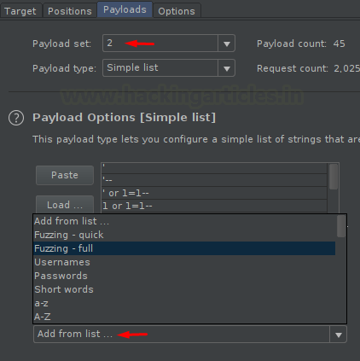

Cool !! From the below screenshot, you can see that we got **some successful responses** as when we alter the **length** section in the **descending** **order**.

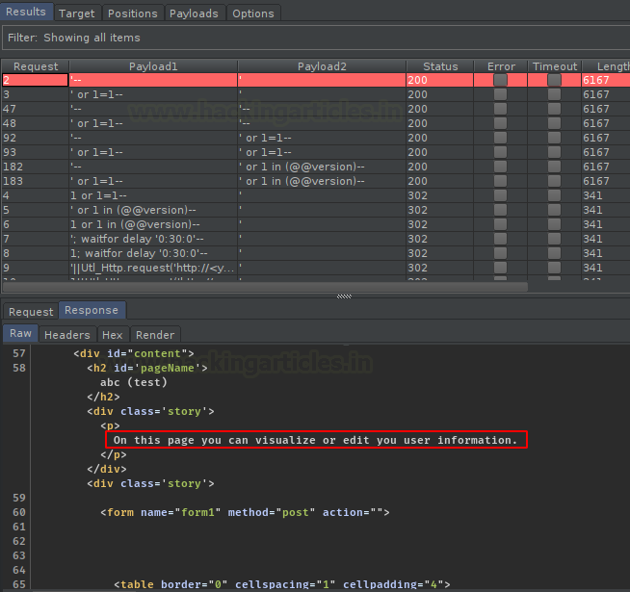

Let’s now check the first captured response in the login fields as **username = ‘–** and **password = ‘**

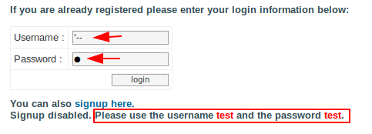

Wonderful !! From the below screenshot, you can see that we’ve successfully bypassed the Login credentials.

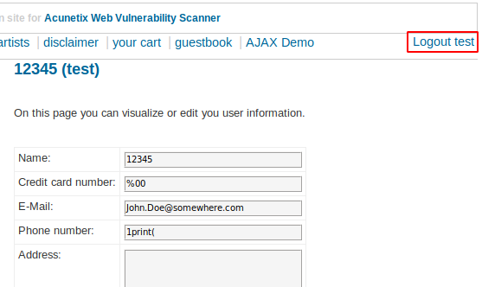

**Fuzzing to find Hidden Files**

There are many web pages that are hidden for the common users but they exist over on a web-application. However, it is quite difficult to determine that, which webpage is giving a **200** Success, **302** Redirection or a **404** Not Found.

Thus, in order to make our work easy, burpsuite drop out with some amazing payload lists which contains almost a number of commonly used webpages that are somewhere hidden inside the webpage.

Back with the bWAPP web-application dashboard, let’s **capture** **an HTTP Request**, and therewith it, we’ll again share it with the intruder.

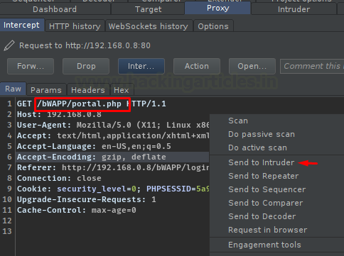

Configuring the payload position to **“portal”**and the attack type to**“Sniper”.**

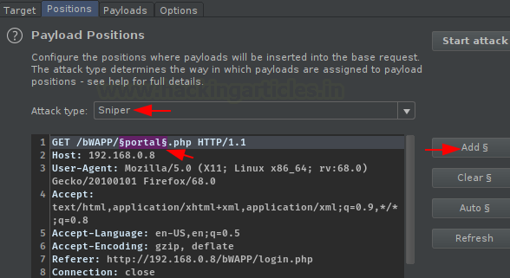

Now, let’s opt the Payload list, and for this time we’ll choose it to **“Filename – short”.**Further, we’ll hit the**“Attack”**button to proceed.

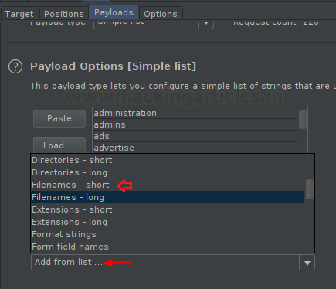

From the below image, we can see that there are a number of files that are unknown to us, let’s check this **secret** one.

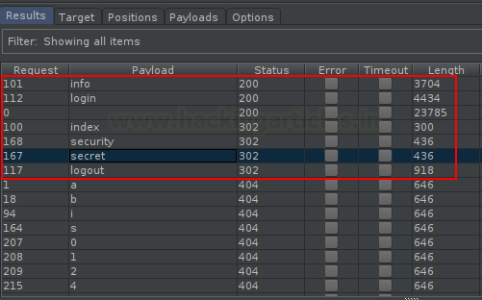

As soon as we manipulate **portal.php** with **secret.php,**we’ll thus land up to an unexpected page that says **“Your secret: Any Bug?”**

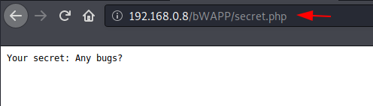

These were the most common filenames that are largely available at web-applications, but what about the unique ones? The **Filenames – long** gives us the possibility to hunt them too.

Now, rather than the **Filenames – short**, let’s opt the **Filenames – long** in the Payload Options.

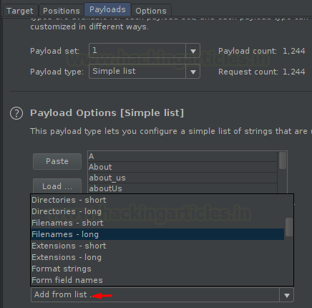

As soon as we hit the **Attack** button, the fuzzing get’s started up and thus within a few minutes we’re presented with the redirecting web pages.

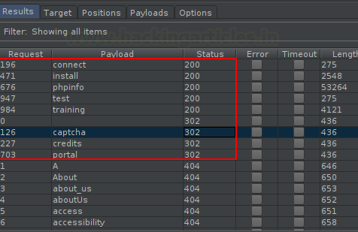

Let’s manipulate **portal.php** with **captcha.php** and let’s check what it offers to us.

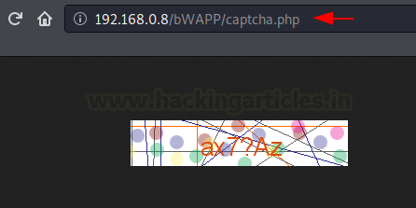

**Fuzz to find Restricted File Upload Extensions**

File upload vulnerability is one of the major problems within web-based applications. Here the **attacker uploads** a **file** **with** some **malicious** **codes** **within** **it,**which **thus** **could** **be** **executed** **on** **the** **server** directly. You can learn more about file upload vulnerability from [here](https://www.hackingarticles.in/comprehensive-guide-on-unrestricted-file-upload/).

There are times when the web-developers blocks up some certain file extensions in order to make their web-applications secure. However, ensuring which extension is blocked by the developer is quite impossible to find out.

But, we can do this task in one of the most simplest way i.e. by **fuzzing. Burp’s Intruder**is having a payload list in-built for this thing too, let’s use it this time.

Initially, over at the file upload option, select a specific file.

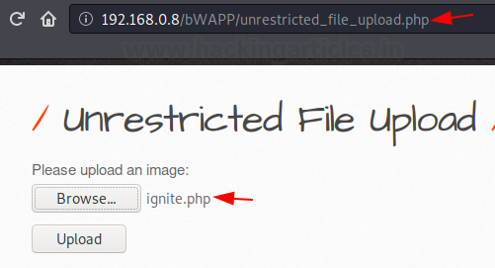

**Capture the request** in a similar way that we did earlier, and share it to the intruder.

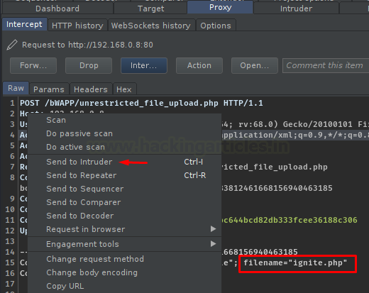

Now, let’s setup Paylaod positions, here we’ll do it with the file extension we’re having.

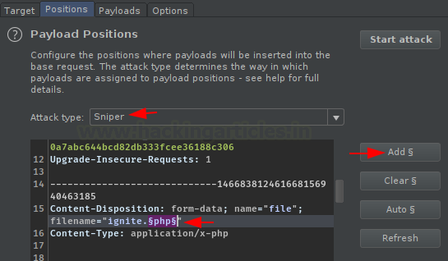

At last, we’re now at our favorite section, i.e. opting the built-in payload list. Choose the **Extensions – short** and hit the **“Attack”**button in order to initiate the fuzzing.

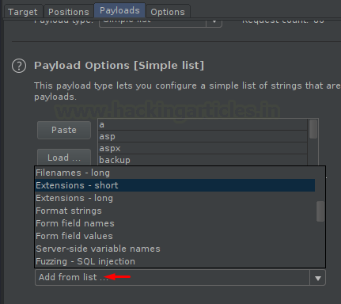

Let’s make the output somewhat simpler to analyze, we’ll use the **grep option** in order to determine which **extensions are blocked** and which are not.

Therefore, at the **Options** tab, scroll down to the **Grep – Match**field, there remove all the predefined keywords and add **“blocked”**over there.

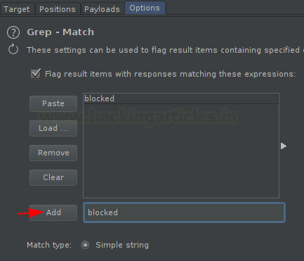

**Note –**

This “blocked” keyword has been added intentionally, as this is the error generated at when a wrong file extension is uploaded. So rather than blocked keyword, you have to use the one that displays as a part of an error message when you upload a restricted file.

As soon as we fire up the **“Attack”**button, we’ll be redirected to the next page where the outputs are displayed. Double click on the **“blocked”**section in order to sort the Request.

Cool !! From the below image, you can see that we got all the **blocked extensions mentioned**. Now with this, we can simply upload any file with an extension rather than the marked ones.

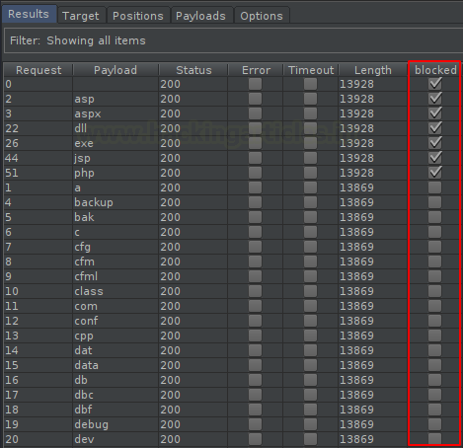

**burp Suite for Pentester – XSS Validator**

[November 3, 2020](https://www.hackingarticles.in/burp-suite-for-pentester-xss-validator/) By [Raj Chandel](https://www.hackingarticles.in/author/raaj/)

You might have used a number of online tools to **detect XSS vulnerabilities** and a few to **validate them** and thereby, at last, with all the generated outcome you try to **exploit the injection point** manually or with **burpsuite’s fuzzing**. But what, if we get all these things wrapped up at a single place. Today in this article, we’ll learn one of the most important burpsuite’s extensions i.e. **XSS Validator**, which thereby **automates the detection and validation** for XSS vulnerabilities in the web-application.

If you’re not familiar with Cross-Site Scripting, then, I recommend, to revisit our [**previous article**](https://www.hackingarticles.in/comprehensive-guide-on-cross-site-scripting-xss/) for better understanding, before going deeper with the implemented sections.

**Table of Content**

* Introduction to Extensions & the bApp Store
* About XSS Validator
* Setting up the XSS Validator
  + Installing the Extension from BApp Store
  + Installing Phantom.js as an XSS Detector
* Fuzzing with XSS Validator
* Customizing the Payload lists

**Introduction to Extensions & the BApp Store**

**Burp Extensions**

You might have heard the term **“Extension”**, probably for a browser, whether it is for chrome or firefox, so what are they?

Extensions are small programs scripted in order to enhance the functionalities over in an application. Thereby, burpsuite offers a feature to **customize its behavior** and to **extend the capabilities** it carries up, whether it is modifying the HTTP requests and responses, customizing the UI or adding the custom Scanner checks, all it wraps up in the form of **Burp’s Extensions**.

**BApp Store**

But where to find such burp extensions ??

Over at burpsuite, we’re having one tab that is build only to manage the burp’s extensions and i.e. the **Extender**. The Extender tab helps us to manage everything related to an extension, but in this, there is a sub-tab too, called the **BApp Store**, which is basically a **hub that contains** a variety of **“Burp Extensions”**.

There at the BApp store, we can **view the list of available BApps**, **install a specific one**, and even we can **submit a user rating** for those we’ve already installed.

However, some extensions might have been removed from the BAPP Store or even we need to set up ours in the burpsuite. Therefore, for such scenarios burp provides us with an opportunity to **manually install an Extension** there.

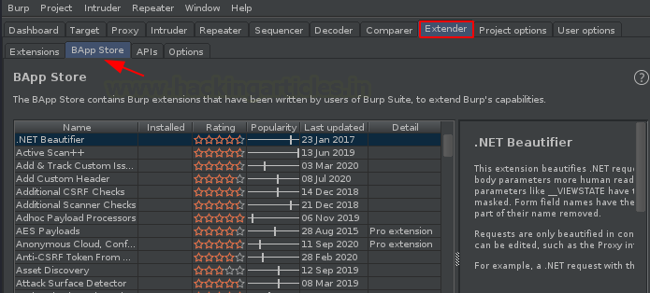

**About XSS Validator**

XSS Validator commonly termed as **Burp Intruder Extension** is designed to detect and validate the most crucial Cross-Site Scripting vulnerability, which **works collaboratively with the burp’s intruder** in order to capture a successful XSS drop out.

John Poulin the author of this extension, developed it in 2017 with an intension to automate the detection of XSS vulnerabilities in the vulnerable web-applications.

This extender is most common due to its **minimal false positives** and the **in-build payload list,**where every payload is bound up with a trigger value of **“f7sdgfjFpoG”**.

Although being a validator, this extension also contributes as a **Detector**. However, in order to make the attack successful, the XSS Validator **sends** **responses to a locally-running XSS-Detector server** i.e. either Phantom.js and/or Slimer.js

Let’s explore the installation and the attack scenario of this XSS Extension in order to be more precise about its working.

**Setting up the XSS Validator**

**Installing the Extension from BApp Store**

As we’ve already discussed, that the BApp store carries up a number of extensions within itself, and thus being the most common, XSS Validator can be found there.

Thereby, this extension can thus be installed up with some simple steps.

Over at the tabs provided at the Burp Suite monitor, navigate to the **Extender tab**, opt the **BApp sub-tab** there, such in order to check the list of the provided extensions.

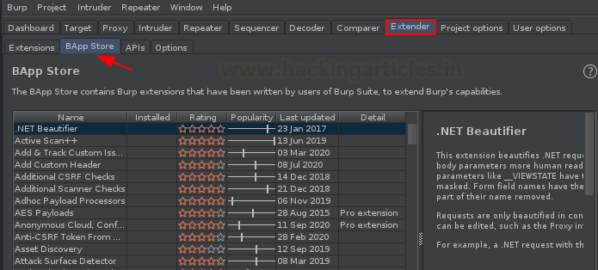

Let’s scroll down until we reach the end of the list, and with that, we’ll get our extension placed.

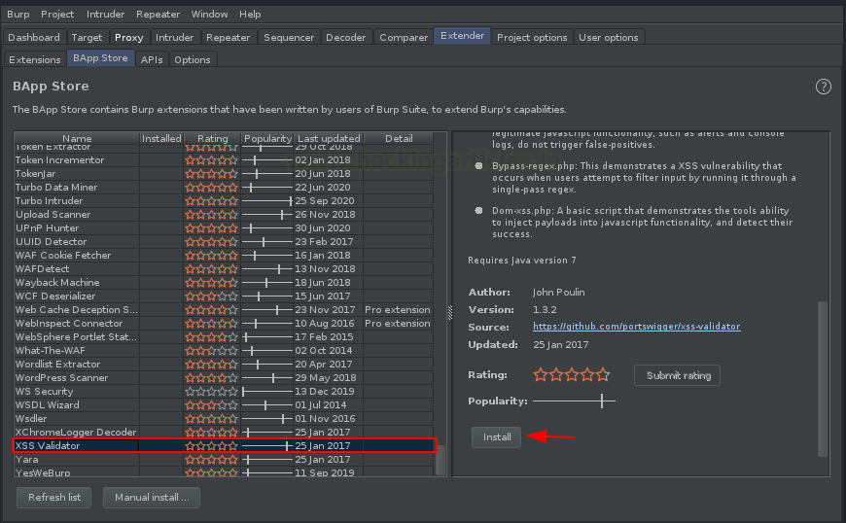

As soon as we hit the **install** button, it will start downloading and within a few minutes, we’ll have our **extension added**at the tabs panel as **“xssValidator”.**

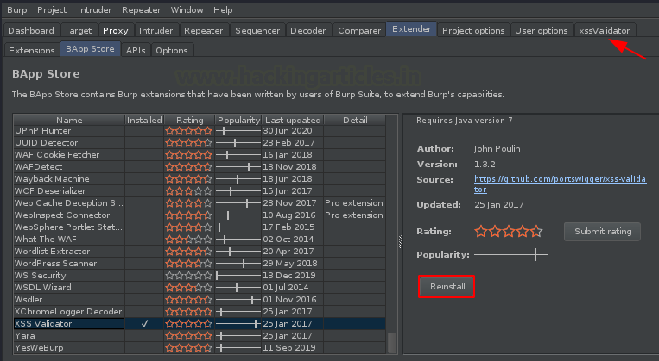

Let’s click and check what it offers to us.

Over at the right side of the below image, we can see, a list with a number **payloads is offered** to us, and along with it, at the left side, we got the **Grep Phrase** which is bound to trigger every payload added there. Above it, we’re having the **PhantomJs Server setting**, that we’ll use it in the future scenario.

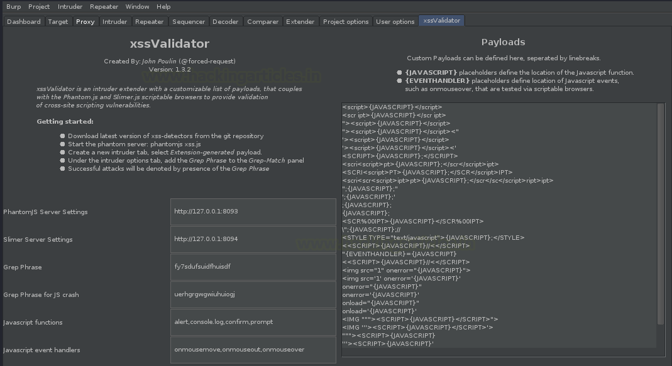

**Installing Phantom.js as an XSS Detector**

You might be wondering, about what is this Phantom.js and why we are installing it ??

Phantom.js is a command-line tool, basically a **headless browser**i.e. it does not contain any GUI interface, which thus runs itself silently in the background.

There are times when the **DOM-based XSS exists** and if we try to hit that, it executes up in the background but **does not get captured by the browser**, therefore in order to reduce this **false-negative** and to detect every possible XSS, we’re thus installing this **Phantom.js**. You can download it from [**here**](https://phantomjs.org/download.html).

Now, in order to integrate our XSS validator with this Phantom.js, we need to **download the xss.js** file which thus could be done from [**here**](https://github.com/nVisium/xssValidator).

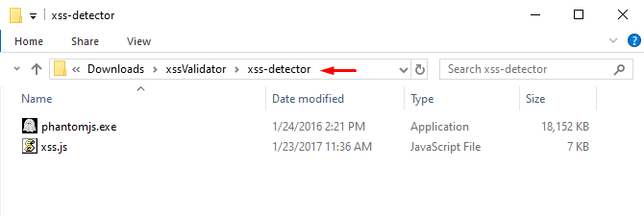

As soon as we do so, we simply need to **move our Phantom.js exe**to the XSS detector directory.

And now with all this, navigate the directory in the command prompt and execute the following command in order to initiate the server.

|  |  |
| --- | --- |
| 1 | phantomjs.exe xss.js |

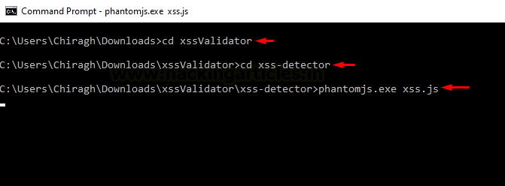

Let’s check whether our server is running or not by executing

|  |  |
| --- | --- |
| 1 | http://127.0.0.1:8093 |

Cool !! From the below image, we can see that our detector server has been configured successfully.

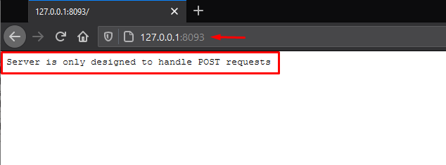

**Fuzzing with XSS Validator**

I guess you might be clear with installation section, lets’s now do a **quick fuzzing** on the search field over at **test.vulnhub** with the XSS Collaborator.

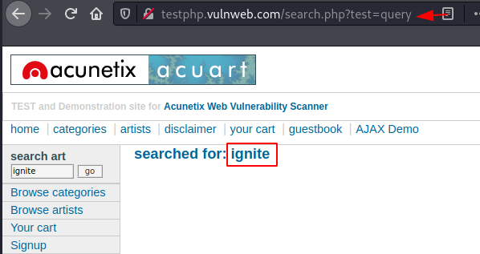

We’ll capture the ongoing **HTTP Request** and thus will share it to the **Intruder**directly.

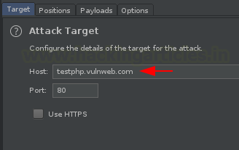

Time to set the payload position and the attack type, navigate right to **Positions tab**, select and hit the add button to set **“ignite”** as the injection point.

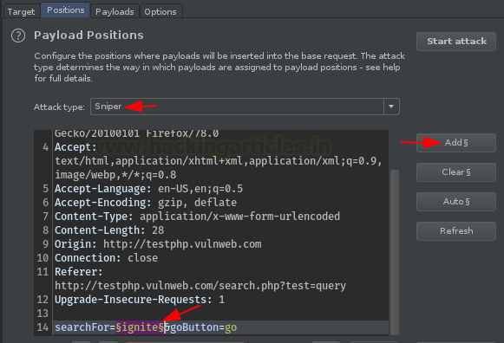

Now, here comes the most important part, rather than simply adding the payload file, we need to first set the payload type to **Extension-generated**

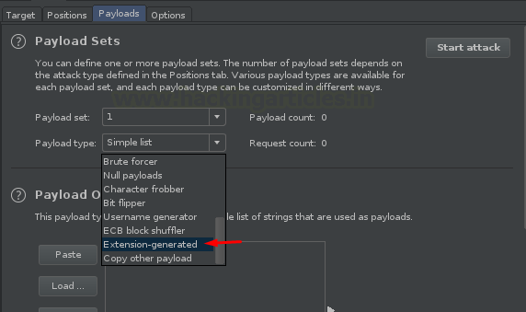

And with this, we now need to select our **generator**as**XSS Validator Payloads** from the Payload option.

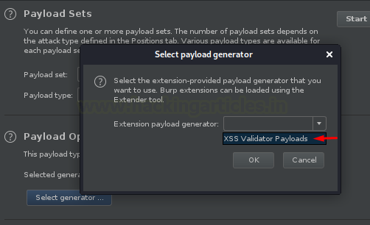

Let’s uncheck the Payload Encoding option for this time.

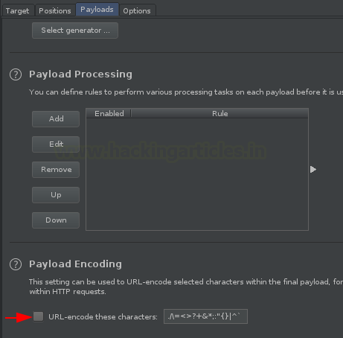

Now back from the XSS Validator, let’s copy the **Grep Phrase,**that triggers back to every subsequent payload.

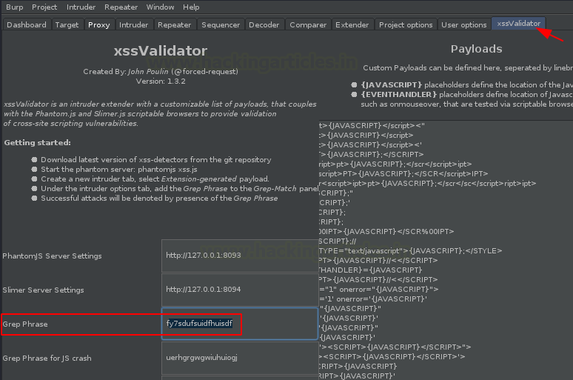

So, we are almost done, we just need to set copied phrase at the **Grep Match** in the **Options** tab in order to flag the result that **encounter a successful XSS**.

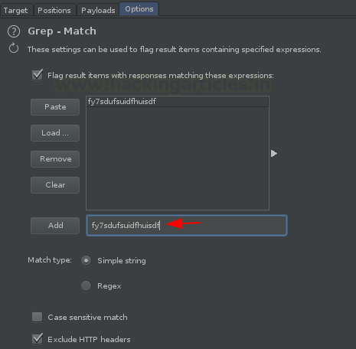

At last, Check the **“Search responses for payload strings”**box and fire up the **Attack** button.

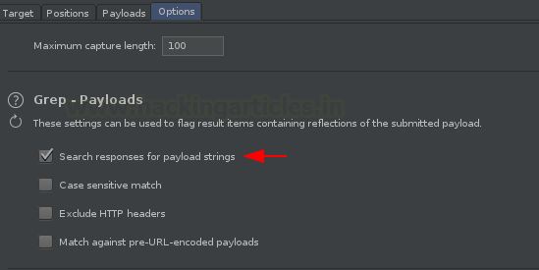

And there we go, from the below image you can see that almost all of our payloads got triggered out with a successful flag.

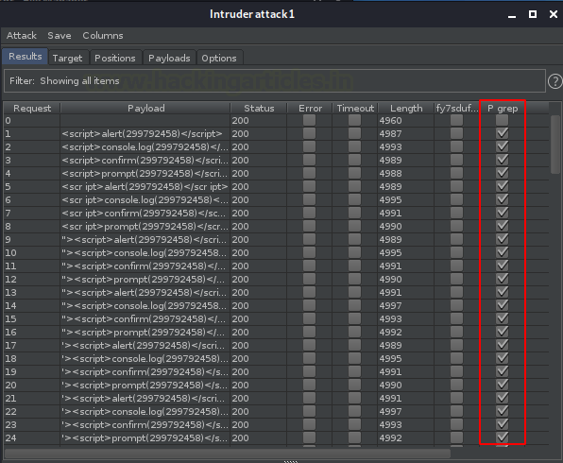

To be more precise, let’s check its output in the browser. **Right-click** on any **successful request**, opt the option to **“Show response in the browser”** and **copy the generated URL** in thus paste it in the browser.

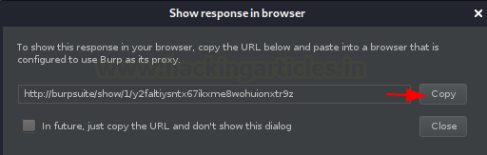

Great !! It’s working, our payload hit at the correct destination.

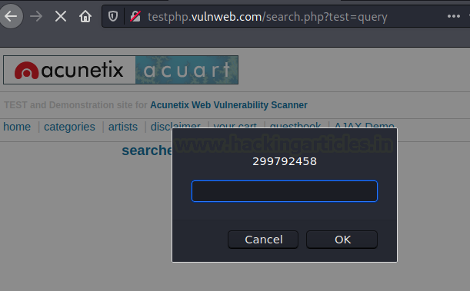

Wait, but what about the phantom.js, did it captured something ??

As soon as the attack starts up, the phantom.js tries to test every XSS injection with the HTTP requests shared by the XSS Validator.

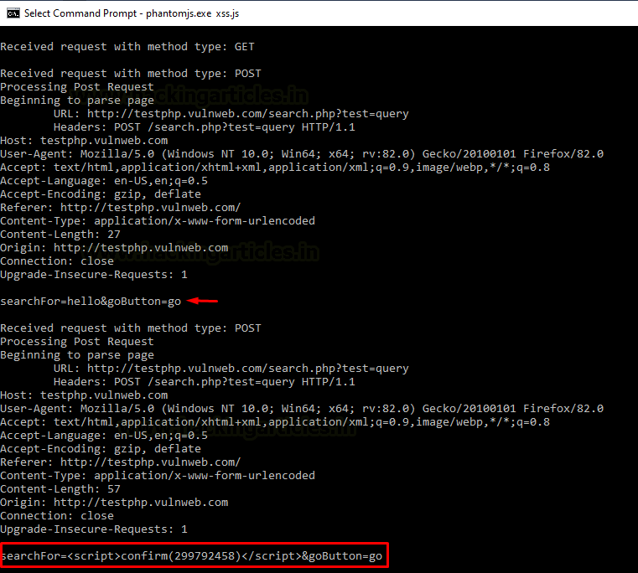

**Customizing the Payload lists**

A number of payloads come pre-installed with the XSS validator, but what if, if we want to add our customized payload??  Yes, we can do so by simply **typing or by pasting the payload(s)** directly in the **Payload option** provided at the right-hand side of the extension.

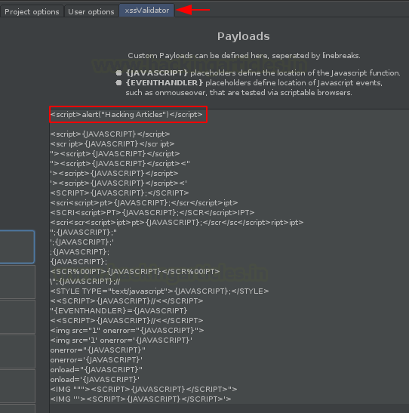

Let’s check whether this newly added **payload is triggering the grep phrase or not**. And for this, let’s do the fuzzing again.

From the below screenshot, we can see that the grep phrase has been successfully triggered out by our payload.

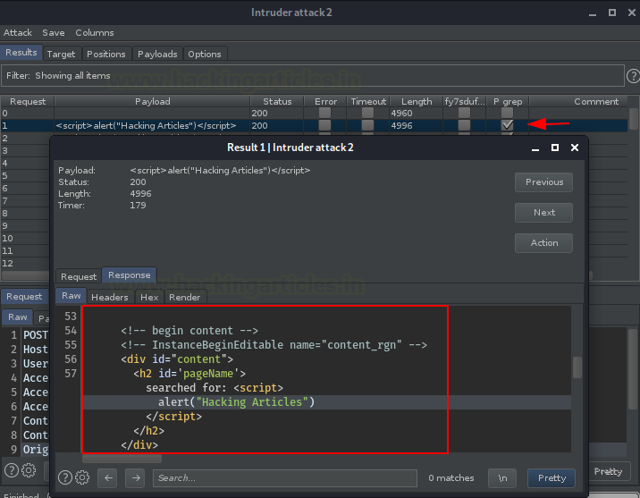

Great !! From the below image, we can also see that the payload is executing as we desire for.

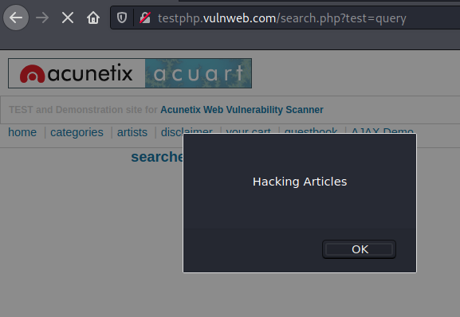

# Burp Suite for Pentester – Configuring Proxy

[November 2, 2020](https://www.hackingarticles.in/burp-suite-for-pentester-configuring-proxy/) By [Raj Chandel](https://www.hackingarticles.in/author/raaj/)

Burp Suite, you might have heard about this great tool and even used it in a number of times in your bug hunting or the penetration testing projects. Though, after writing several articles on web-application penetration testing, we’ve decided to write a few on the various options and methods provided by this amazing tool which thus could help our readers in their further penetration testing analyses.

Today, in this article, you will experience the complete installation and configuration of this Port Swigger’s product from its different editions to setting up proxies for **web** and **android applications**.

### ****Table of Content****

* Introduction to Burp Suite
* Burp Suite Installation
* Configuring Burp Proxy for Web Applications
  + Manual Configuration
  + Using Firefox Extension
* Configuring Burp Proxy for Android Applications

### ****Introduction to Burp Suite****

Burp Suite commonly termed as **“Burp”**, is a **Java-based web-application** penetration testing framework, which is often adopted widely by professional enterprise testers or bug bounty hunters.

Burp Suite is a **collection of tools** that seamlessly work together to accomplish the entire penetration testing process, from setting up the target and analyzing the application with the known vulnerabilities, by giving the opportunity to find and exploit other security vulnerabilities in the application.

Burp Suite is an **intercepting proxy**which acts as a man-in-the-middle between the target web-application and the webserver. Here, it captures the ongoing HTTP Requests, such that the penetration tester or the bug bounty hunter could easily pause, replay and even manipulate them before reaching the destination server.

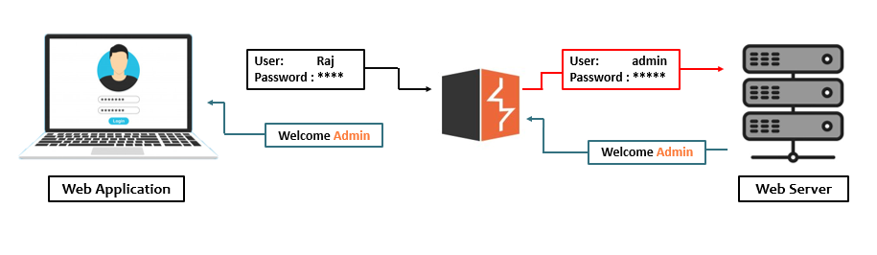

Port Swigger who is thereby responsible for the maintenance and the development of this great tool offers a number of editions for it i.e. –

* **Enterprise**
* **Professional**
* **Community**

The Community and Professional editions are the most common, thereby let’s compare these two only, in order to be more precise.

The **Community version** was once termed as the **Burp Suite’s Free Edition,**although it doesn’t offer several options, but it carries up everything that we need for the manual penetration testing whether it is capturing the request, crawling, or manipulating the request in the repeater.

However, **the Professional edition**has all the functionalities enabled, from the passive to active scanning, saving the projects, usage of the bApp Store and many more. All its tools make the testing somewhat faster and effective as it even drops us the opportunity to use the build-in payloads for fuzzing and brute-forcing by increasing the number of threads to make the fuzz faster. Even the professional edition offers some additional tools such as the burp collaborator and many others.

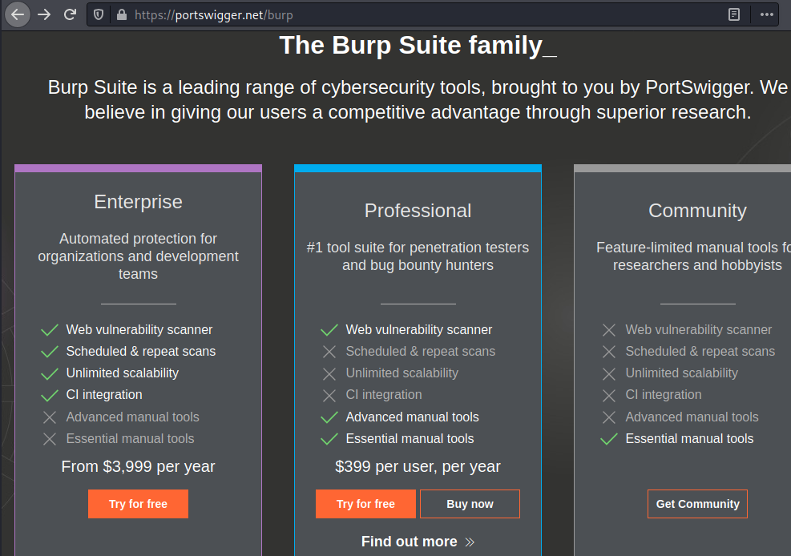

### ****Burp Suite Installation & Configuration****

Until now, you might have understood about, what is Burp Suite, how it works and what are the different variants do Port Swigger offers. So, let’s take a deep dive and create an account on Port Swigger and **download the Professional edition**of this great tool. As we’ve already discussed, that most of the options are not available in Burp’s Community edition, thereby we’ll be using this professional edition in all the next further articles. But still, you can opt the community version, to get familiarity with the product before purchasing or either you can choose the trial option for the Professional edition too.

Let’s Start !!

Before initiating the execution, let’s download the prerequisite i.e. “Java”, its latest version from [**here**](https://www.java.com/en/download/windows_offline.jsp).

Now, burp suite comes with two modes of execution – one as an executable and second as burp at the command line.

However, burp as an **executable** is quite simpler as it requires a **double click only** **to initiate up** and is majorly for the windows users; but the non-windows users need to execute burp over through their command lines i.e. with **java -jar** followed with the **burp suite’s downloaded jar file**

java -jar burpsuite_pro_2.0.jar

In both the startup sections described, we’ll be welcomed with a splash screen. This splash screen depicts which edition we’re using and thereby drops out the corresponding options for it.

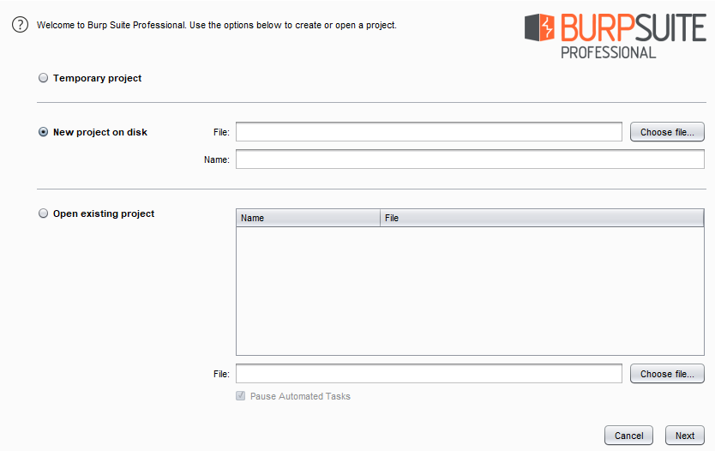

From the above image, you can see that we got several sections for the **project files to begin with**, either by opting the **Temporary project**, or starting with the **New project on disk**, or even by resuming by**opening the existing project.**

However, in the community edition, we’ll only get the option to start with a **temporary project only.**So let’s begin with a temporary project for this time.

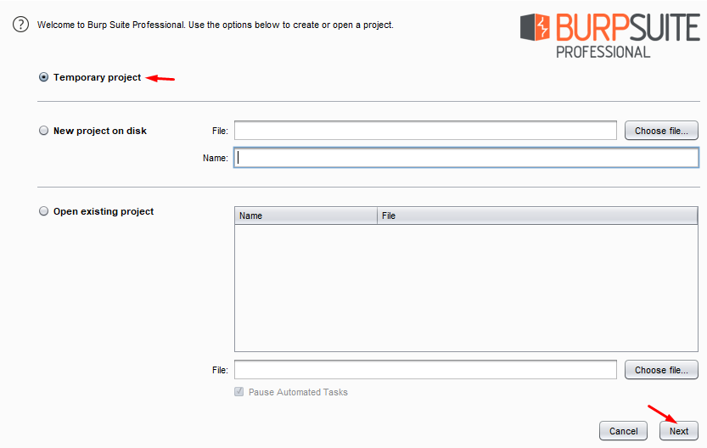

As we hit the next button, we’ll be redirected to the next splash screen asking us for the configuration we would like to use. Although as we’re not having any specific, let’s choose the default one and hit the **Start Burp** button.

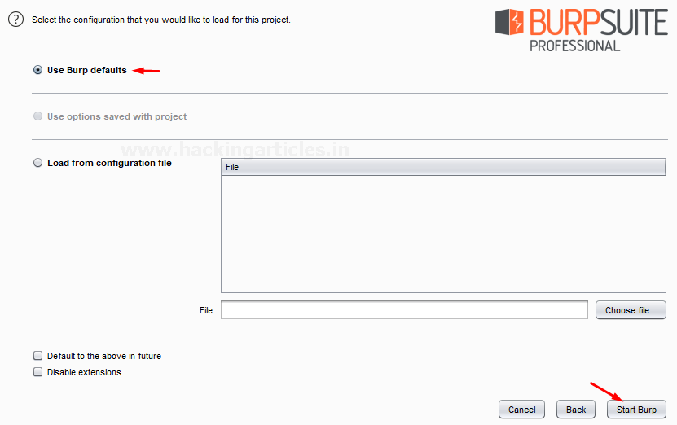

### ****Configuring Burp Proxy for Web Applications****

As soon as Burp Suite initiates up, we’ll get redirected to its **dashboard**, where we got to see a number of **pre-defined tabs** that are developed for a specific purpose.

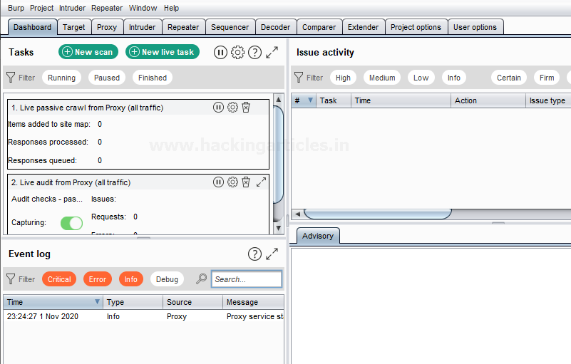

We’ll check all of these tabs in the later section, but first, let’s **configure the proxy** such that our Burp could intercept and capture the browser’s request. And for this, opt the**proxy tab** and thus then move to the **Options sub-tab**.

Over there, you’ll find the default configuration as – the **IP Address** bound to **127.0.0.1** and the **port with 8080**. If you didn’t find such, hit the Add button and configure the same.

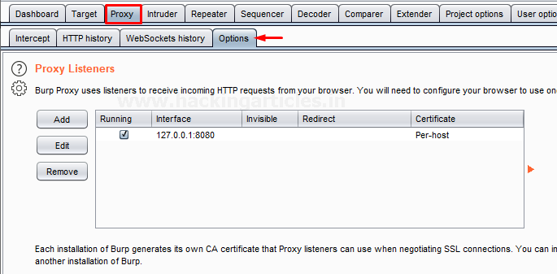

#### ****Manual Configuration****

Now, in order to capture the request, we need to configure our browser with this same configuration. Let’s do it manually with the following simple steps –

1. Boot inside your Firefox browser and go to **Options**.
2. There, in the **General tab**, scroll down to the Network Settings and hit the **Settings button**.
3. Over in the Connection Settings, opt the **Manual proxy configuration** and type in the IP address as **127.0.0.1** with the port as **8080**.
4. Select **“Also use this proxy for FTP and HTTPS”** checkbox:

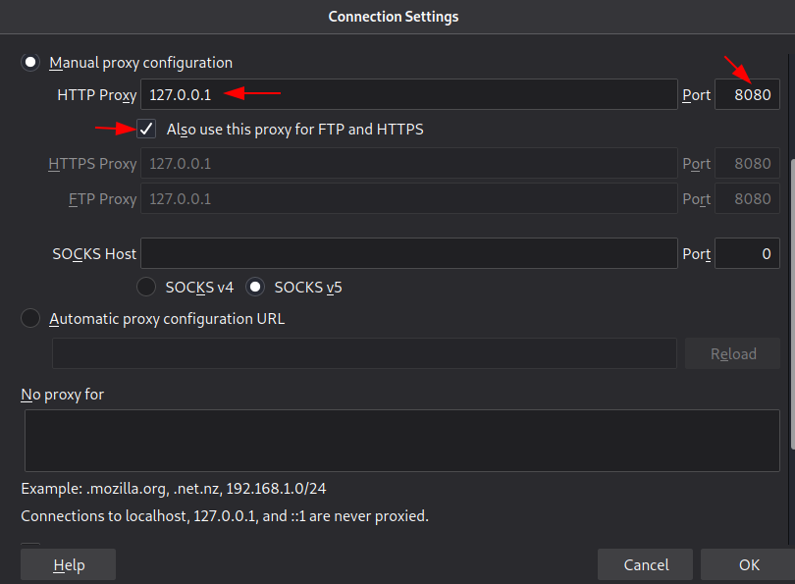

Great, we can thus now capture the HTTP traffic, but wait, **what about the HTTPS one?** Although we’ve configured the proxy for that too, but still our burp would not intercept the HTTPS Requests.

Thereby, in order to capture such traffic, we need to **establish trust between Burp, the target’s web application and the client’s browser**. And for this, we need to install the PortSwigger’s certificate as a trusted authority within the browser.

1. Back into the burpsuite, over in the proxy tab, hit the intercept section and check whether the **Intercept button** is labelled **On** or **Off**, if disabled, **enable it to capture** the further requests.

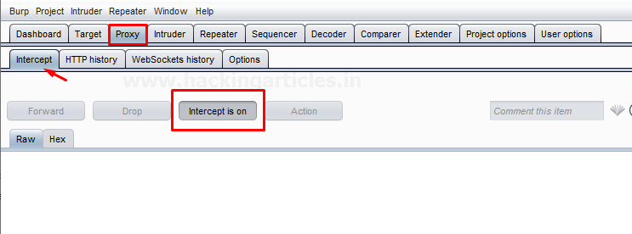

1. Open the Firefox browser and redirect it to **http://burp** There, hit the **CA Certificate**in order to download the PortSwigger’s Certificate.

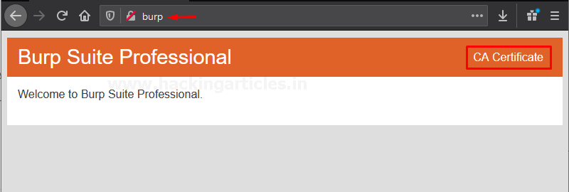

1. Back into the options section in firefox, click **Privacy & Security** on the left-hand side, and scroll down to **Certificates** Click the **View Certificates…**button in order to add up the downloaded certificate.

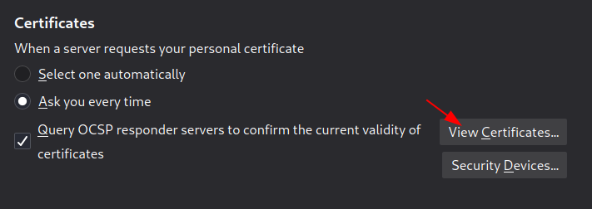

1. Move to the **Authorities tab**, click **Import** and thus select the downloaded **Burp CA certificate file.**

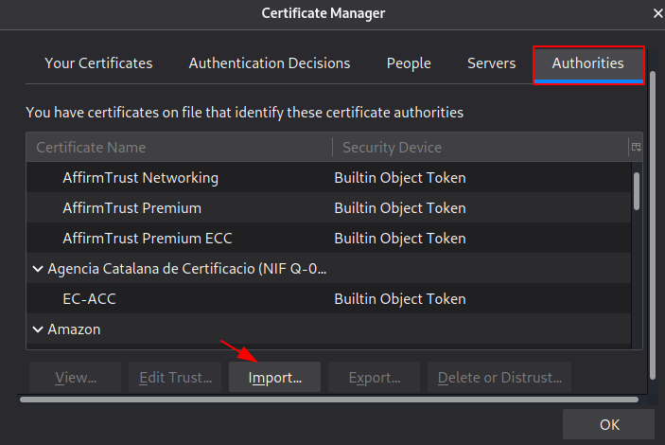

1. As soon as the certificate loads up, a **dialogue box** will get prompted up, there, check the**Trust this CA to identify websites** box, and fire up the **OK**button, in order to finish the configuration.

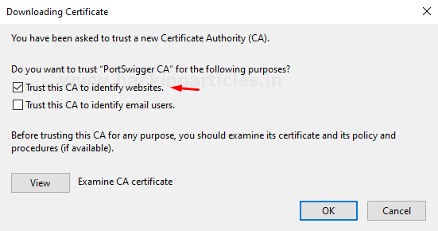

Time to capture up the ongoing HTTPS Request. With the **intercept**option**ON** and the **proxy enabled** in the browser, search [https://www.google.com](https://www.google.com/).

As soon as we hit the search button, our request will get pause at its **first checkpoint**i.e. our burpsuite.

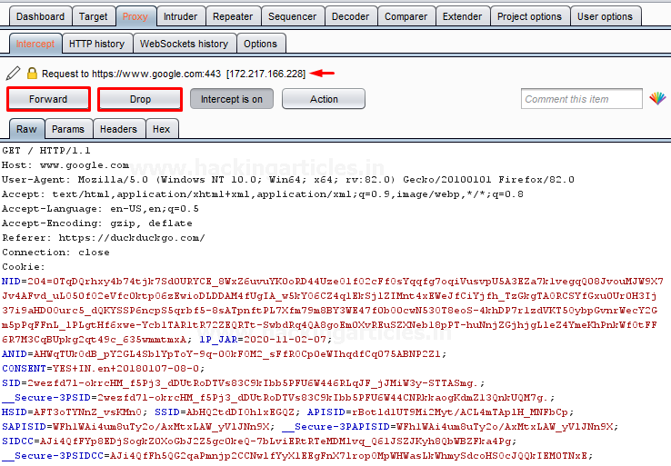

Now with this, it’s our choice about what we want to do with this request, we can **Forward** the same or **Drop** it here only i.e. it will never reach to the web server for further processing and even we can also **Manipulate this request** before reaching to the server.

So for this time, let’s forward it directly. Thereby, with every subsequent successful captured request, we’ll get the same options.

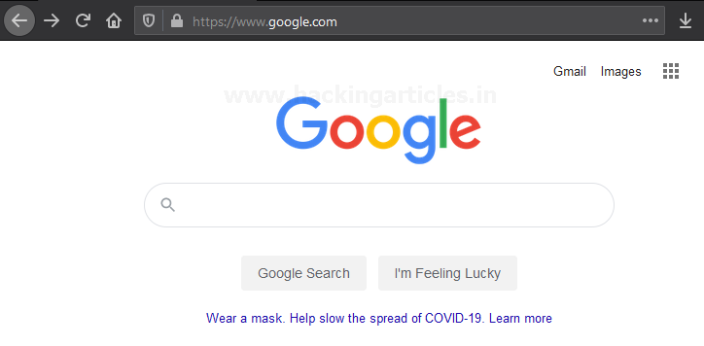

#### ****Configuring Using Foxy Proxy****

Isn’t the procedure for **setting up a proxy** in the browser is too long?? As whenever we need to capture the request, the **proxy needs to be enabled**, and if the burpsuite isn’t capturing the request the proxy should be disabled in order to surf the internet seamlessly.

Therefore, with this ease to set up the proxy, we’ll be using one of the greatest firefox plugins i.e. **Foxy Proxy,**this will give us the option to enable and disable the proxy service whenever we wish too, directly from the webpage we’re surfing at.

You can simply install and add this plugin from [**here**](https://addons.mozilla.org/en-US/firefox/addon/foxyproxy-standard/).

As soon as you hit the **Add to Firefox** button, a dialog box will get popped up asking you for the confirmation, again click on the **Add**button and within few minutes you’ll get redirected to the Foxy proxy’s about page.

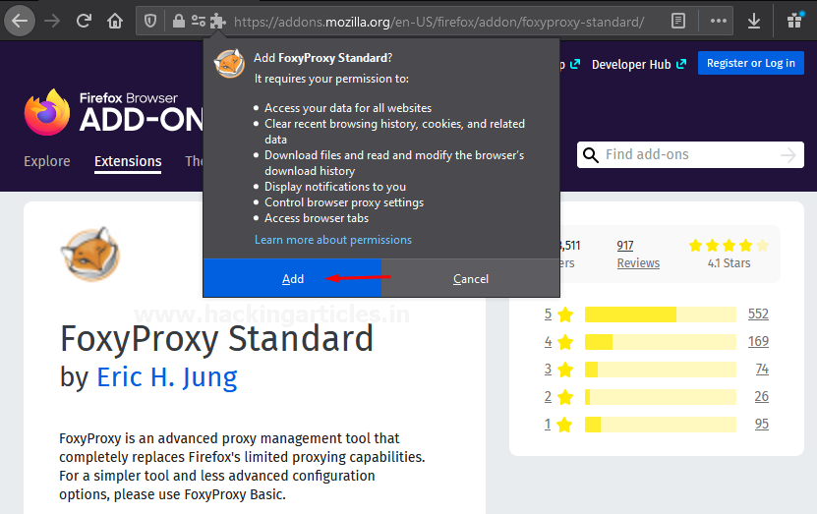

Now, over at the right of the search bar, you’ll be able to see the newly added plugin, click it and select the **options** tab.

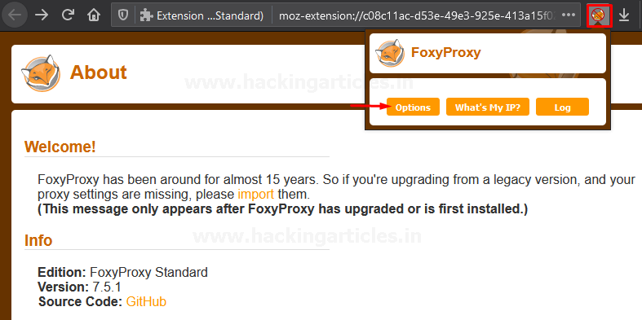

Time to **configure the proxy service**, we’ll do it as we did it over in the manual proxy setup, set the IP address to **127.0.0.1** and the port to **8080,**and with the successful configuration, hit the **save** button.

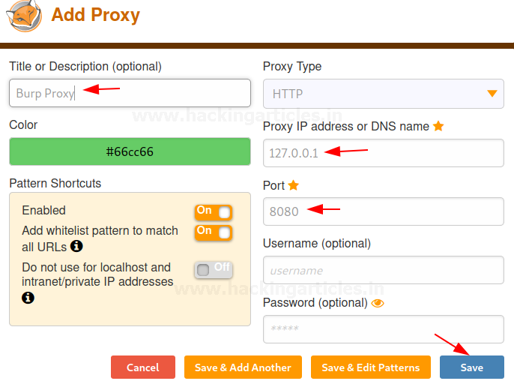

Therefore, with this, we can now enable and disable the proxy service directly from the web application’s homepage. Now enable the foxy proxy and turn ON the intercept option for capturing the HTTP request of the web page as done above.

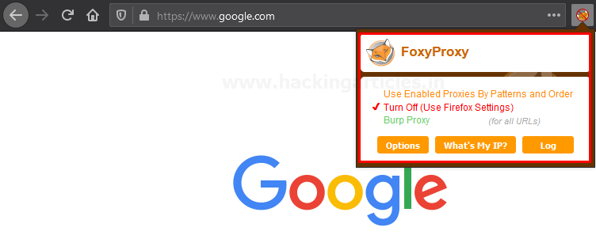

### ****Configuring Burp Proxy for Android Applications****

Android Penetration Testing is the process of analyzing and testing the **android applications** in order to **find security issues** and **loophole vulnerabilities** in them.

However, in order to test such applications, the penetration testers or the bug bounty hunters sometimes need to intercept the travelling Requests, and thereby burp suite plays a major role into that.

So, let’s learn how to configure a proxy in the mobile applications in order to capture the ongoing requests in burpsuite.

For the instance, we’ve used **Genymotion**(an android emulator) and there we’ve even installed up an android device within it. You can set up the same from [here](https://www.hackingarticles.in/android-pentest-lab-setup-adb-command-cheatsheet/).

Now, back into **Burp Suite**, switch to the **Proxy** tab and hit the **Options** sub-tab there. Click on the **Add** button in order to set up a **new interface.**

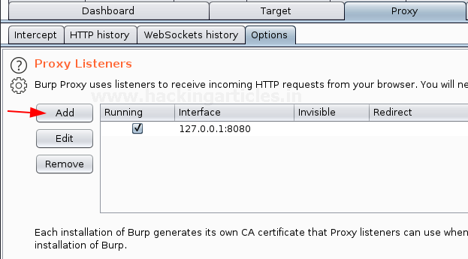

As soon as we do so, a dialog box will prompt up asking for the **binding Port** and the **IP Address.**Here, I’ve used the **port number as 8081** and rather than assigning a specific IP address I’ve initiated it to **All interfaces.**

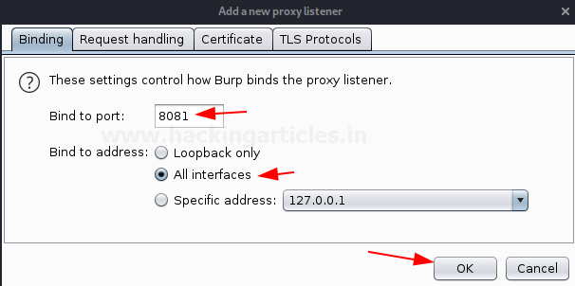

Great, from the below image you can see that our interface has been added up and it is **Running**.

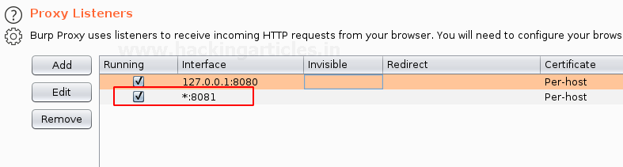

Now, its time to configure the Android device, such in order to intercept the ongoing requests.

Over in our android device, let’s navigate to the **Network and Internet** option in the **Settings**.

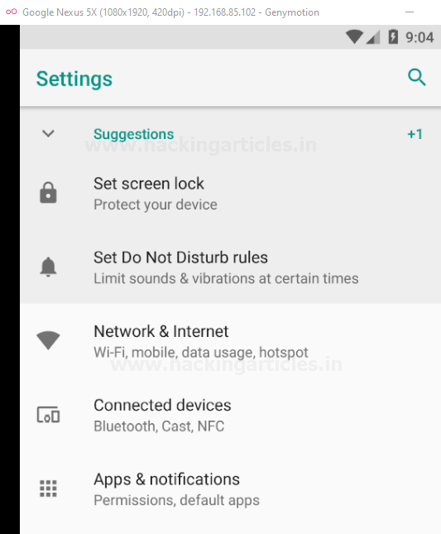

There at the Wifi option, let’s click the connected wifi and hold it until it offers further options for us.

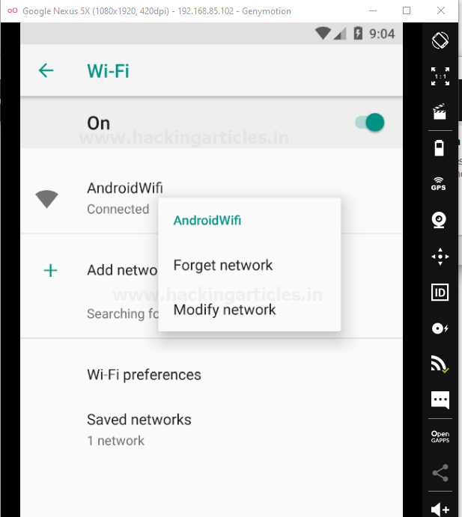

Click on **Modify network** and over in the **Advanced Options,**opt the **Manual proxy** configuration

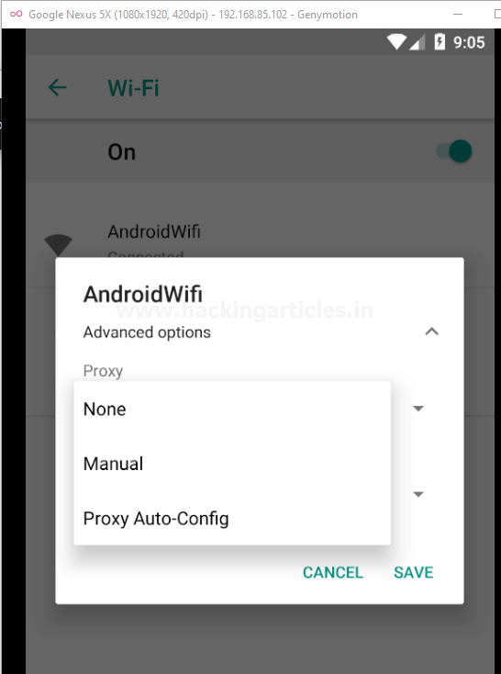

As soon as we hit the **Manual**option, we’ll get redirected to the proxy configuration section where we need to provide the **Proxy hostname** and the **Proxy port**.

Thereby for the Proxy hostname you need to check the **IP address of your window’s machine** (where the burpsuite is running), as over in our case, it is 192.168.1.9; and over in the Proxy port, we need to enter the **port** that we used to **bind the burp’s proxy**i.e. **8081.**

Hit the **Save** button and there we go.

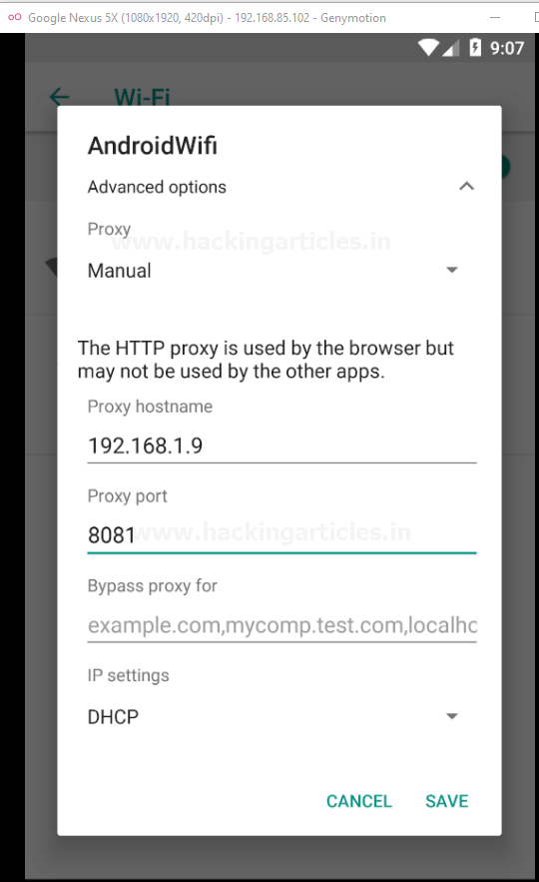

Now, similar to the web applications, our burpsuite will only listen to the HTTP requests made, thereby to intercept the HTTPS requests we need to install the certificates into this android device too.

Over with the same option, surf [**http://burp**](http://burp/) in order to download the certificate.

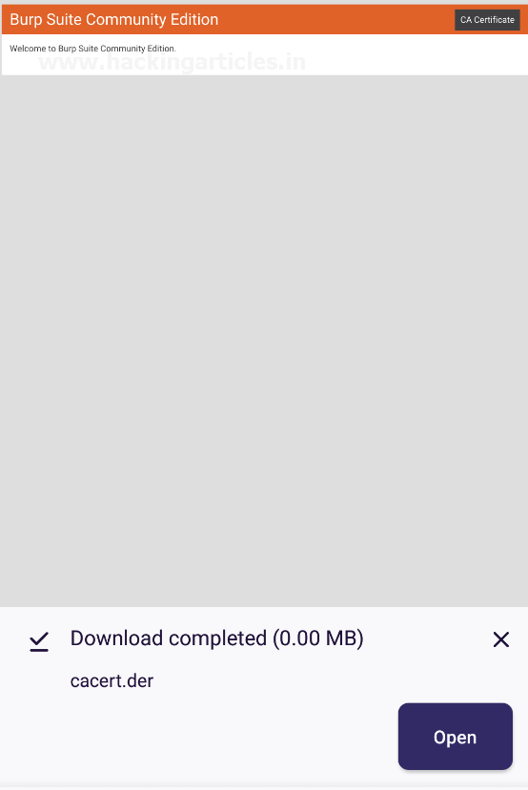

Now, for this, we need to rename the certificate file from **“cacert.der”** to **“cacert.cer”.**

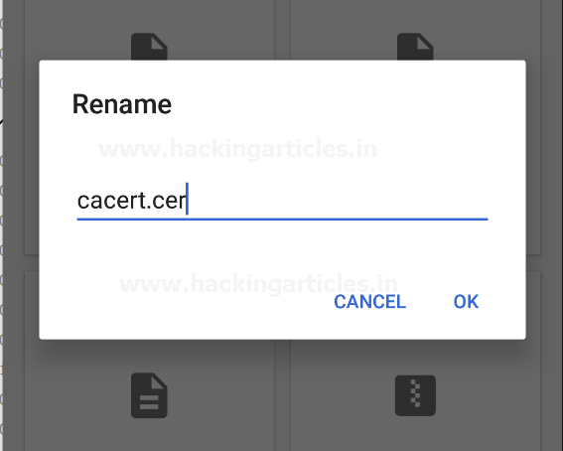

Cool !! Now, back into the device **settings**, navigate to **Security & Location ->** **Encryption & Credentials,**over there hit the **Install from SD card**option to install the CA certificate.

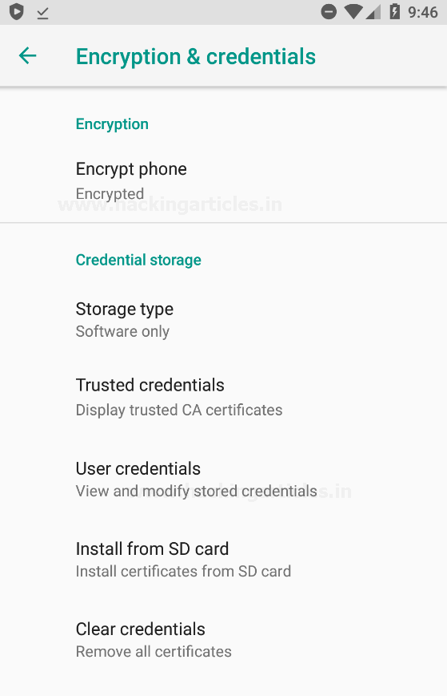

The follow-up to the path where your **certificate was downloaded** and as soon as you select the file, a pop-up will drop up at the screen asking to name the certificate, as in our case we named it to **cacert**.

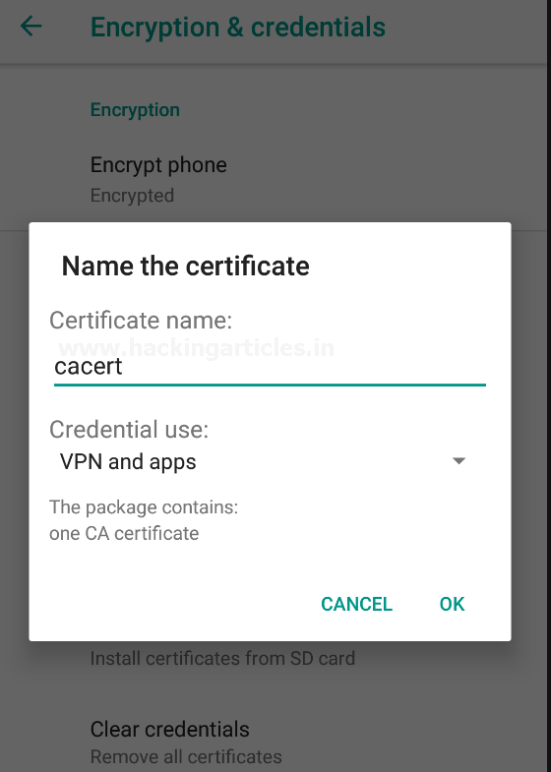

**Great!!** As soon as we hit the **OK** button, we’ll thus be able to capture and intercept the HTTPS Requests too over in our Burp Suite.

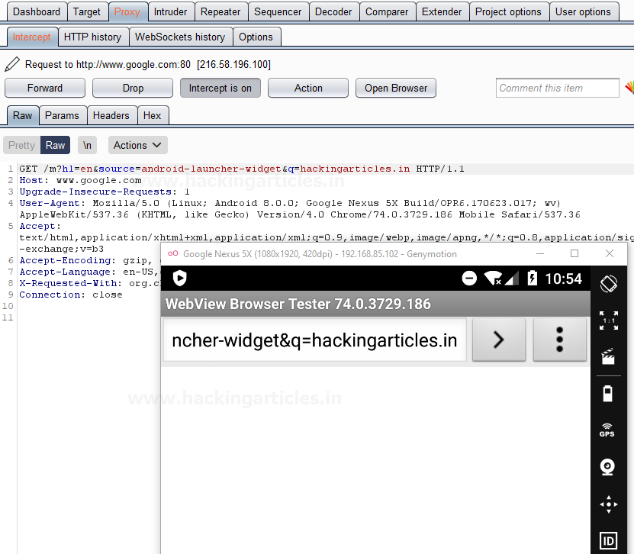

**Burp Suite for Pentester: Burp Collaborator**

A number of vulnerabilities exist over the web, but the majority of them are not triggered directly as they do not reproduce any specific output or an error. So, is the output or the error is the only solution to determine that the vulnerability exist or not?

So, today in this article of the series of Burp Suite for Pentester, you’ll learn how the out-of-band or the blind vulnerabilities are detected with one of the most amazing features of burp suite i.e. with Burp Collaborator.

**Table of Content**

* Introduction to Burp Collaborator
* Detecting vulnerabilities with Collaborator Client
  + Blind Remote Command Execution
  + Cross-Site Scripting Detection
  + Blind XXE
  + Server-Side Request Forgery
  + Fuzzing for SSRF Detection

**Introduction to Burp Collaborator**

Burp Suite’s Professional edition offers one of its best features as **“Burp Collaborator**” to determine or detect vulnerabilities that try to interact with external services but do not cause any difference in the content of the application’s responses when specific payloads are injected.

However, in simpler words, this collaborator is basically a **network service** used by Burp Suite to determine the **out-of-band vulnerabilities** by injecting payloads to the application and then waits for the response to analyze their unusual behaviours

Being a network service, this Burp Collaborator works seamlessly with a **server and a client** in order to fetch the hidden responses made by the application. So, let’s take a deep dive with what these server and clients are, and where we can find them.

**Burp Collaborator Server –**The burp collaborator server is a service used by Burpsuite while auditing or testing vulnerable web-applications in order to find sections that interact with an external system. However, this Burp server functions only to responds the interaction it receives from the other systems, by continuous polling out at its client to determine whether any of its payloads have triggered interactions or not.

By default, Burp uses the **public Collaborator Server** provided by PortSwigger, but it even offers the feature to host or **deploy a private collaborator server** too. Thereby in order to modify the server configuration, simply head to the **Project option** and then switch to the **Misc tab** there.

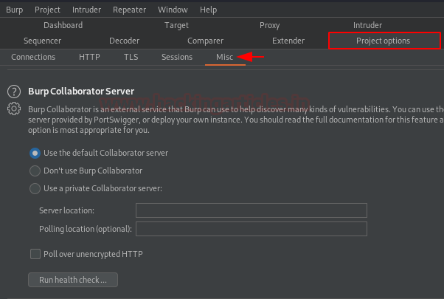

However, for this section, we’ll be using the default collaborator server. But before following up further, let’s do a **health check**by hitting the **Run heath check** button in order to be sure that our collaborator is working properly.

Great from the below image we can see that our collaborator server had passed all the tests.

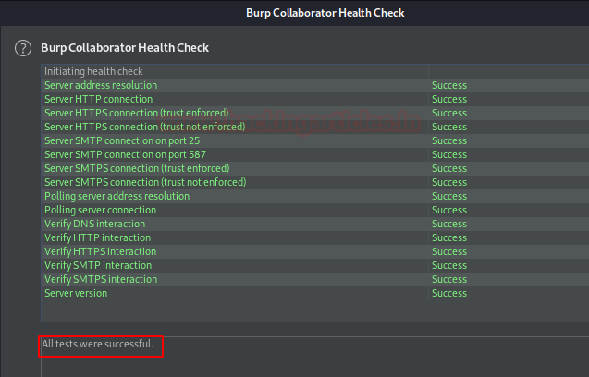

**Burp Collaborator Client** – Burp Collaborator Client is a tool to make use of the Collaborator server during manual testing. This collaborator client helps us to generate payloads such that we can use them over at the injection points in the vulnerable applications with the Burp’s Intruder or Repeater.

However, over with this client, we can even poll the collaborator server when there seems to be a network interaction with the injected payload.

The Burp Collaborator Client resides within the **Burp tab** at the top left section as shown in the image.

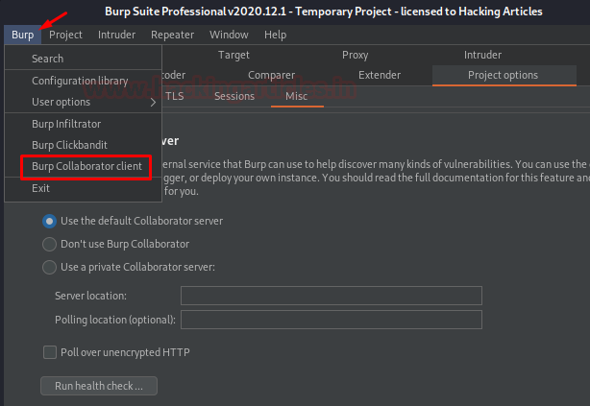

As we move forward with it by hitting the Client option, we’ll thus be redirected to a new window as the **Collaborator client**. Dropping a number of options within it, there are two important ones – Copy to clipboard; & Poll.

Understandable with the name, the **Copy to Clipboard** will simply copy the generated payload(s) such that we can paste them wherever needed. Whereas, the **Poll** **Now**option will help us to poll the server whenever we want to, rather not wait for the default time i.e. “60”.

Nevertheless, the **Number to generate**and **Poll every** option are also important as, over in the Number to generate we can modify the number of payloads ranging between 1-10 (this helps us while doing fuzzing), whereas if we do not care about the performance we can reduce the time (sec.) to automatically poll in the poll every option.

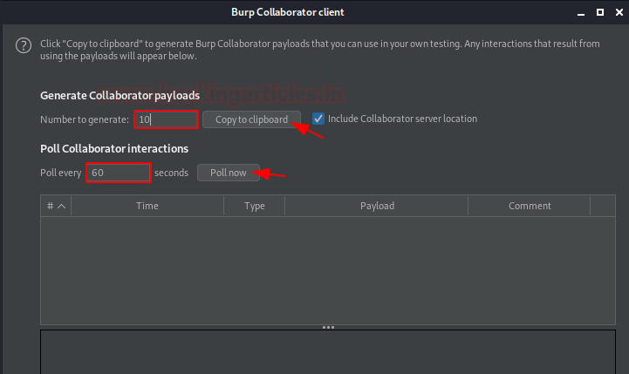

**Detecting vulnerabilities with Collaborator Client**

Up till now, you might be having a clear vision about what is Burp Collaborator and its client, and where to find them. So, let’s use this amazing feature to have some practical exposure by detecting and finding the most crucial out-of-band vulnerabilities.

**Blind Remote Command Injection**

Remote Command Injection or OS Injection is the vulnerability where the attacker tries to perform system-level commands directly through a vulnerable application in order to retrieve information of the webserver.

But there are times when the results of the injected commands are not displayed back at the application and even the error messages are not returned. So, over in such a situation does the command injection exists up?

Let’s find it out !!

Head to the bWAPP vulnerable application and opt the **OS Command Injection – Blind** by setting the security level to low.

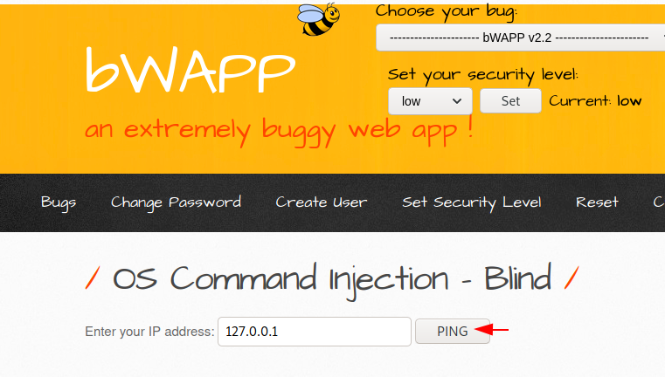

Over there, as we tried to ping our local machine with **“127.0.0.1”**, we didn’t get any output neither any error, just we got a message **“Did you captured our GOLDEN packet?”.**

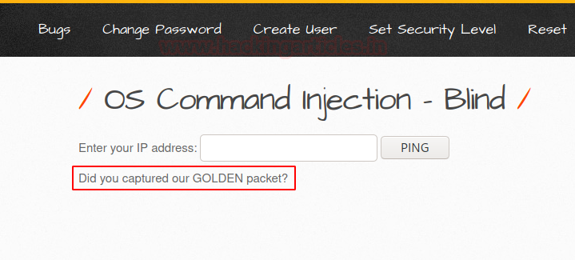

So, with this output, we can’t depict that the application is suffering from OS command Injection or not.

Thereby in order to confirm this, we’ll be using the Burp collaborator, which will pop out the response if the application somewhere or the other tries to interact with any other external service(DNS; HTTP; SMTP).

Let’s **copy the collaborator payload** by navigating to Burp at the dashboard and then opting Burp Collaborator Client.

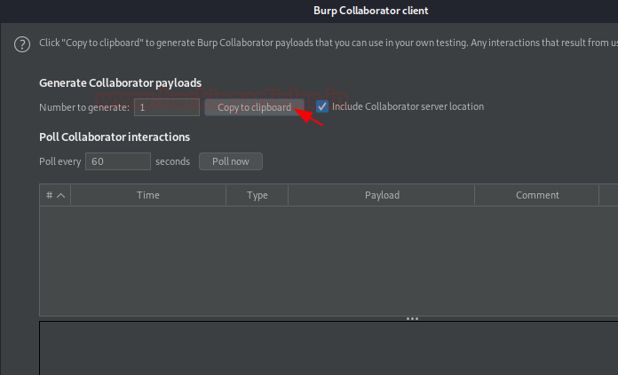

Now this time we’ll modify the input value, i.e. along with the IP we’ll inject the collaborator payload too and will hit the **“Ping”** button

|  |  |
| --- | --- |
| 1 | 127.0.0.1|nslookup <Burp Collaborator copied payload> |

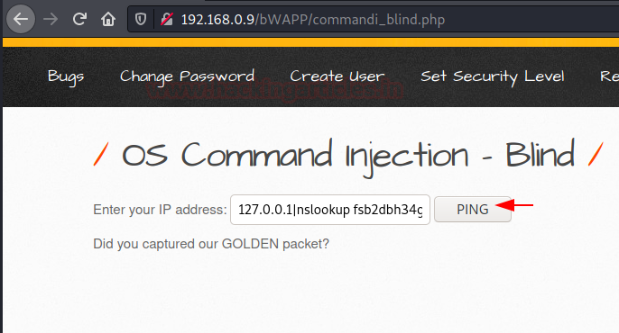

As soon as the page reloads back, the output is still the same, but over at the Burp Collaborator Client’s window, we got some new entries filled in as we hit the **Poll now**button**.**Let’s check them out.

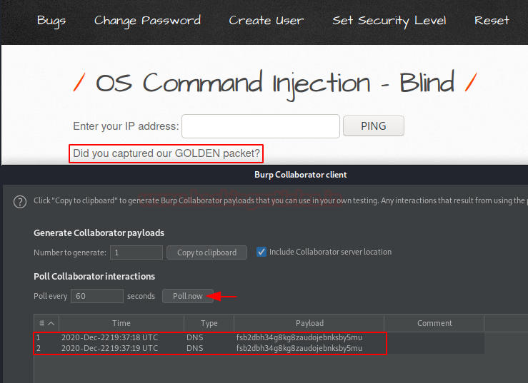

With the first response, we could notice that the application used the **DNS service** as the payload was bounded with the **nslookup** command. Thereby this confirms that the web-page is vulnerable to OS Command Injection.

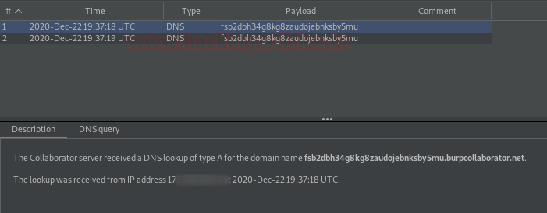

**Cross-Site Scripting Detection**

Cross-Site Scripting is a client-side code injection attack where malicious scripts are injected into trusted websites and are triggered when the user visits the specific suffering web-page.

But many times, we never know, where our injected payload will end up or when it will be executed.

Thereby, in order to determine, whether our payload is executed or has been triggered by an external service, we’ll be using burp collaborator which will dump the responses in the client window as soon they got hit.

Initiating back into the bWAPP application and opting the XSS – Stored (User-Agent), we’ll thus be able to see that our user-agent value has been stored into the database.

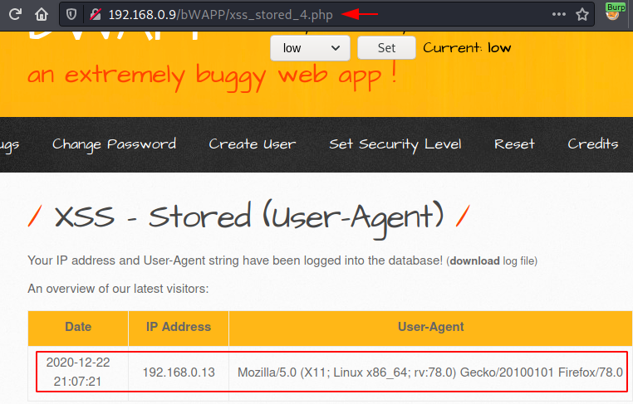

Now, turn ON the browser’s poxy and head to the Burpsuite’s Proxy tab, and capture the ongoing HTTP Request.

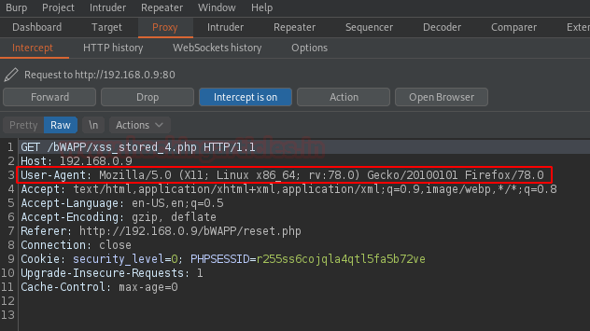

So, in order to manipulate this User-Agent, let’s first copy the Collaborator payload by moving the Collaborator Client window.

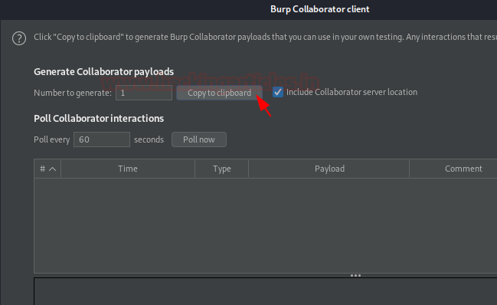

Back into the proxy tab & **modify the User-Agent** with the image tag and hit the **forward button.**

|  |  |
| --- | --- |
| 1 | <img src="http://copied_payload_value"> |

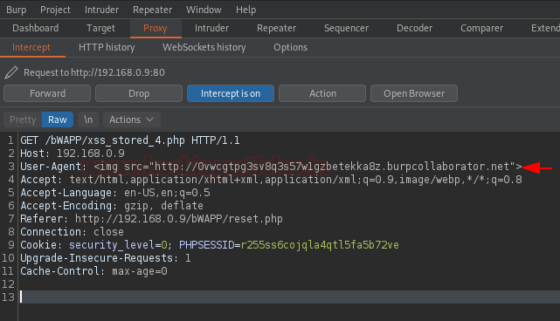

As soon as we do so, we got the alteration in our Client window, the burp payload has been triggered by an external service, which thus confirms that there is a Cross-Site Scripting exists up.

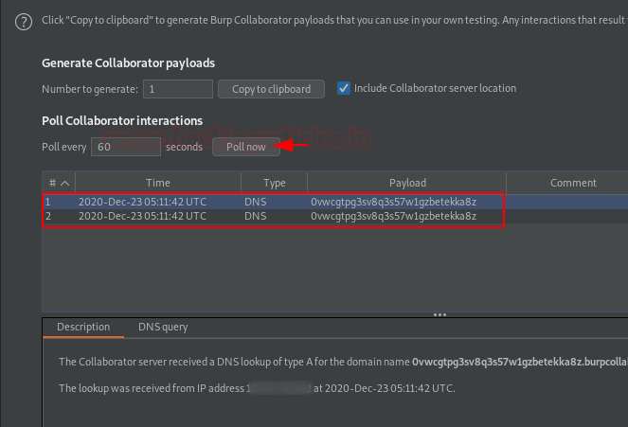

**NOTE –**

However, this is a basic demonstration as the vulnerable application has been hosted locally, but over in real-life scenarios, it takes time to get executed by the administrator or the developer, as many applications stores user-agents in their databases. In order to explore more about Blind XSS exploitation, visit our previous article from [**here**](https://www.hackingarticles.in/cross-site-scripting-exploitation/).

**Blind XXE**

XML External Entity (XXE) attacks are the most common in today’s era, as almost every application carries up XML inputs and parse them. However, the majority of these are blind ones as the weakly configured XML parser parses the malicious content but do not render it directly on the visitor’s screen.

But these Blind XXE vulnerabilities can be encountered with some great tools, I hope you’re getting me. Yes, Burp Collaborator, it can even detect the blind XXE triggered. Let’s check it out how.

Login into the **PortSwigger academy** and drop down till **XML external entity (XXE) injection**and further choose the lab as “**Blind XXE with out-of-band interaction”**and hit **“Access the lab”** button.

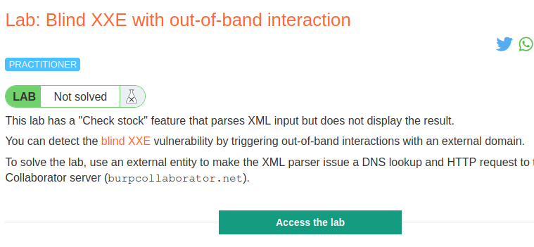

There as we do so, we’ll be redirected to an e-commerce web-page; let’s check out the details of the **“Vintage Neck defender”.**



Over in the details of the item, as we scroll down to the bottom, we got something like **“Check Stock”.**Seems to be suspicious, let’s turn ON our burpsuite monitor and capture the on-going HTTP Request for the Stock values.

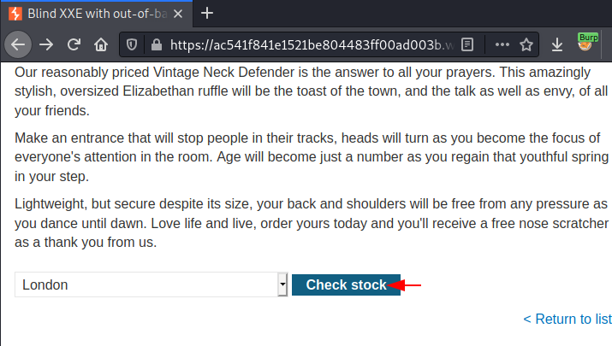

And there we go; We got the XML queries that are dumping the data out of this.

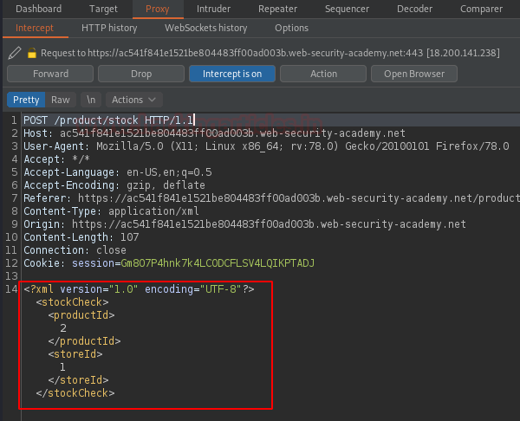

Time to modify the content and check for an XXE vulnerability, thereby in order to detect let’s copy the Collaborator payload value!!

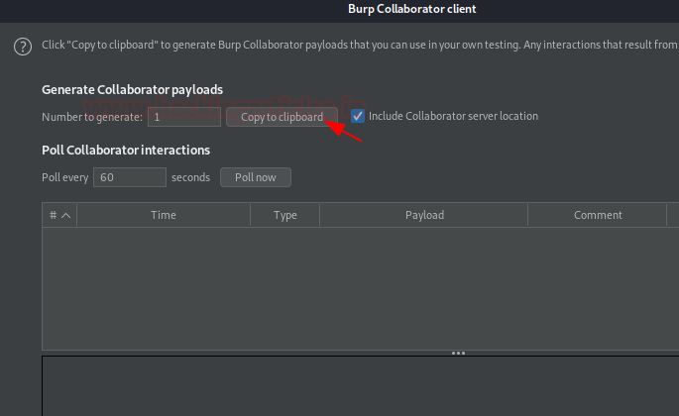

Now, let’s first share the request to the Repeater tab and then we’ll inject the copied payload into the XML data and call up the value within the productID as shown in the below image  –

<!DOCTYPE stockCheck [ <!ENTITY xxe SYSTEM “http://payload_value_.burpcollaborator.net”> ]>

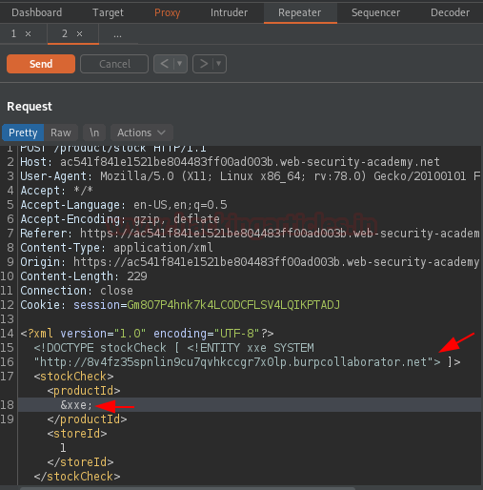

Now, as soon as we hit the **“Send”**button we got the response in the Repeater tab.

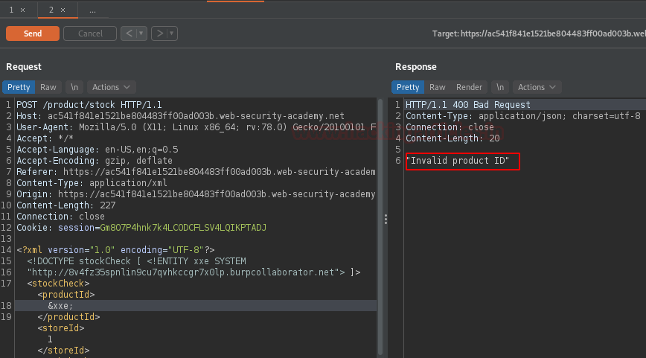

But wait, it’s an error an **“Invalid Product ID”**!! Now what?

Let’s check out the collaborator, did the request hit at the background or not. And there it is, this time, not only the DNS but also an HTTP service has also been triggered.

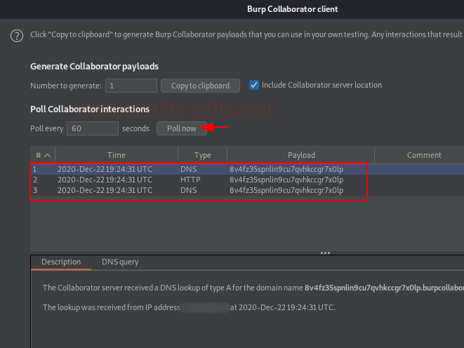

Let’s take a look at the HTTP response. There it offers us a Request and a Response from the collaborator.

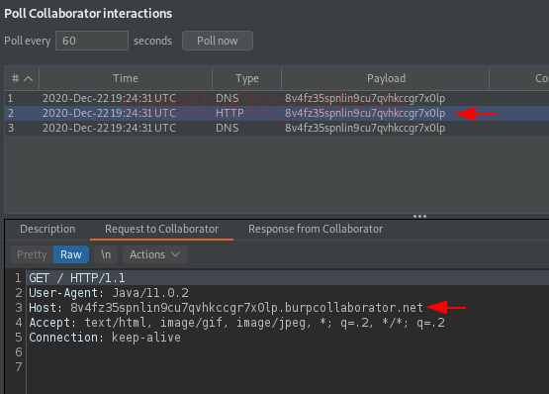

Over in the request tab as the host has been modified, thereby over in the response, we got the section injected into the HTML which confirms the detection and exploitation of the XXE vulnerability.

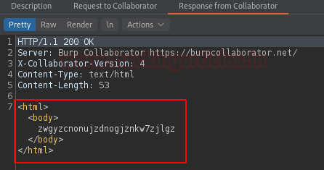

**Server-Side Request Forgery**

**SSRF** or **S**erver-**S**ide **R**equest **F**orgery is the most crucial web-application vulnerability where the attacker is able to use the vulnerable application to send **crafted HTTP Request** to a third-party server or application in order to **fetch internal information, banners or open ports**. However, majorly the response from the application comes in form of error but there are times when there is a possible SSRF but we do not get any error for it i.e.,**Blind**, thereby in such cases we know our helping hand “Burp collaborator”.

Let’s start.

Back into the PortSwigger Academy, switch to Blind SSRF with out-of-band detection and hit the **Access the lab** button.

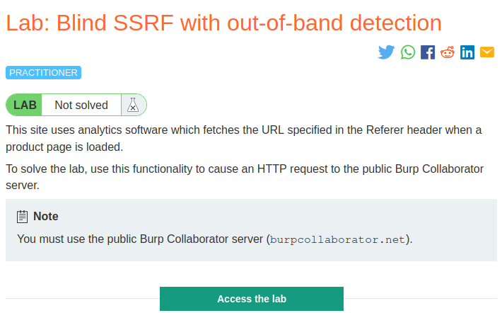

As soon as we do so, we’ll be redirected back into the shop page, but this time content is somewhat different. Let’s check the second item within it.



But before accessing the item, let’s turn our Burp monitor and capture the ongoing HTTP Requests for it, and as it captures them, we’ll throw it directly to the repeater.

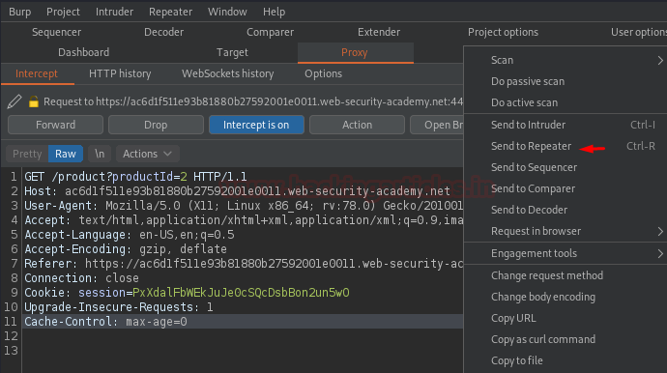

Over in the request section, the referer value seems to be injectable let’s manipulate it.

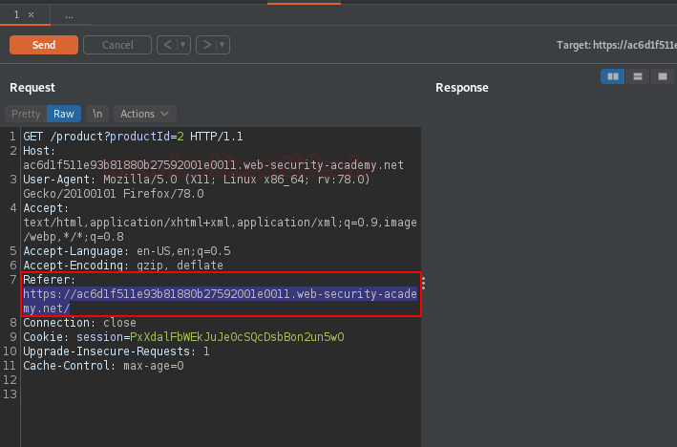

Back with the collaborator client window, copy the payload, and modify the referer with it.

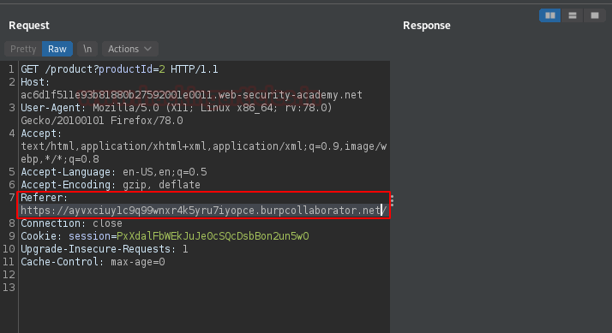

And there we go, as we hit the **“Send”** button, we got the **200 OK,**but where the output, was it vulnerable or our payload got triggered??

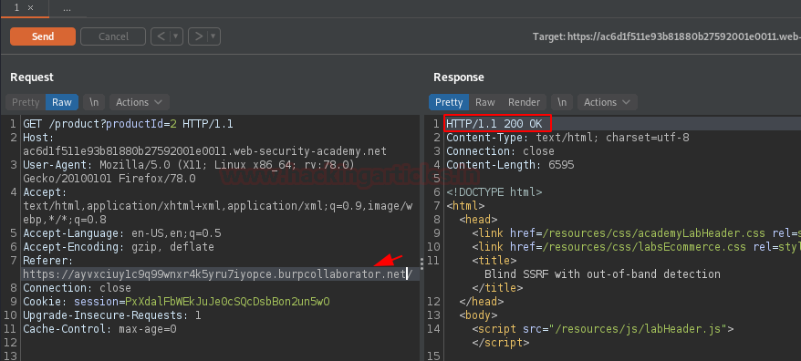

Back into the collaborator client window, as we hit the **Poll Now** button, we got our responses headed in front of us, which confirms that there is a possible SSRF vulnerability exists up.

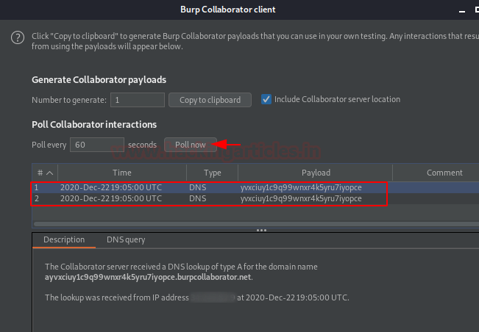

Let’s open the browser again. Cool the lab has been cleared.

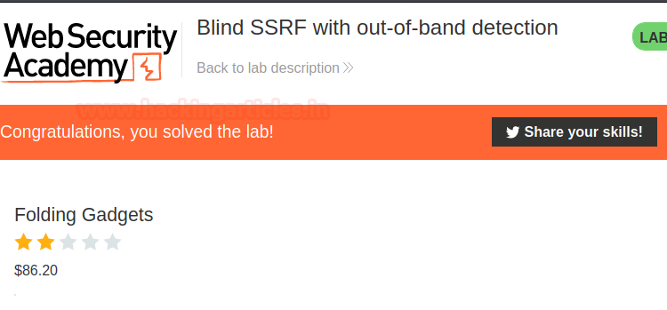

**Fuzzing for SSRF Detection**

Over in the previous section of PortSwigger’s lab, we’ve encountered the Blind SSRF with the single payload. But what if the payload didn’t work ??

Thereby for such situations, we can fuzz the injection points in order to determine the SSRF’s crucial hit.

Let’s move to the Mutillidae application and then we’ll navigate to **OWASP 2017 | A1 – Injection**

**(Other) | Application Log Injection | DNS Lookup.**

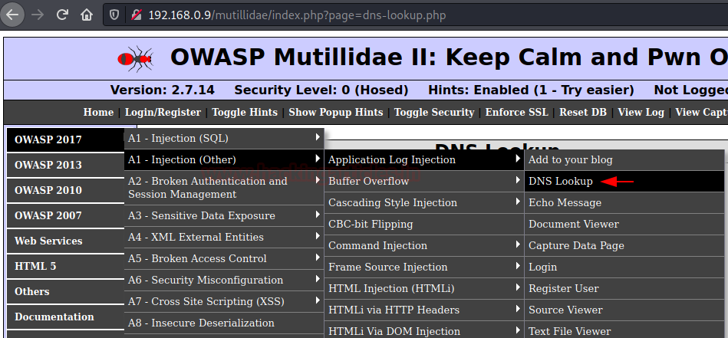

As soon as we reach there, we got an input field to **enter the IP Address**, let’s enter the localhost IP.

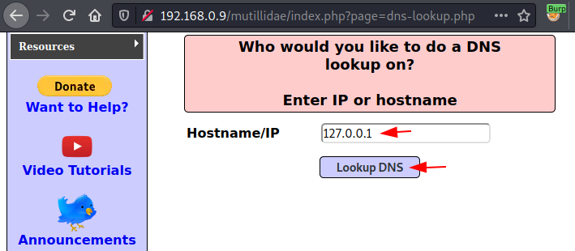

Before hitting the **Lookup DNS** button, let’s configure our burp monitor in order to intercept the passing HTTP request and as soon as it captures it up, we’ll share it to the **Intruder tab**.

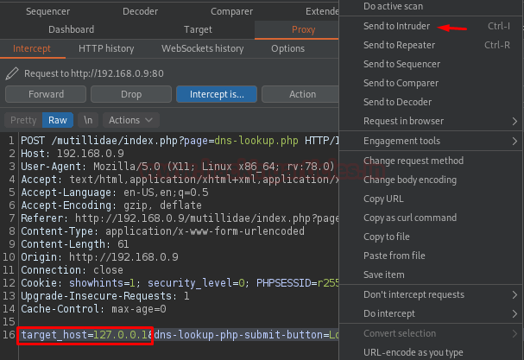

Over in the intruder tab, we’ll modify the injection point and set the payload position at the IP address we’ve entered.

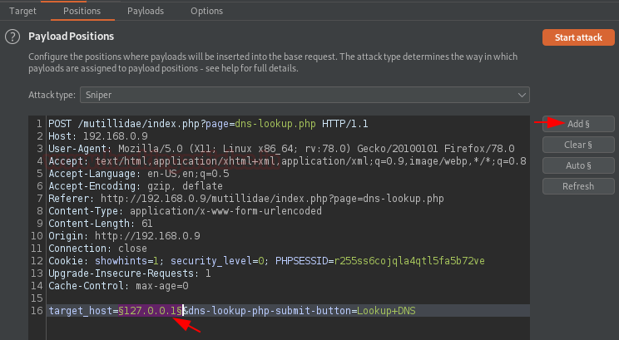

Now time to take help. Back into the collaborator client window, set the **number to generate to 10** and hit the copy to clipboard button.

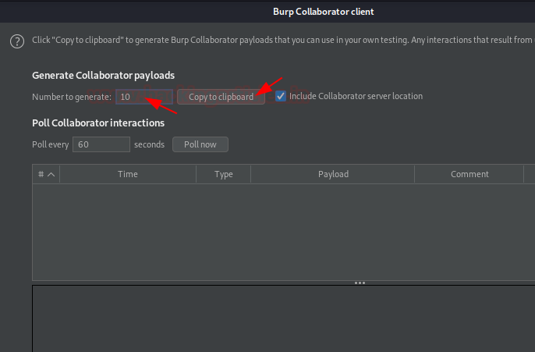

Over into the payload section, simply hit the **Paste** button in order to move all the copied payloads in the empty box, further hit the **“Attack”** button to initiate the fuzzer.

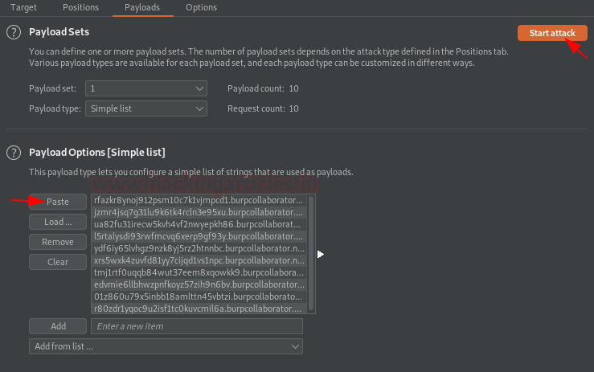

And there we go, every payload has the same length. Let’s check the collaborator does it offers something or not.

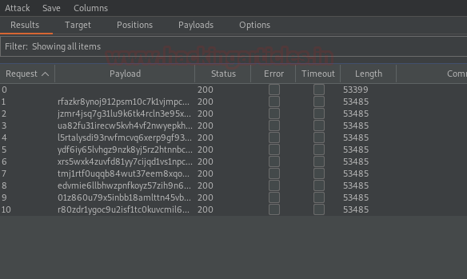

Great !! From the below image we can see a numerous amount of **DNS service is triggered out** by the application confirming the presence of SSRF vulnerability.

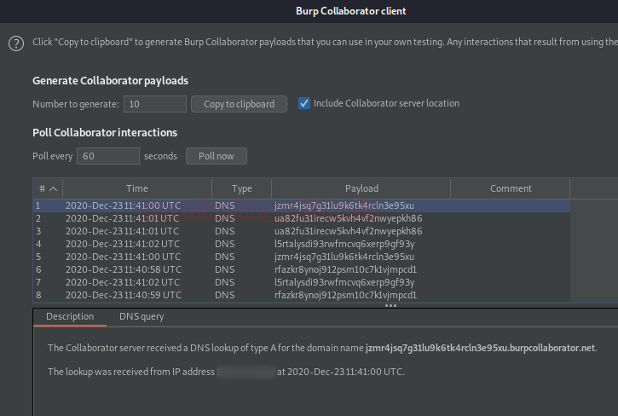

# Burp Suite For Pentester: HackBar

Isn’t it a bit time consuming and a boring task to insert a new payload manually every time for a specific vulnerability and check for its response?

So, today in this article we’ll explore one of the best burp suite’s plugins **“Hack Bar”** which will speed up all of our manual payload insertion tasks and will work with almost all the major vulnerabilities.

### ****Table of Content****

* Introduction to Hack Bar
  + What is Hack Bar?
  + Hack Bar Installation
* Exploiting Vulnerabilities with hack bar
  + SQL Injection
  + SQLi Login Bypass
  + Cross-Site Scripting
  + Local File Inclusion
  + XXE Injection
  + Unrestricted File Upload
  + OS Command Injection

### ****Introduction to Hack Bar****

**What is Hack Bar?**

Hackbar is a plugin designed for the penetration tester such in order to help them to **speed their manual testing procedures.** However, the hackbar are specifically built for the **browser’s extensions**, which contains a number of dictionaries according to the vulnerability type whether its SQL Injection, Cross-Site Scripting, or URL Redirections. This hackbar are designed somewhat similar to the **address bars** in the browsers.

The Burp’s Hack Bar is a **Java-based Burpsuite Plugin** which helps the pen-testers to insert any payload by opting from a variety of different dropdown lists. Although it works the same as the browser’s hackbar, its design and implementation are totally different.

Scroll your mouse down and you’ll get to know about it.

**Hack Bar Installation**

You might not find this great plugin over at the bApp store neither in the professional version or the community one. So, how will you set this up?  In order to make this Hackbar a part of our pentesting journey, we need to **download its**[**jar file**](https://github.com/d3vilbug/HackBar/releases/tag/1.0) from the [**GitHub repository**](https://github.com/d3vilbug/HackBar)**.**

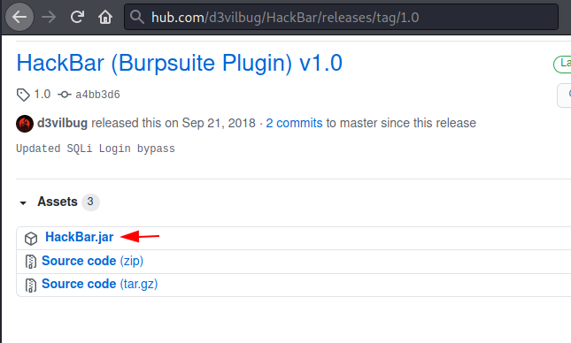

As soon as the file gets downloaded, we’ll tune back into our burpsuite monitor and will navigate to the **Extensions section** in the **Extender** **tab**. There we’ll hit the **Add button** in order to pull the **“Load Burp Extension”**window.

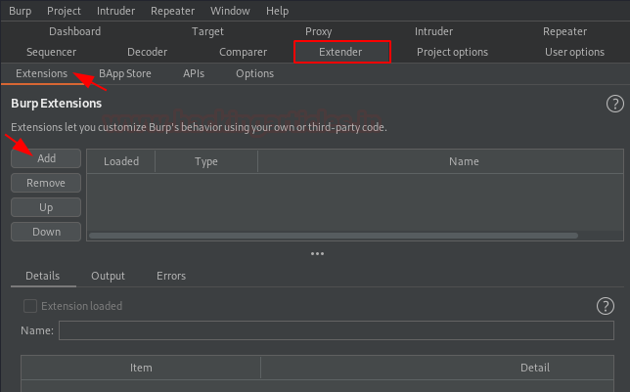

Let’s now set the extension type to **“Java”**and opt the downloaded file. Further, we’ll hit **“Next”**to initiate the installation.

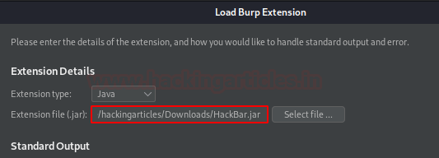

Once the installation ends up, we got our payload listed into the **“Burp Extensions”** section.

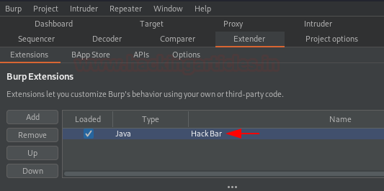

Let’s check that out, whether it’s working or not !!

Follow up at the repeater tab and make a right-click anywhere at the screen. Over with that, we can see a new option lined up as **“Hackbar”.**

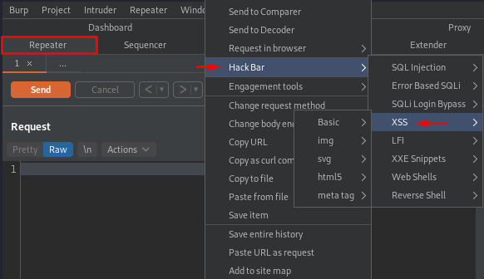

### ****Exploiting vulnerabilities with Hackbar****

Hackbar has been designed in such a way to hit a number of crucial vulnerabilities as the dictionaries within it are segregated according to the type they belong too. However, we can use this hackbar or its dictionaries wherever we wish to, whether it’s at the **Repeater tab** while manipulating the requests or at the **Proxy tab** during their interception.

So, for the time being, let’s explore it and exploit the vulnerabilities exits up in bWAPP & Acunetix(test.vulnweb) vulnerable applications.

**SQL Injection**

SQL Injection is one of the most crucial vulnerabilities exists over the web as almost every dynamic web-application carries a database within it. Thus with this, the attacker could bypass the authentication, access, modify or delete data within a database. You can learn more about it from [**here**](https://www.hackingarticles.in/beginner-guide-sql-injection-part-1/).

However, the automated tools that are designed to exploit this vulnerability need some of **the manual detection for the injection points**. And up till now, we know this thing that the manual pentesting can be best done with our hackbar, so let’s try it out.

Initiating with test.vulweb, let’s login inside it and check the artists within it.

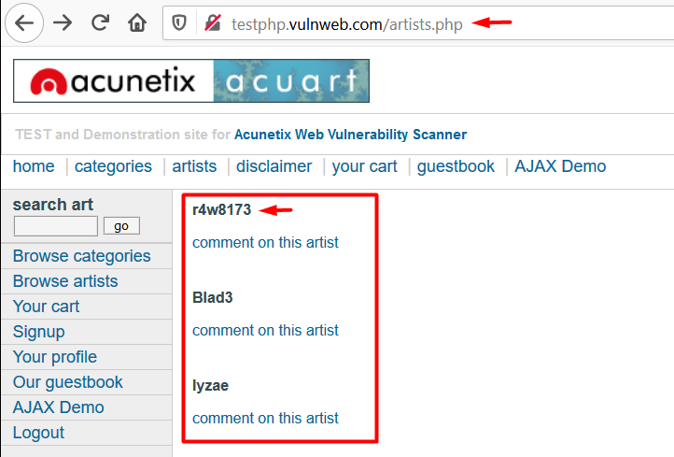

Now, time to analyse what it offers. Let’s **capture the request** for the first artist over in our burpsuite monitor and then we’ll further share it with the **Repeater.**

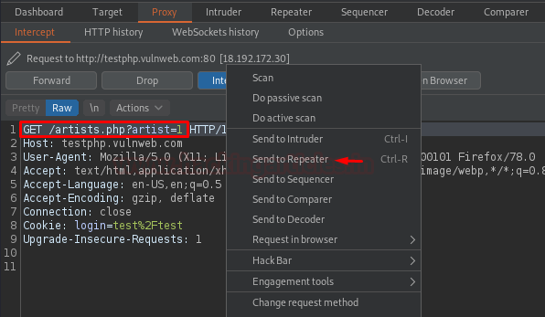

As soon as we do so, we’ll hit right-click after **“artist=1”**and then will navigate to **Hack Bar -> SQL Injection -> Column Count -> Order By**in order to determine the number of records it consists of.

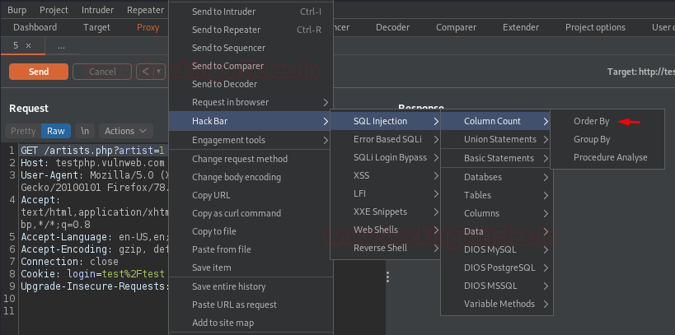

With the interception, let’s try for **“3”**and check what it dumps.

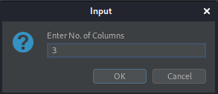

Over at the 3rd field, we’re having an entry fed up as **“r4w8173”.**Let’s increment it will **1**i.e. **“4”.**

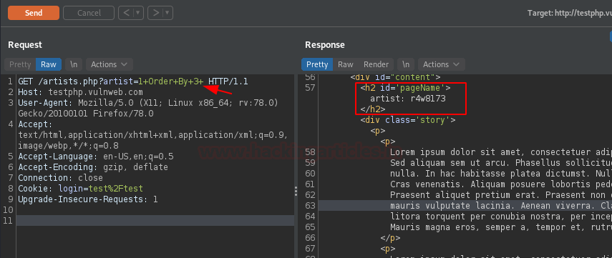

And there is an error for the 4th field, this confirms that it consists of only **three records.**

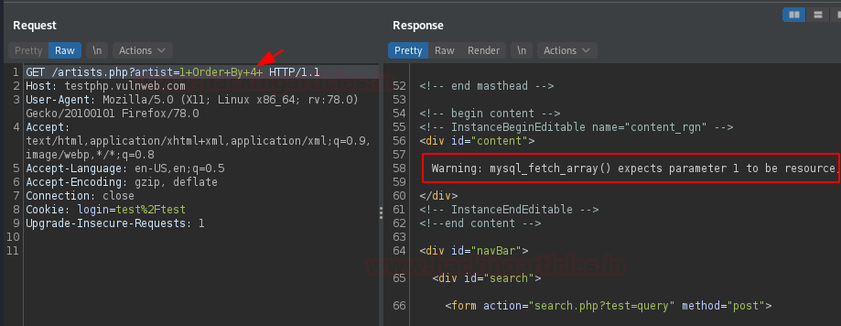

Let’s penetrate more inside using **Union base injection** and even we’ll pass wrong input into the database by replacing **artist=1** from **artist=-1**

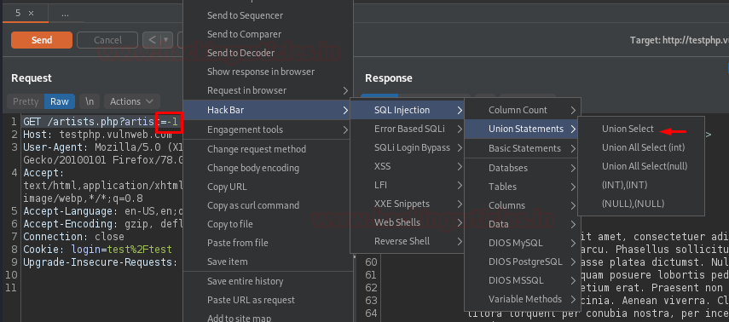

As for the **Order By section,** we got that the records are 3, thereby we’ll set the **No. of Columns**as**3** here too.

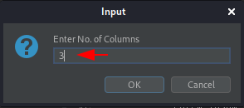

With the completion of the query and as we hit the **send button,** we got the result displaying the remaining two tables, which thus could be used to fetch the details within the database.

However, you can follow up more for manual SQL exploitation from [**here**](https://www.hackingarticles.in/manual-sql-injection-exploitation-step-step/).

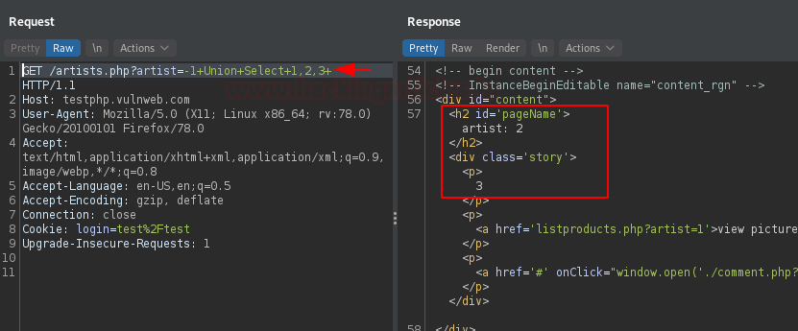

**SQLi Login Bypass**

As discussed in the earlier section that over with the SQL Injection vulnerability the attacker tries to bypass the login portal so let’s explore this exploitation with our Hack bar.

Login with some random credentials and capture the request into our **Burpsuite’s Proxy tab**.

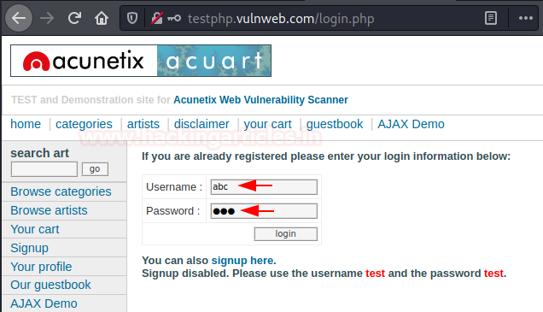

Once the Proxy **starts intercepting the request**, share it with the **Repeater**.

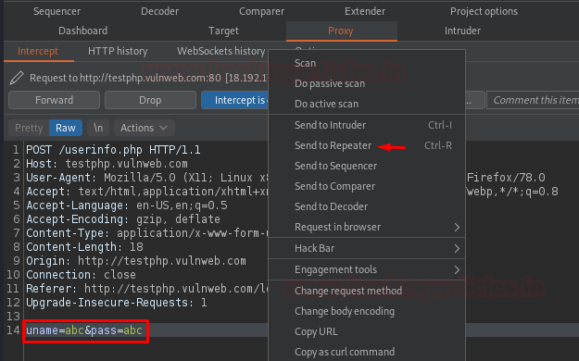

Here in the Request content, let’s select the injection points **“uname”** and **“pass”**and then follow up with a right-click to **Hack Bar -> SQLi Login Bypass -> Set 1 -> ‘or’‘=’**dictionary value.

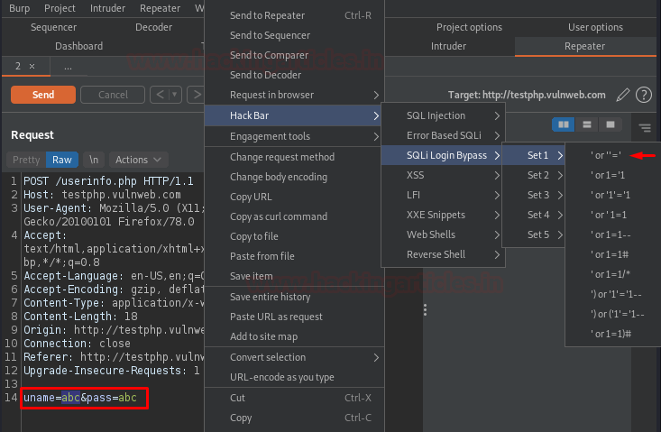

Hit the **Send**button to pass the values for authentication, and over at the right panel of the Response section, we can see some alterations. Let’s check the same in the browser.

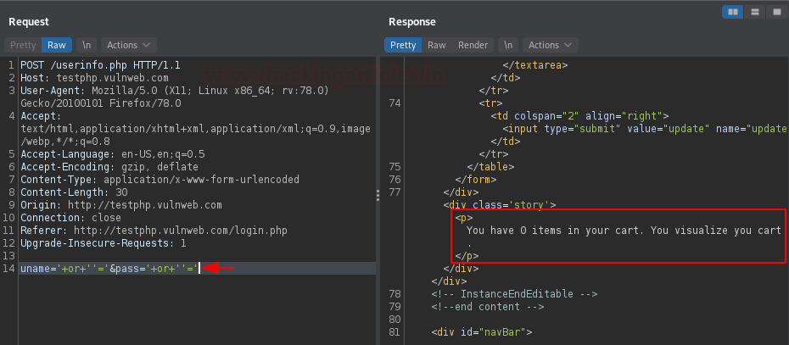

From the below image you can see that as soon as we paste the copied value generated with the **“Show Response in browser”**option, we got landed directly over at the dashboard.

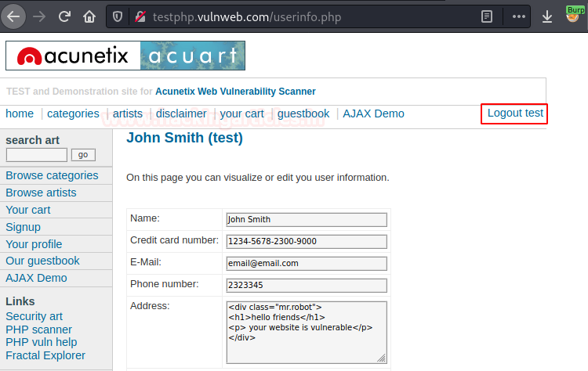

However, the SQLi Login Bypass contains a number of other dictionary sets too, you can explore any of them if the payload within a specific dictionary is not working.

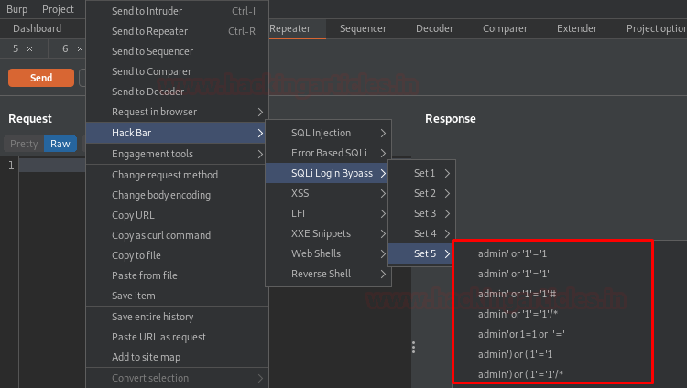

**Cross-Site Scripting**

**C**ross-**S**ite **S**cripting or **XSS** is a client-side code injection attack where malicious scripts are injected into trusted websites and are triggered when the user visits the specific suffering web-page. You can learn more about it from [**here**](https://www.hackingarticles.in/comprehensive-guide-on-cross-site-scripting-xss/).

During an XSS exploitation, we majorly try to **inject payloads manually** at the injection points. But this manual exploitation sometimes didn’t work due to typing error or blacklist implementation. Thereby in order to save our time and hit the vulnerability manually let’s use our Hack Bar.

Open the target IP in the browser and login inside bWAPP as a **bee: bug**, further set the **“Choose Your Bug”** option to **“XSS –Stored”**and fire up the **hack button.**

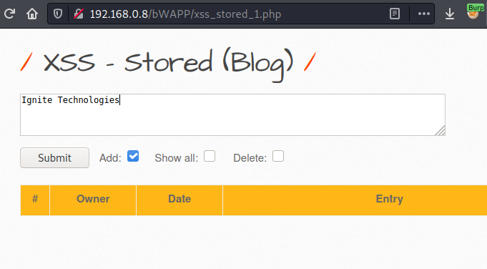

Before hitting the submit button, turn your burpsuite monitor and capture the ongoing HTTP Request. As soon as you got that, simply share it with the repeater for the manipulation part.

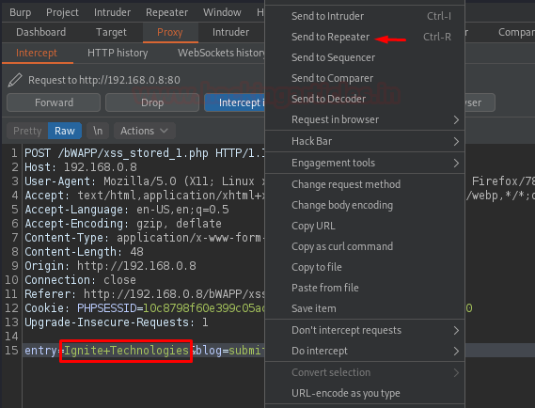

Time to go with the Hack Bar. Over at the Injection point, select it, and then navigate to **Hack Bar -> XSS -> Basic -> <script>alert(‘XSS’)</script>**

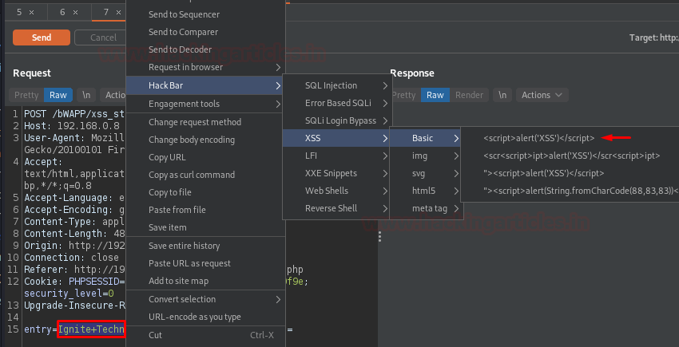

Once the payload gets injected up, hit the **Send** button and analyse the **Response.**

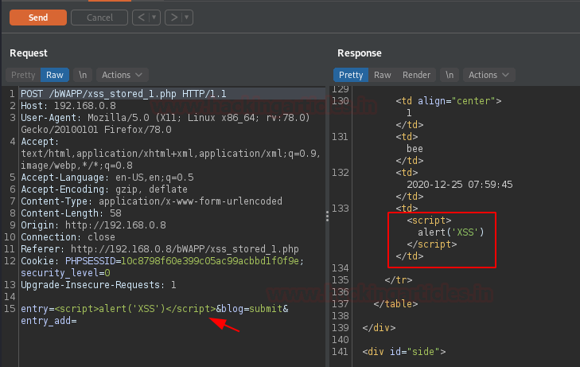

From the above image, you can see that our script has been embedded over into the webpage HTML content. Let’s check the same in the browser.

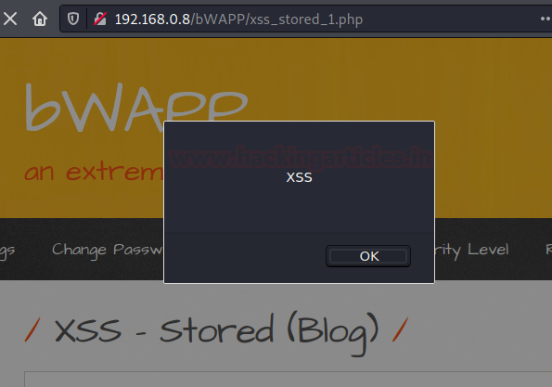

And there is a **Pop-up !!**

Similar to the SQL section, specific sets of dictionaries are also here. You can explore them according to your need.

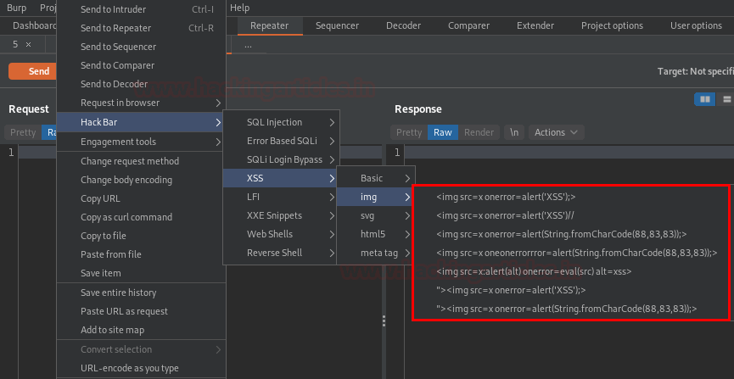

**Local File Inclusion**

Local file inclusion is the vulnerability where the attacker tries to trick the web-application by including and calling the files that are already present locally into the server. This File Inclusion vulnerability is totally dependent on the type of injection point it carries up.

So, let’s exploit its injection points with the Burpsuite’s Hackbar.

Back into bWAPP switch to the **Remote & Local File Inclusion** vulnerability, and then opt **“English”** from the drop-down list and hit the **Go** button with the **Proxy service enabled.**

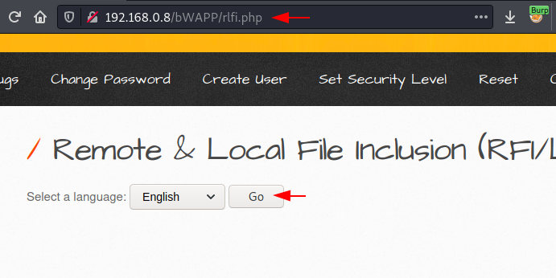

Once the request got captured by the burpsuite simply share it with the **Repeater.**

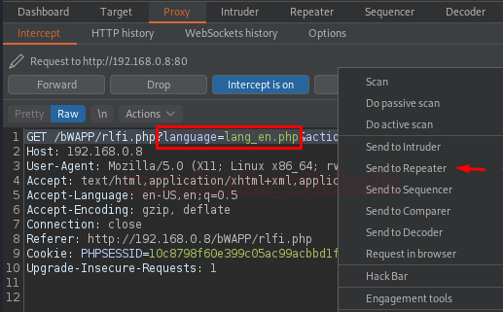

And I hope you know the next step. Navigate to **Hack Bar -> LFI -> Simple Check -> /etc/passwd**

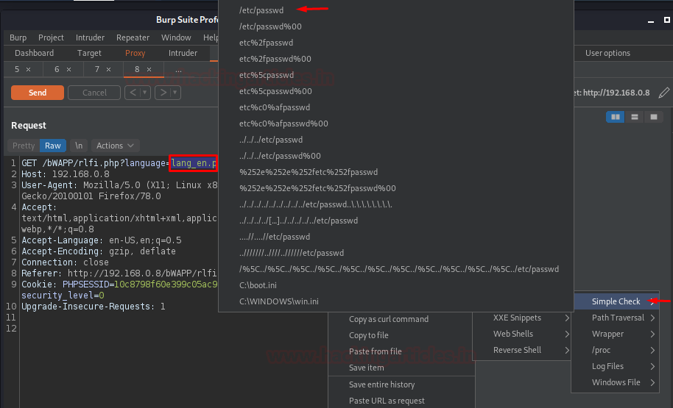

As soon as we hit the **“Send”**button, we got our output listed over at the right panel.

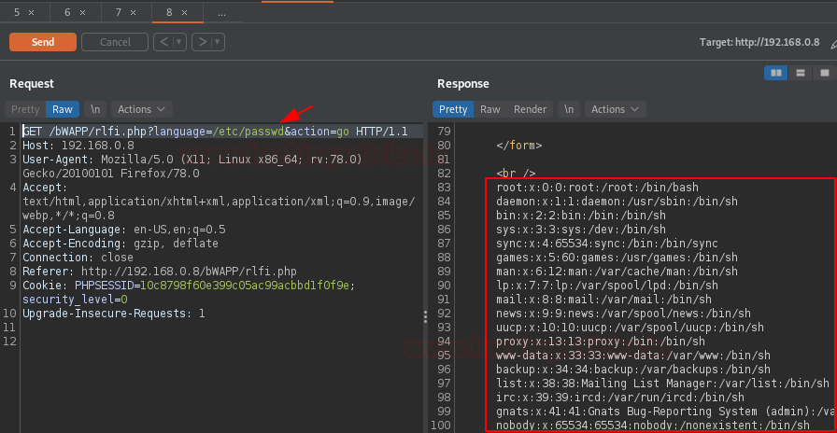

However, the payloads for this file Inclusion vulnerabilities varies with the operating systems, thus the Hack Bar offers a number of payloads for**Linux and Windows**. It even carries some for the Path Traversal vulnerability.

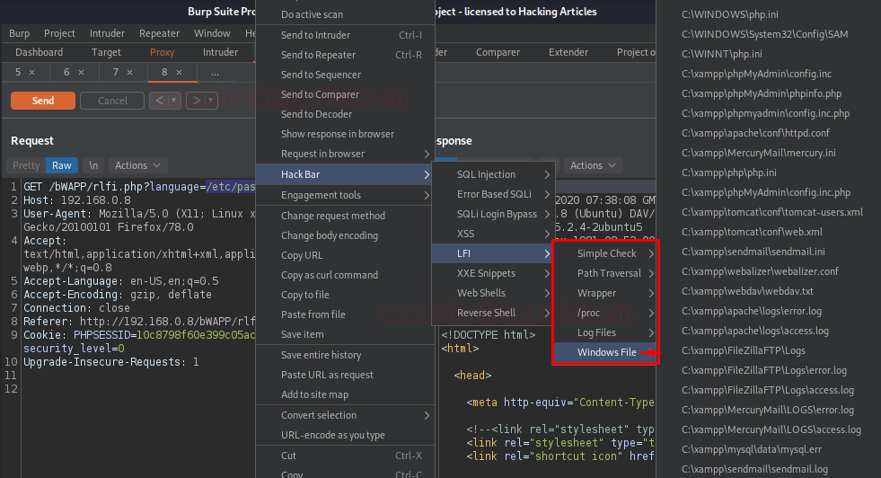

**XXE Injection**

**X**ML e**X**ternal **E**ntity **(XXE)**attacks are the most common in today’s era, as almost every application carries up XML inputs and parse them. Such XML attacks are possible as the input contains a reference to an external entity which is thus processed by a weakly configured XML parser. In order to learn more about it, check our [**previous article**](https://www.hackingarticles.in/comprehensive-guide-on-xxe-injection/).

To exploit the XXE vulnerable applications, we need to type down the payloads. And yes we’re a bit lazy to type the things down, thereby for this vulnerability too, hackbar is also having some great payloads. Let’s check them out.

This time switch to the **XML External Entity Attacks**web-page and push the **“Any bugs?”**button with the proxy service **ON.**

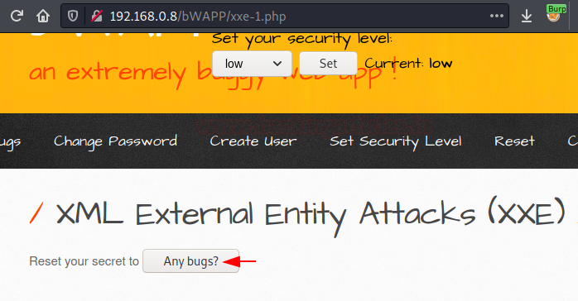

And our burpsuite did its work, the **request has been captured** again. Now, it’s our turn to follow the next.

Share the captured request with the **Repeater** and hit right right-click just above the XML code and select **Hack Bar -> XXE Snippets -> XXE 1**

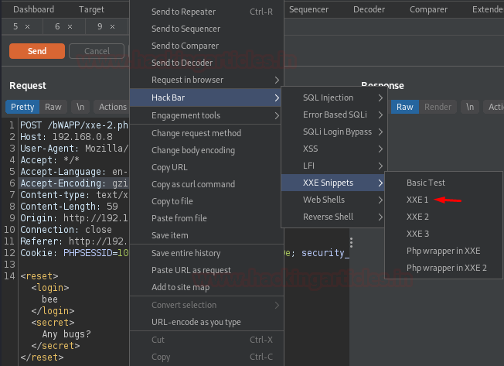

As the payload got injected, replace **bee** with the entity name (file) as **“** **&file; ”,**and then fire the **Send** button. And within a few seconds, we got the password file over at our right eye.

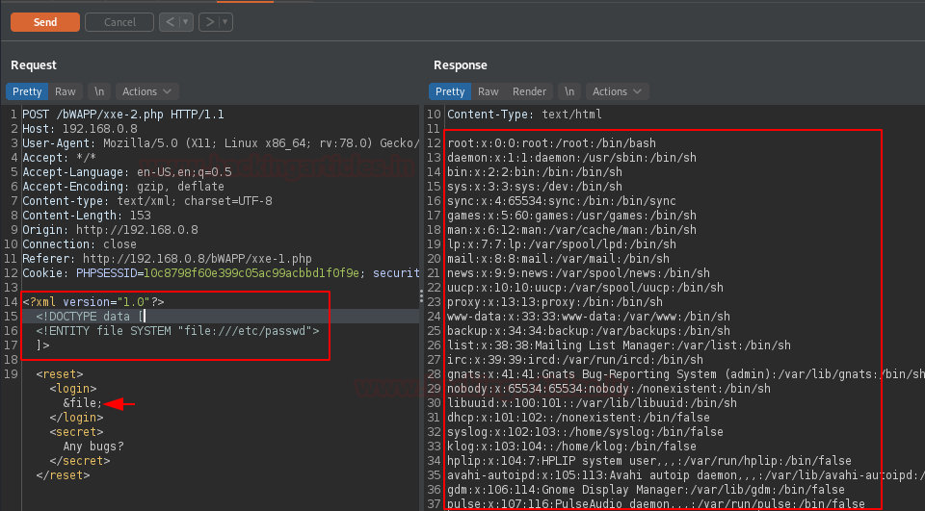

**Unrestricted File Upload**

The File Upload vulnerability **allows** **an** **attacker** **to** **upload** a **file** **with** **malicious** **codes** **embedded within** **it**, which **thus** **could** **be** **executed** **on** **the** **server** directly resulting in **Information Disclosure**, **Remote Code Execution** and **Remote Command Execution**. Check out the [article](https://www.hackingarticles.in/comprehensive-guide-on-unrestricted-file-upload/) for File Upload impact.

However the uploading could not be done with this Hackbar, but it offers us the feature to create files with the malicious codes which were thus stored up into its dictionary. Let’s check where they are.

Over in the Burpsuite’s Repeater tab, open a new section and do a right-click at the empty portion of the Request bar and then follow to **Hack Bar -> Web Shells -> php**

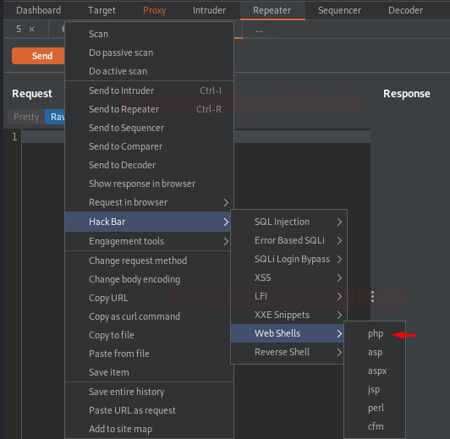

The empty section is thus filled with some code.

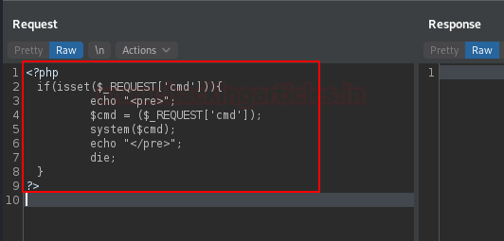

Let’s copy that all and paste it into notepad, further saving it as **hackbar_webshell.php**

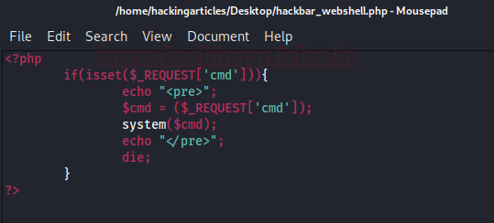

Now time to hit the vulnerability, back into the bWAPP application and opt **Unrestricted File Upload.**

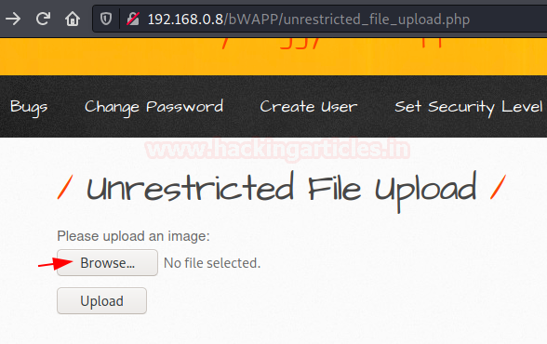

Further clicking on the **“Browse..”**button, select hackbar_webshell.php file.

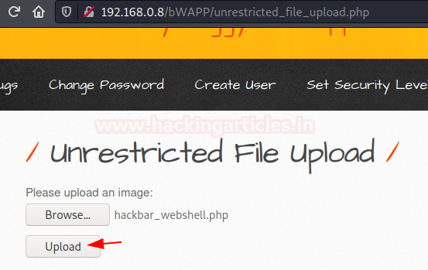

As soon as the file got uploaded we got the redirection link, let’s check that out.

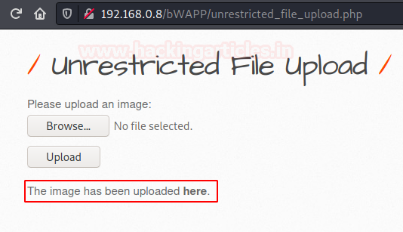

However, the webpage was blank, as in order to execute the payload we need to call the **command** with **cmd**and that is with

http://192.168.0.8/bWAPP/images/hackbar_webshell.php**?cmd=cat+/etc/passwd**

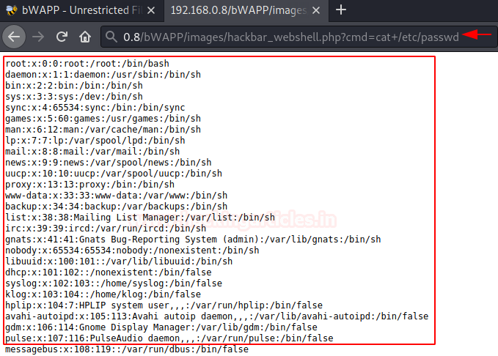

**OS Command Injection**

Remote Command Injection or OS Injection is the vulnerability where the attacker tries to perform system-level commands directly through a vulnerable application in order to retrieve information of the webserver. Learn more about this vulnerability from [here](https://www.hackingarticles.in/comprehensive-guide-on-os-command-injection/).

Similar to the web shells, hackbar offers us **Reverse shells** too which thus could be used over with netcat and command injection vulnerability. So let’s dig them out.

For the last time, check you bWAPP and navigate to OS Command Injection and hit the **“hack”**button and capture the request there.

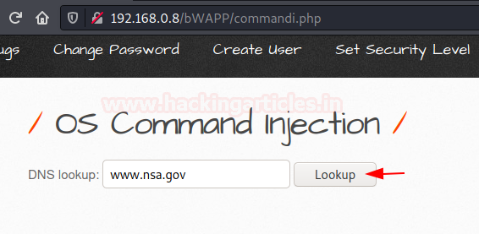

As soon as we share the captured request to the **Repeater,** we got remind off to hit right-click after **“www.nsa.gov”**and then choose **Hack Bar -> Reverse shell -> One Liner -> nc.**But, remember to set the meta-character between the two commands.

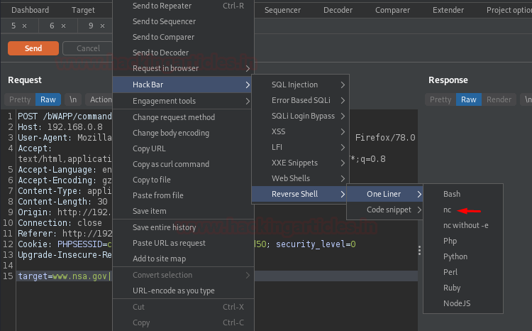

As we do so, we got the option to enter the RHost value, let enter our Kali Linux IP.

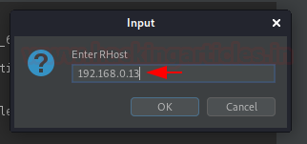

And now, our reverse shell needs a port, let’s set it to **4444** our favourite one.

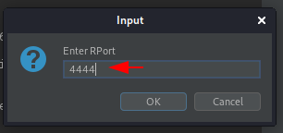

Before hitting the **“Send”**button let’s initiate our netcat listener at our Kali machine with

|  |  |
| --- | --- |
| 1 | nc -lvp 4444 |

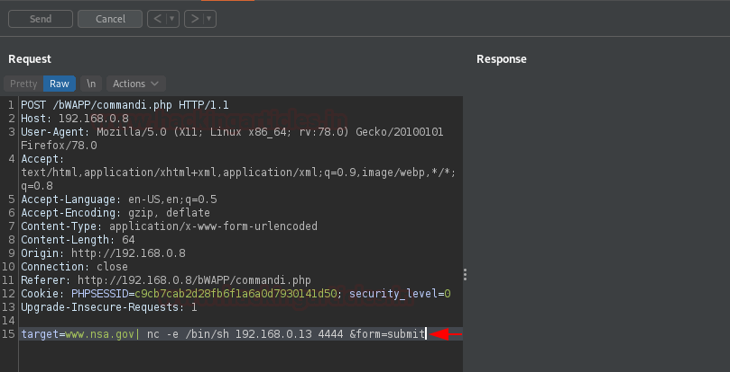

As the **Send**button got pressed up, our listener fluctuates and we got the connection established.

Time to dig into the web-server.

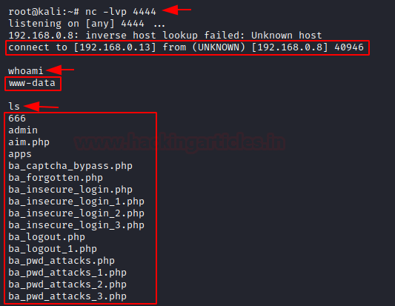

# Burp Suite for Pentester: Burp Sequencer

[December 29, 2020](https://www.hackingarticles.in/burp-suite-for-pentester-burp-sequencer/) By [Raj Chandel](https://www.hackingarticles.in/author/raaj/)

Whenever we log into an application, the server issues a Session ID or a token, and all over from the internet we hear that the session ID we get is unique, but what, if we could guess the next unique session ID which the server will generate?

Today, in this article we’ll try to overtake the application’s algorithm that helps them to generate a randomized session ID for a specific user and will try to log in inside the application impersonating that user with our predicted session ID.

### ****Table of Content****

* Introduction to Burp Sequencer
* Session ID exploitation via Sequencer
* Manual Request Analysis
* Comparing the Captured Tokens

### ****Introduction to Burp Sequencer****

Burp Sequencer is a tool for analyzing the **quality of randomness** in a sample of data items. The data items can either be application’s session ID’s, CSRF tokens, password reset or forget password tokens or any specific unpredictable ID generated by the application.

The Burp Sequencer is one of the most amazing tools that try to **capture the randomness** or the **variances in the session ID’s** by employing some standard statistical tests which are based on the principle of testing a hypothesis against a sample of evidence, and calculating the probability of the observed data occurring.

However, the tool tests the given sample in a number of different scenarios whether it is a character-level analysis or a Bit-level one, the analyzed output would be in the best-segregated format. To learn more about how the sequencer tests the randomness, check the sequencer’s documentation from [**here**](https://portswigger.net/burp/documentation/desktop/tools/sequencer/tests).

The best part of this tool is that it is available for both the editions i.e. for the **Professional and community version**, you just need to tune in your burp suite application and navigate to the **Sequencer tab** over at the top panel.

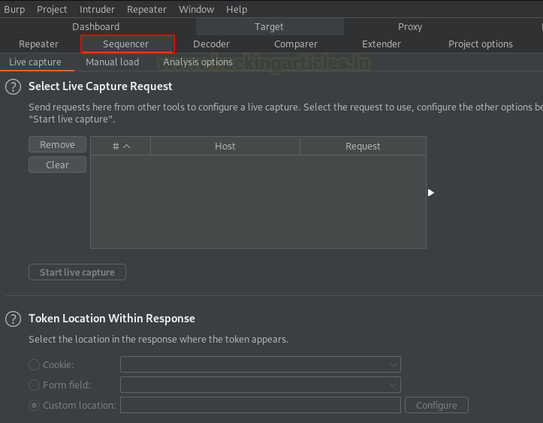

### ****Session ID exploitation via Sequencer****

Whether it’s a basic Session ID or a token generated from the server-side, the burp’s sequencer analysis that all, as the tool’s only requirement is a**“Request”** shared with it.

So, let’s initiate the analyzer within the burp sequencer by capturing and sharing a login Session ID over from our favourite vulnerable application i.e. bWAPP.

Feed the target IP in the browser and login with **bee: bug**.

Wait!! We talked about login session ID right, so let’s turn the proxy service here only, and then hit the **“Login”** button.

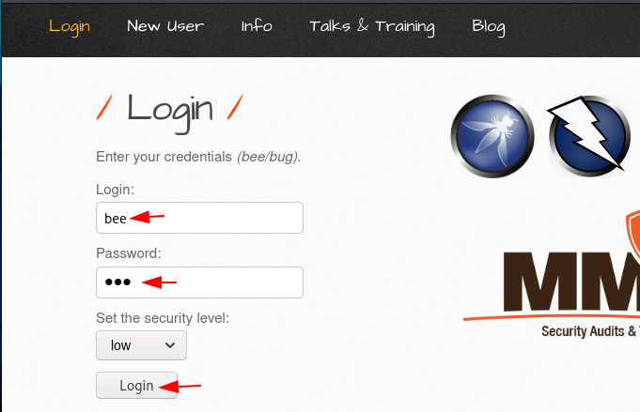

Let’s check our burp suite, whether it captured the request or not. From the captured request we can see that a **PHPSESSID** is in the **Cookie** **header,**let’s share the complete request with the **Sequencer** by hitting right-click over on the white space.

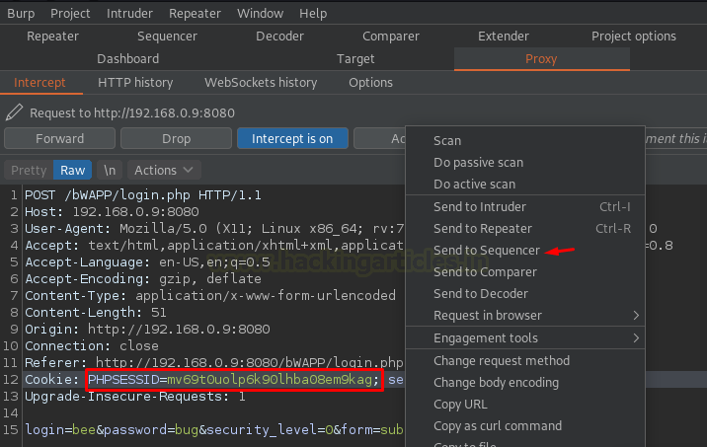

As soon as the Sequencer receives the request, the empty fields got filled up directly with the Token ID that goes with the **“Response”** for the specific shared Request.

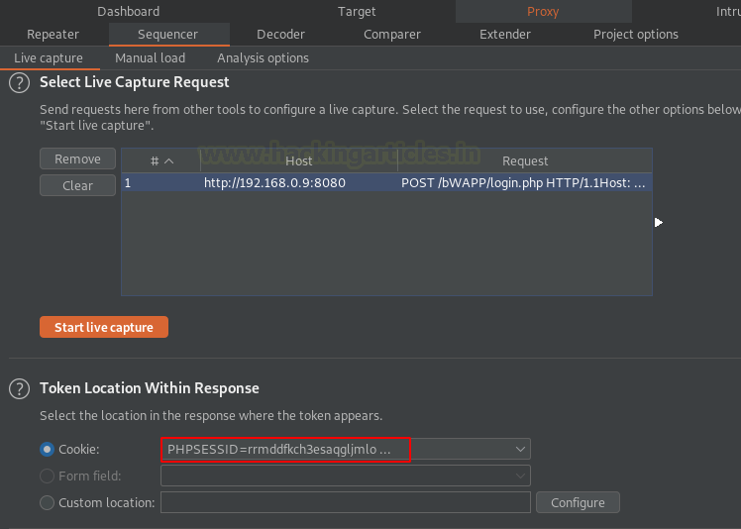

However, there are times when we want the sequencer to analyze some different value. Thus, over in such cases, the burp suite’s creators give us the opportunity to define the **Custom location** within the response. Let’s check that out.

Hit the **Custom location**radio button below at the cookie option and then navigate with **Configure**. As soon as we do so, we got a new window opened as **“Define Custom token location”**where we’re having the response of our shared request.

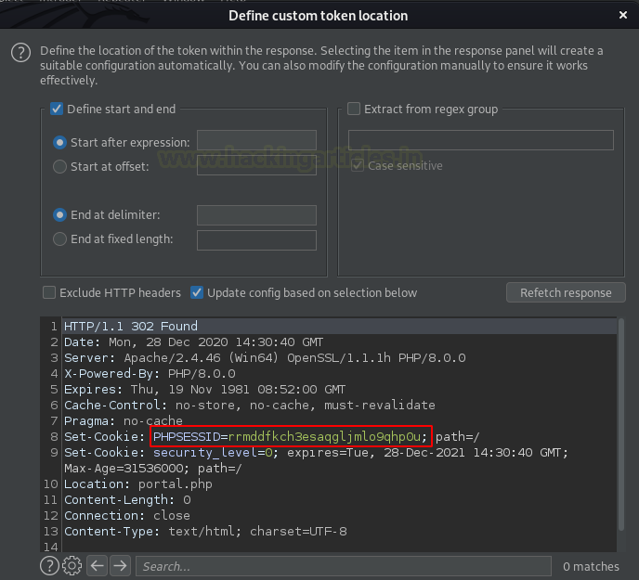

Over into this, we can opt either the defined options whether **“Define start & end”**or **“Extract from regex group”.**Let’s check the first one.

As we hover and select the value from the shared Response, we got some manipulation at the Start and the End delimiters. Thus, hit the**Save button** and our custom location will be defined up at the panel.

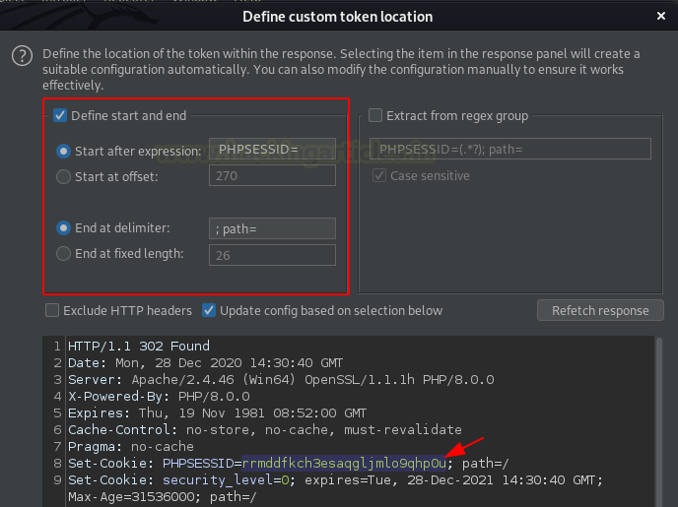

Now simply hit the **“Start Live Capture”**button having the **Cookie**option selected at the **“Token Location within Response”**section.

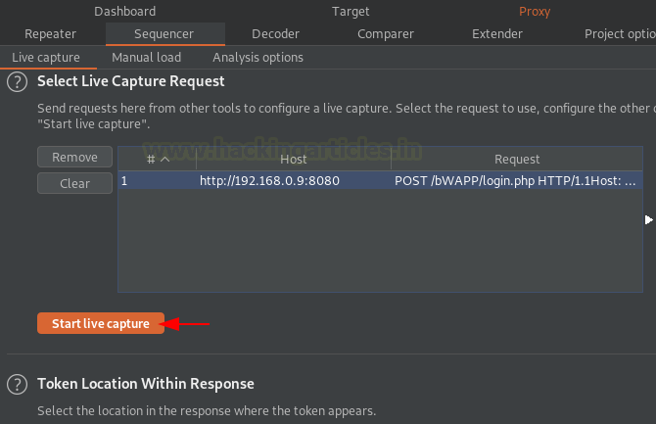

And, as we did that a new window **[** **Live capture #1 ]**  got popped up. Okay!! But what’s this? Let’s define it all.

As soon as the **“Start Live Capture”**button got fired up, Burp repeated the original request (potentially about a thousand times) and thereby extract all the tokens received from the responses.

However, within all this, once the **Capture page** boots up, a **progress bar** is displayed with a counter of tokens generated and the requests made by the sequencer. A number of buttons also contributes into this Live Capture window as –

1. **Pause/Resume:**This temporarily pauses the capturing request and the counter, such in order to help the pentester to analyze the requests generated till then.
2. **Copy Tokens:** It helps to copy all the randomized tokens generated.
3. **Stop:**A major road block for the live capture analyzer.
4. **Save Tokens:**Output can be dropped down as in the form of randomized generated tokens into a defined file.
5. **Auto analyze:** This check box (if enabled) will thus help the Sequencer to dump the analyzed results as soon as a specific number of tokens are generated.
6. **Analyze now:**This button is only available when at least 100 tokens have been generated and if clicked, will thus print out the analyzed report on the screen.

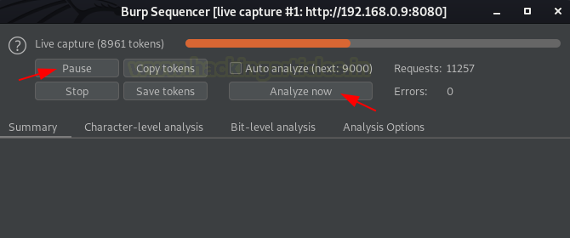

So, let’s **pause** the sequencer and then we’ll hit the **Analyze now** button, such in order to determine what it gathers.

From the below image, we can see that the sequencer had dropped a report by analyzing about **16000 requests,**having an overall quality of randomness within a sample estimated to be **“excellent”.**

We could have either got randomness quality to be **“poor**” if the web application’s session ID is repetitive.

However, the amount of effective entropy is **110 bits**which are considered to be a good one as the least is **“64”**and the best is **“128”.**

**NOTE –**

Burp Sequencer works over **Sample,**thereby a large number of captured tokens will thus drop a better and a precise result. Thus, it is recommended to have at least a 1000-2000 sample tokens before analyzing the application’s session ID randomness.

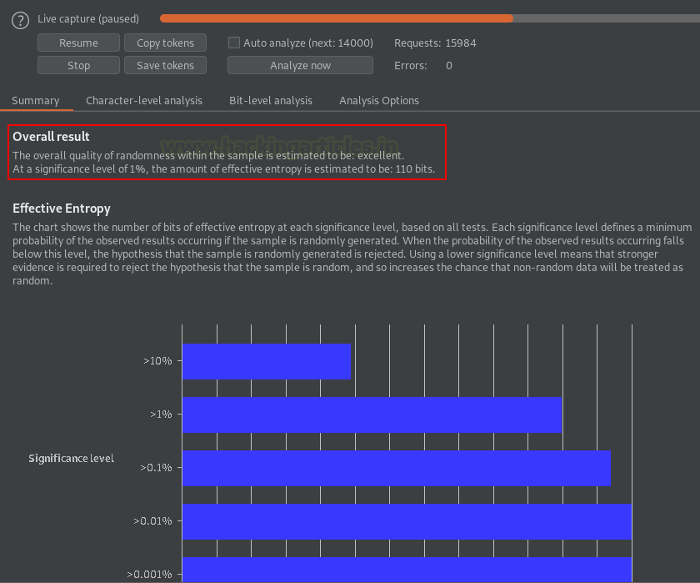

A number of sub-sections are available which thus could help us to analyze the application-properly, but being a pentester we just need to analyze the reliability of the results. Thereby, in order to learn more about it, check the Port Swigger’s documentation from [**here**](https://portswigger.net/burp/documentation/desktop/tools/sequencer).

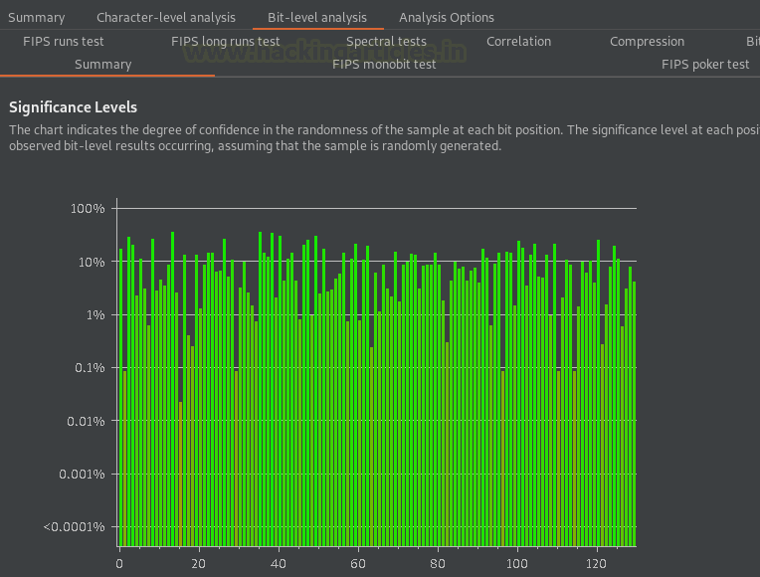

Let’s hit the **“Save Tokens”** button and dump the generated token values into **token.txt.**

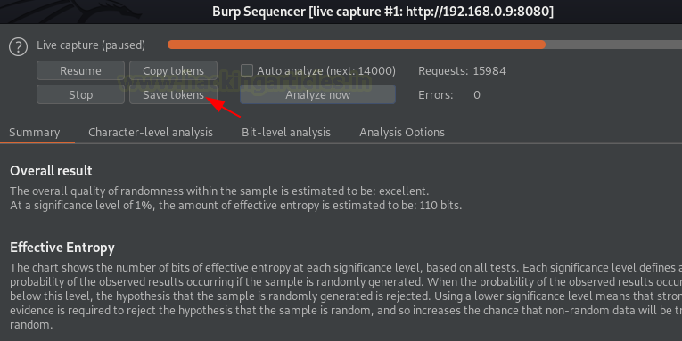

Till the file is saving in the background, let’s get back to out bWAPP application and will **logout the user** such in order to end the session.

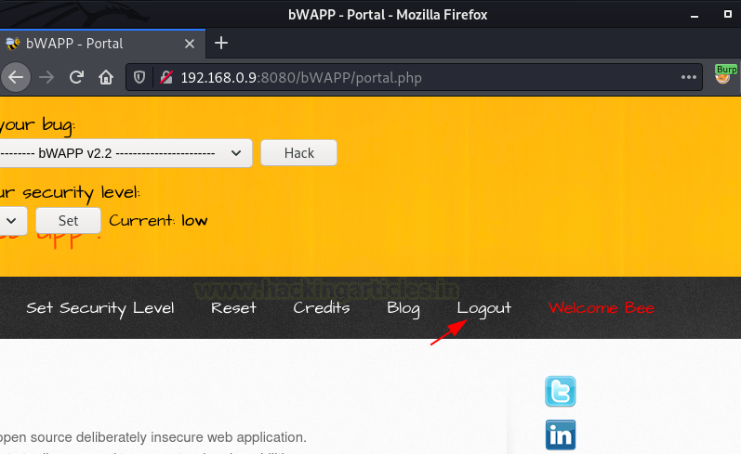

Now, as soon as we redirect back to the login page, we’ll modify the URL within it i.e. setting it to

|  |  |
| --- | --- |
| 1 | http://192.168.0.9:8080/bWAPP |

And we’ll **capture the ongoing HTTP Request** over at our burpsuite.

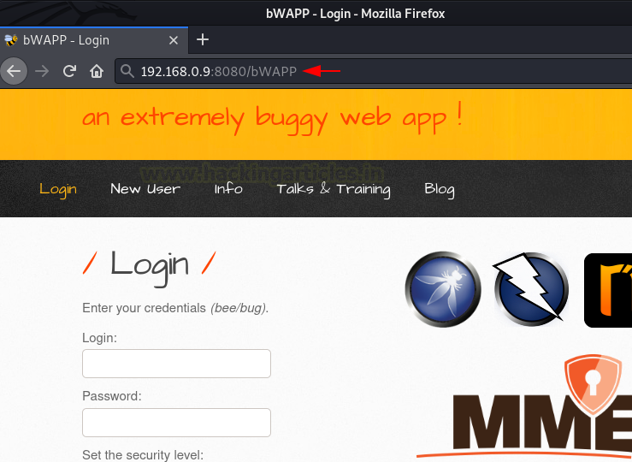

Back into our burpsuite’s monitor, we can see that there is a session ID in the cookie header.

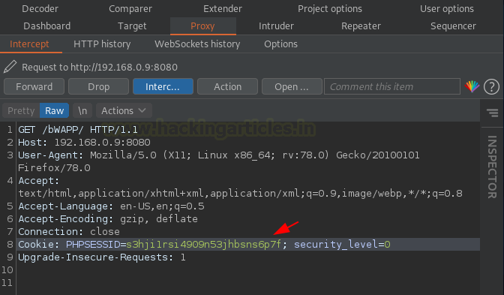

Let’s manipulate the Session ID with one of our saved results.

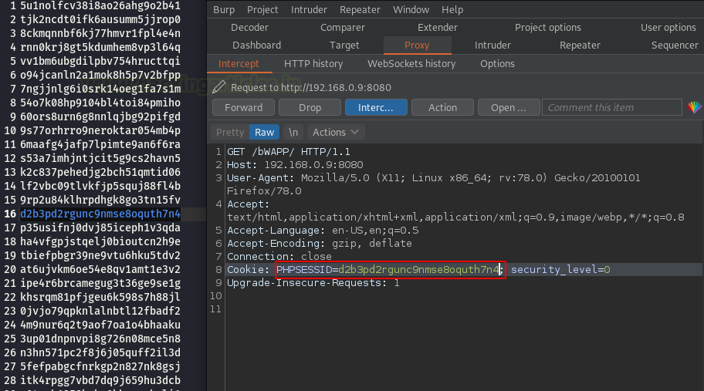

As soon as we hit the **forward** **button**, we got redirected to **portal.php** page and a session ID is required here too, let’s manipulate it with the same.

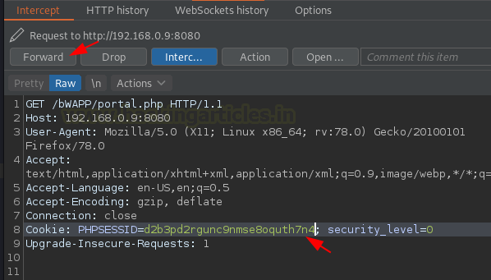

And as we fire the button again, over at the browser we got logged in as **“Bee”**and this time it was without the credentials.

There are times when the session ID that we manipulate might not valid, thus in such cases, we can use the entire **tokens.txt** with our **intruder** and will hunt for a successful login.

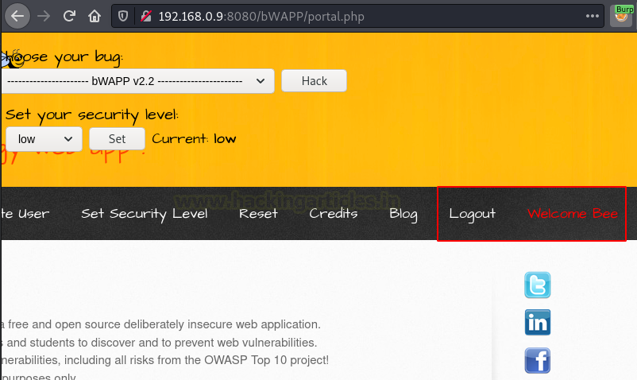

### ****Manual Request Analysis****

What, if we’re not having any specific live web-application, but we’re having a sample of tokens or Session ids and we want to analyze or depict its randomness?

Whether the sample is from a live-application or not, the burp’s sequencer is always there for you to perform a **statistical analysis** such in order to determine the randomness.

Over at the dashboard, navigate to the Sequencer tab and move to the **Manal load**option, hit the **paste** button if the sample is in your clipboard or the **load** button if the tokens are within a specific file and then hit the **“Analyze now”**button to initiate the sequencer.

**Note –**

The sample or the number of tokens should be more than 100 in order to initiate the manual analysis.

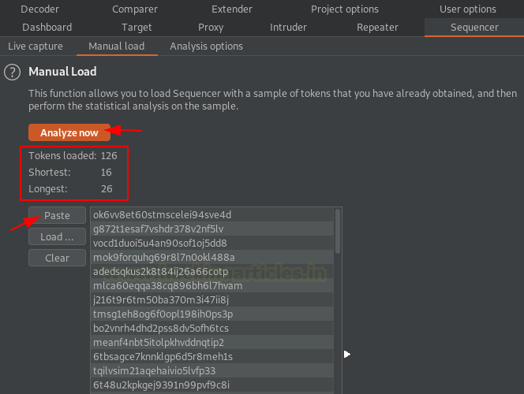

However, within a few seconds, we got the result dumped over in the new window as **“manual load analysis”.**

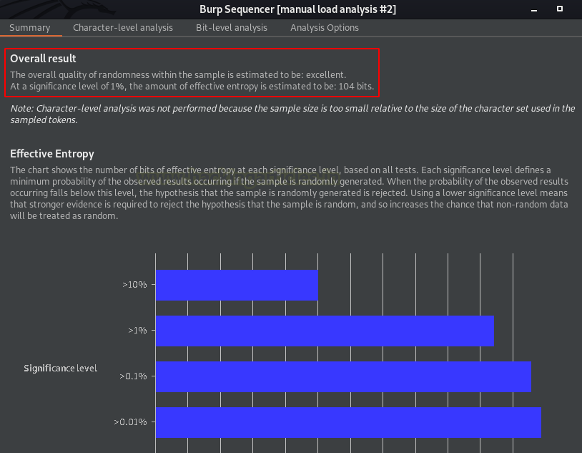

Aren’t you wondering like what if the application’s session ID or the token was bounded with base64 encoding scheme?

However, if such situations arise, the burp’s sequencer is there for us, over at the **Sequencer’s dashboard**as we switch to the **analysis option** tab we just need to enable the **“base-64 decode before analyzing”**option and we’re happy to go.

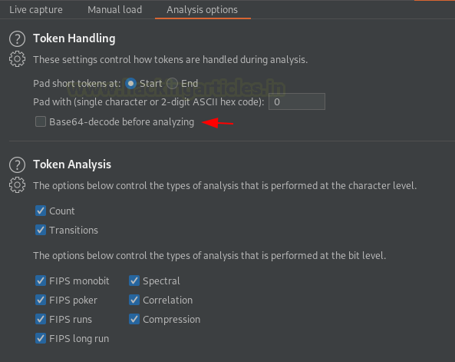

### ****Comparing the Captured Tokens****

Burp Comparer is a tool to perform a comparison between two requests or responses against one another, this somewhere helps us to analyze the different responses in a way simpler.

However, this tool is the most friendly as it works with almost every other burp’s section whether it’s with proxying the requests, or fuzzing with the intruder, or capturing response with the repeater.

Being the most helpful, it thereby has its own space at the burp’s panel. Simply open your burp suite and you’ll find it right in front of you.

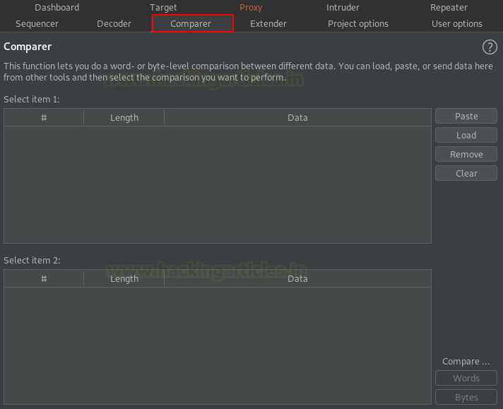

So, let’s use this Comparer tool with our Proxy tab and will compare the two intercepted requests captured within it.

Simply do a right-click near the white space of the captured request and share it with the comparer.

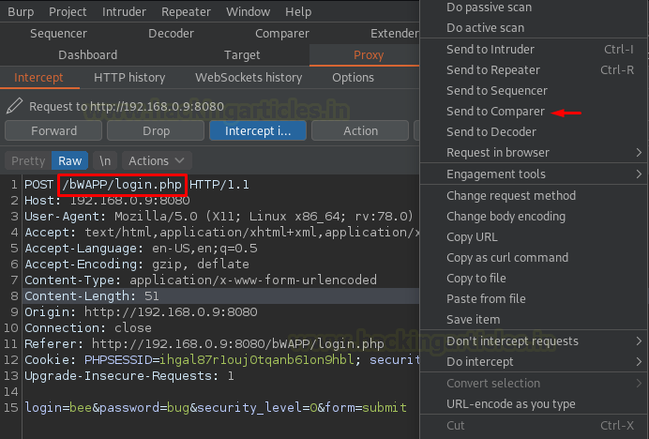

Further, intercept the next request and share the same.

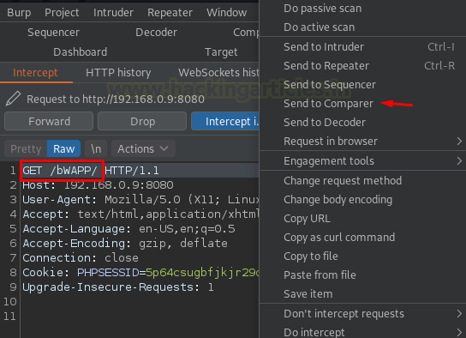

Now switch to the comparer tab from the panel. Over within it, we’ll see that both of our requests are aligned within their specific regions as **Item 1**  & **Item 2.**

However, we can even paste the request or response directly from our clipboard by hitting the **paste button**or either we could have loaded the files simply by firing the **load button.**

The comparer tab offers us two options, either a word-by-word compare or by a bit-by-bit one. Let’s initiate with the **Words** one.

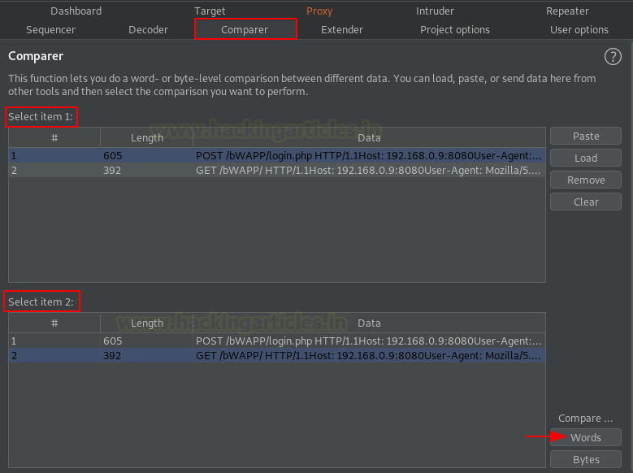

As soon as we select the comparison option, we got a new window popped up displaying both the requests in-front and highlighting the **Modified, Deleted**& the**Added**keywords.

Over the right-bottom, a check-box as **Sync Views (**if enabled**)**will help us to analyze and scroll the two requests or responses simultaneously where the content within them is a bit lengthy.

From the below image, we can determine that the session ID’s are unique and different throughout the web-application.

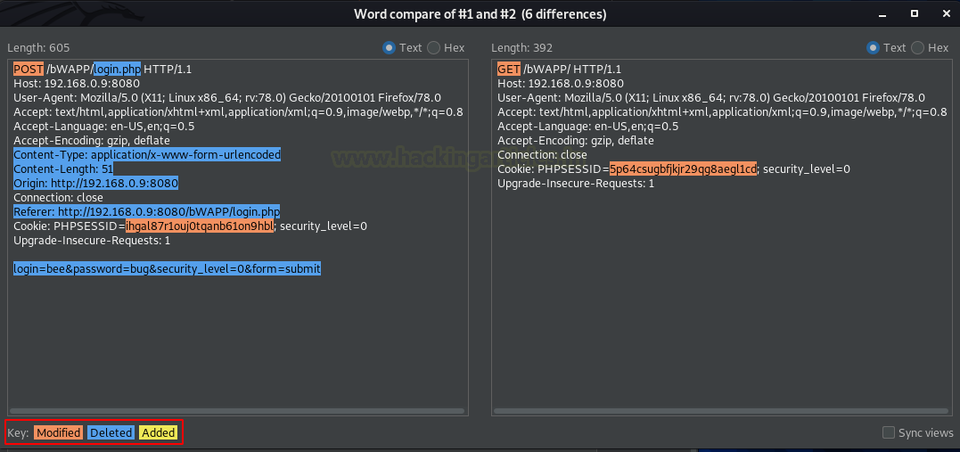

# Burp Suite for Pentester: Turbo Intruder

[December 31, 2020](https://www.hackingarticles.in/burp-suite-for-pentester-turbo-intruder/) By [Raj Chandel](https://www.hackingarticles.in/author/raaj/)

Is fuzzing your favourite attack type, but you didn’t enjoy it due to the low speed and high memory usage when you work over with some big dictionaries?

So, today over with this article, we’ll explore one of the fastest and the most reliable fuzzer **“Turbo Intruder”** – a burp suite extension that will dump the output within a few minutes without worrying about the number of payloads embedded within the dictionary, keeping the memory usage in its mind

### ****Table of Content****

* Introduction to Turbo Intruder
  + What is Turbo Intruder
  + Burp Intruder v/s Turbo Intruder
  + Turbo Intruder’s Installation
* Brute Forcing the application’s Passwords
  + Via Burp Intruder
  + Via Turbo Intruder
* Customizing the Python Scripts
* Fuzz for Multiple parameters

### ****Introduction to Turbo Intruder****

**What is Turbo Intruder**

Turbo Intruder one of the greatest burp suite extensions scripted by **“James Kettle”**in order to send a large number of HTTP requests and analyzing the results. However, the functionality of this extension is as similar as of the Burp’s Intruder carries. Yes, it is a fuzzer. But as it uses the HTTP-stack thereby some features make it a bit different and faster –

* High speed with least latency during fuzzing
* Low memory usage with a million payloads
* Customizable python scripts for different attack scenarios
* Reliable for Multi-day attacks

**Burp Intruder v/s Turbo Intruder**

No doubt, **the intruder tab** is the most powerful part of the burp suite. Whether it’s about to fuzz an application over at a single injection point or multiple, it does it work seamlessly. However, this tool provides whatever we wish to, whether it’s about payloads or the error detections, it is good-to-go.  But when it comes to the fuzzing speed or the memory usage it drops it out. If the dictionary exceeds about a lakh payload, the latency and the memory consumption will be at their peak. But why this all happens?

In order to analyze this, we need to **understand the mechanism** it carries while fuzzing.

All the major brute forcers, create a **TCP handshake** for a single request and send the request to the server, thereby the server waits and shares the response back, as soon as the tool gets the response, it then reads out and the same happens again. However, the handshake consumes a lot of time and the sending & reading phases contain a much latency too, thereby giving a high load on the CPU and consuming a lot of memory reducing the speed to fuzz that.

But the **turbo intruder** is different and as its speed is. It works on an old technology i.e., **HTTP pipelining** which establishes the connection first and shares as many possible requests in one go without worrying about the received responses in order to minimize the latency and server processing time.

**Turbo Intruder’s Installation**

It’s not difficult to find this plugin neither to install it, simply navigate to the **Extender tab** and then further select the **bApp Store** option within it and once you scroll your mouse down, you’ll find it right in front with a rating reaching to almost **5 stars.**

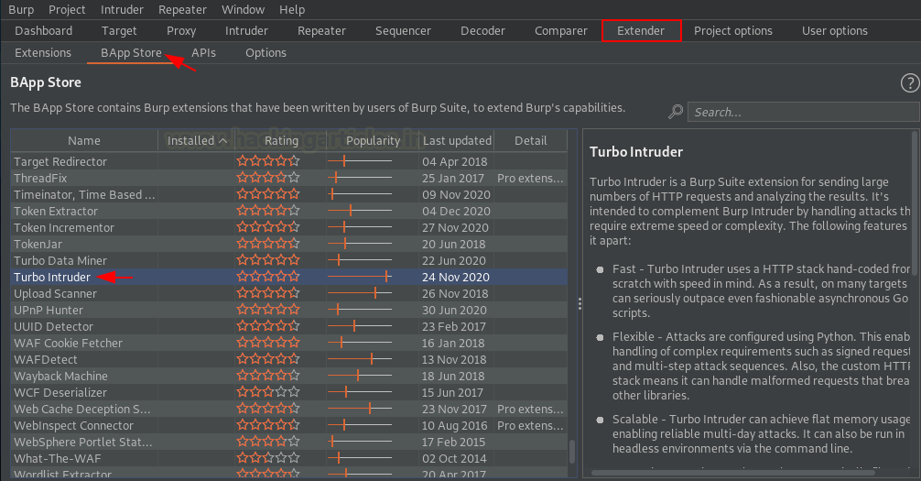

Now simply **hit the install button** over in the description and there we’re ready to go.

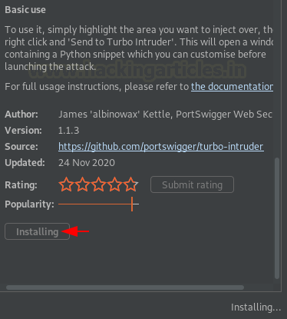

But where it is, it’s not aligned in any of the tabs?

Let’s check out within the **Action section,**a simple right-click can give us the **Send to Turbo Intruder**option.

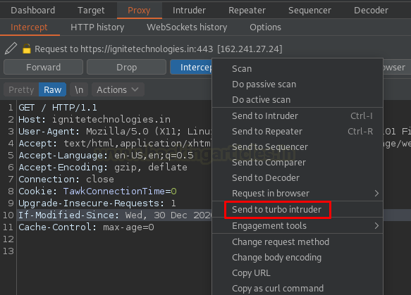

### ****Brute Forcing the application’s Passwords****

You might be wondering like, all of these concepts are documented either at the portswigger’s web-page or at the extension’s GitHub repository, so what’s new. And what about the practical exposure, how we could confirm that, yes turbo intruder fuzz the application in a much faster way than the basic burp’s intruder does.

Thereby in order to confirm and check that all, let’s tune into our vulnerable application bWAPP and we’ll capture the login portal’s HTTP Request by setting the username to **bee** and a random password as **12345.**

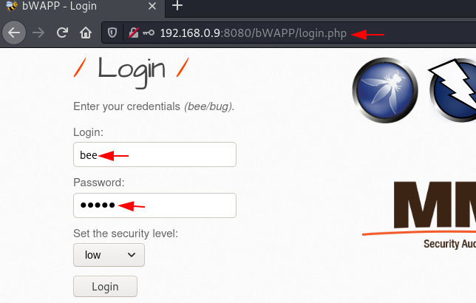

**Via Burp’s Intruder**

Once the **Login**button got fired up, we got the Request intercepted at our Burp monitor, so let’s first share it with **“Intruder”.**

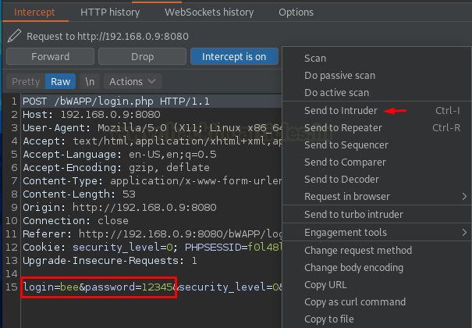

However, the Intruder steps are on our tips, so let’s recall them once again. As soon as the Intruder receives the request, our first work is to set the clear out the things and set the **injection points** over at the **position** **tab**.

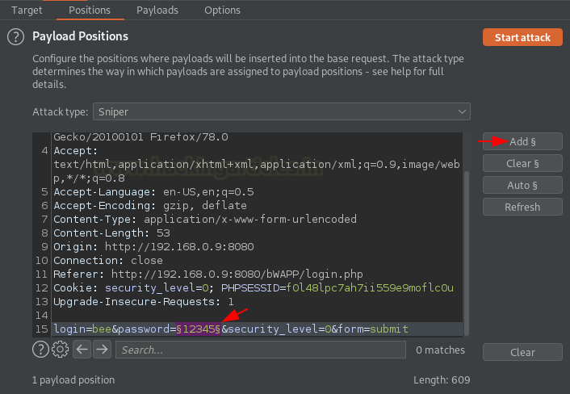

Now, time to inject our fuzzing lists. Switch to the Payloads tab, right next to Position one, and click the **Load button** in order to select the desired list. For this section, we’ve modified the [10-million-password-list](https://github.com/danielmiessler/SecLists/tree/master/Passwords/Common-Credentials) of **Daniel Miessler SecLists Github’s repository**and have injected **bee & bug** within it.

From the below image, you can see that the number of requests is more than **100,000,**which is not large but still it could help us to determine the speed.

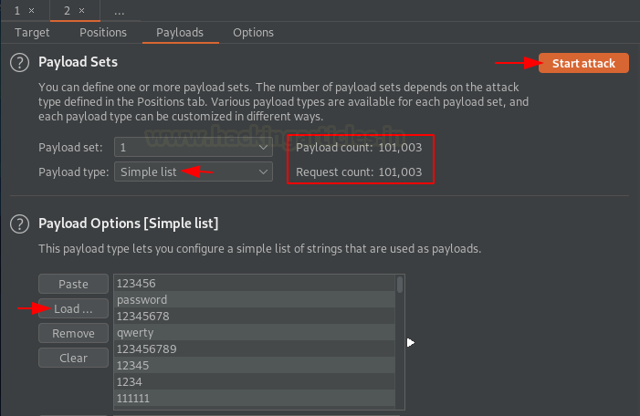

Now as soon as we hit the Attack button, the fuzzer starts up and it took about **60+ seconds** to fuzz about **1700 requests** which makes it about **23 requests per second (RPS).**

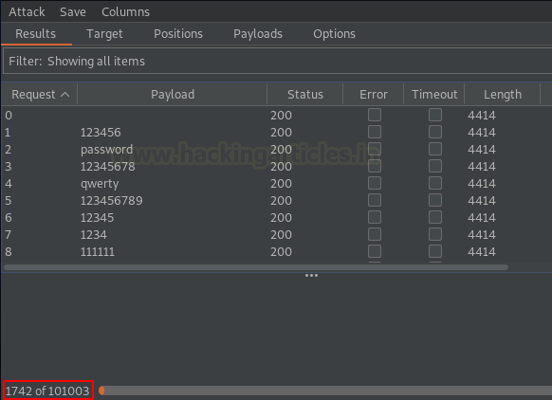

**Via Turbo Intruder**

Let’s first **pause** the intruder here and will check what Turbo Intruder dumps out as its speed.

Back into the intercept tab, we’ll **select the payload position** and will then hit right-click in order to share the request to the Turbo Intruder.

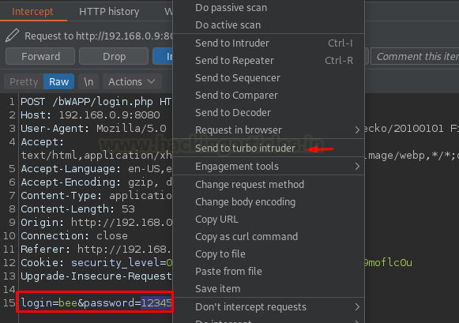

As soon as the **“Send to turbo intruder”**option got fired up, we got a new window popped in-front of us. Let’s explore what it contains.

The window was segregated into two sections the upper part where our **“shared request”**is embedded into and just below that in the other part we got a **“snippet of python code”**aligned.

However, over into the **Request section**, we can see that our injection point was converted into **“%s”,**representing where the payload will be going to hit.

And at the other section, there is a **drop-down list** with a **python code** displayed, which thus could be modified as per the attack scenario.

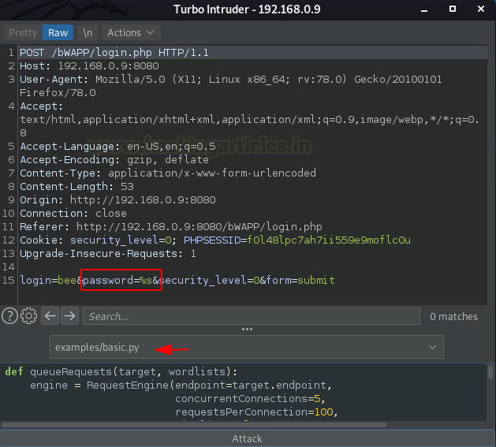

The drop-down list contains a number of attacking python scripts, that we could use accordingly whenever we need.

So, for the time being, let’s use the most common script of the Turbo Intruder i.e. **examples/basic.py**

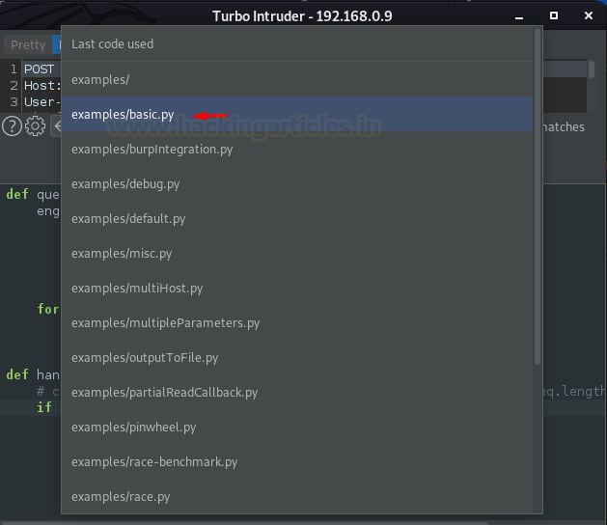

Once we select that, the python code within it got displayed on the screen. Let’s see what it says –

1. The script within the **first highlighted box** is responsible for the **fuzzing speed** and the **number of connections made** by the turbo intruder. However, it even carries up the **requests made per connection.**
2. Over in the **second box** we need to **add the dictionary**manually by specifying its location.
3. The **third code snippet** is the most highlighted section as it defines **which request should be displayed** in the output table. Here the code **“if req.status != 404:”**defines that all the requests will get added to the table leaving the once that are having **status code = 404**

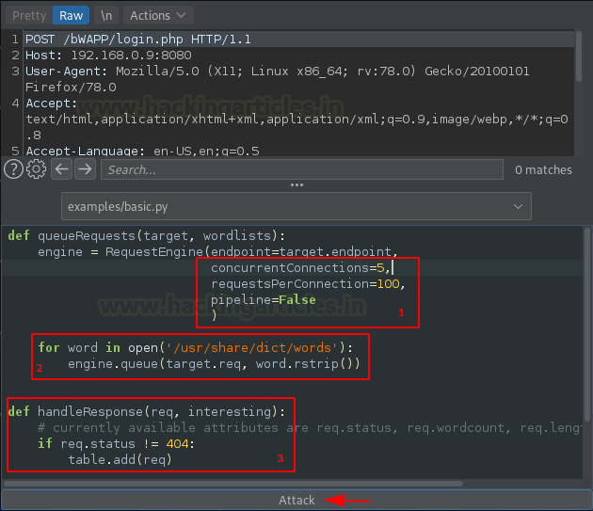

Now, let’s **inject our dictionary** by defining its path while manipulating the code.

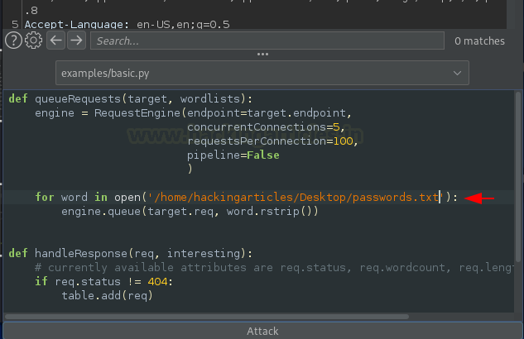

Further, we’ll hit the **Attack button**in order to initiate our fuzzer. As we do so, within **73 seconds** it’s just **1029 requests** shared, creating the **RPS** (**R**equest **p**er **S**econd) count to **14.**

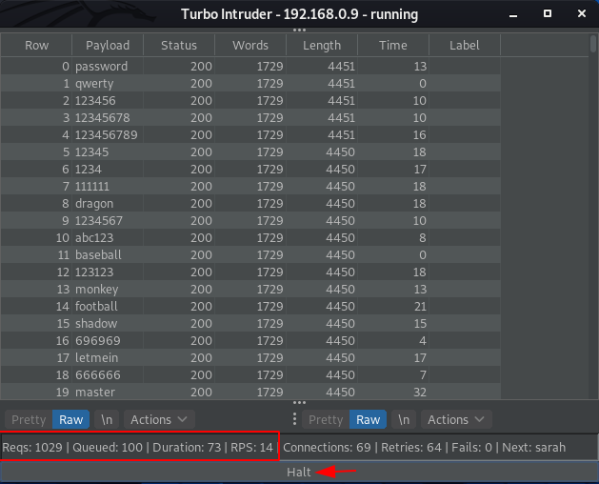

You might be wondering like, this needs to be faster than the basic intruder, however, the RPS rate for the Burp Intruder was 23, and it’s just 14.

This is all due to the default configuration in the python script as the **concurrentConnections** was just **5** and the **Request per Connection** was **100**. Let’s modify it all and start the attack again, in order to do so hit the **halt**button and configure the same with

        concurrentConnections=20,

        requestperConnetction=200,

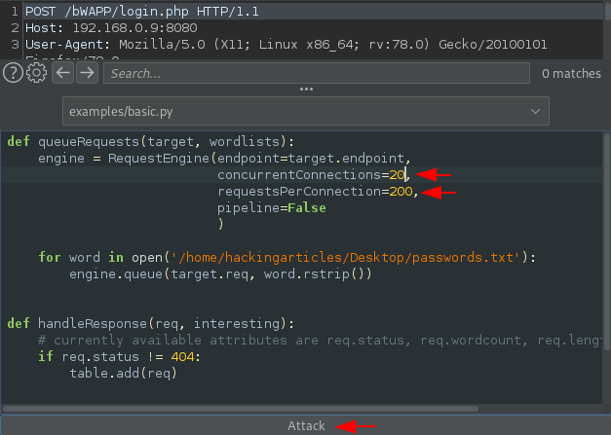

And as the attack executes up, the **RPS rate jumps directly to 94** and within just **3 seconds** the fuzzer hit about **280 requests**.

Thereby for this attack, we can say it’s about 4 times faster than the Basic Intruder.

However, during the attack, you could find that the **retries value is going up**, as the fuzzer was initiating. So, is the requests are not hitting?

No, it is an indication that the connection per request value might be too high for the server to handle, making the attack is less optimal, thus we need to cut it down and reduce it to half.

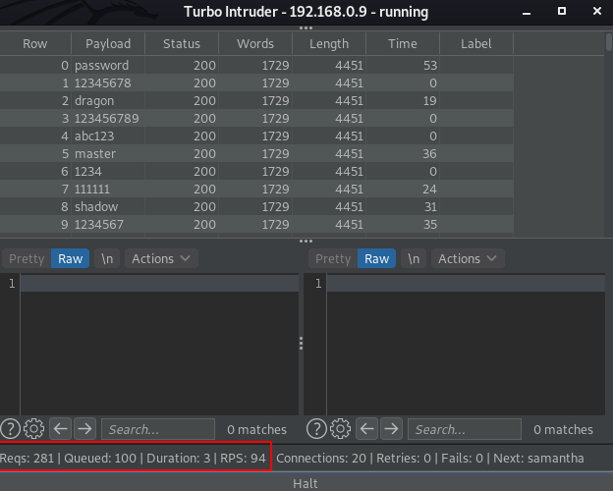

Do you remember, we halted the Intruder’s fuzzing? Let’s resume it and restart our attack over the turbo intruder, and we’ll then wait for a few minutes in order to analyze the output.

From the below image, we can see that **Turbo Intruder is ahead with 3000+ hits**, displaying the speed it carries within.

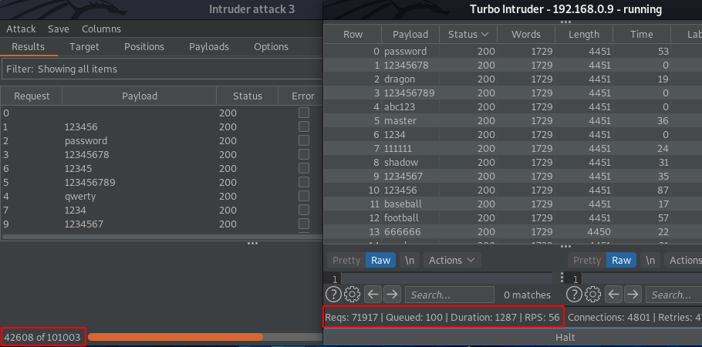

### ****Customizing the Python Scripts****

Over in the above section, we’ve discussed that we can manipulate the python script as we wish so. However, manipulating it doesn’t require any advanced scripting skills, it’s just that we know what the code wants to say. So, for example –

We want the table to dump only the **302 Redirection**, we don’t want any **200 OK**, neither **404 Error**, thereby in order to do so we just need to manipulate the 3rd code snippet.

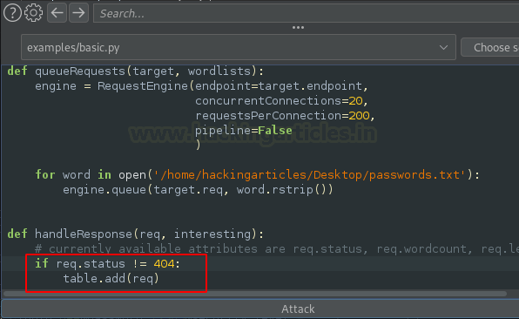

Now over here, we’ll change **not-equal to (!=)**with **equal-equal (==)** and will modify 404 with 302, Such that the output will only have the redirection requests listed.

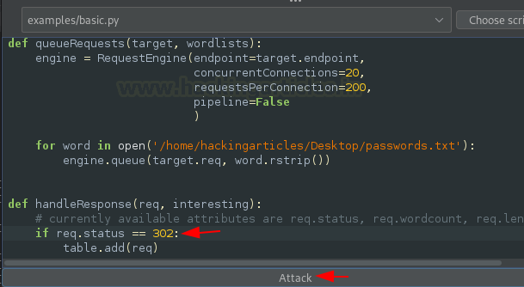

From the below image, we can see that within 3 seconds we got our output listed over at the table segmented.

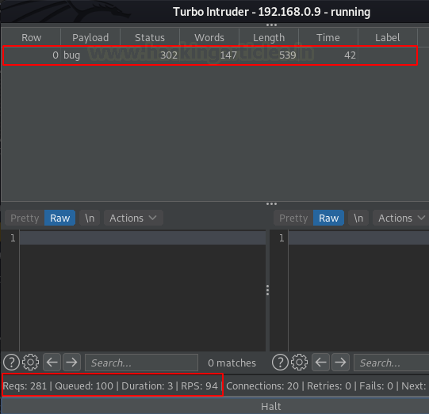

### ****Fuzz for Multiple Parameters****

You might have used **Cluster Bomb** over in the basic intruder which helps us to fuzz the application with multiple parameters. However, in the same way, we’re having a python script listed in the drop-down menu too which will thereby provide us with the option to fuzz as similar to the cluster bomb payload-type. Let’s check that out.

Back into the **Proxy tab** let’s select any parameter and hit a right-click in order to navigate to **turbo intruder**

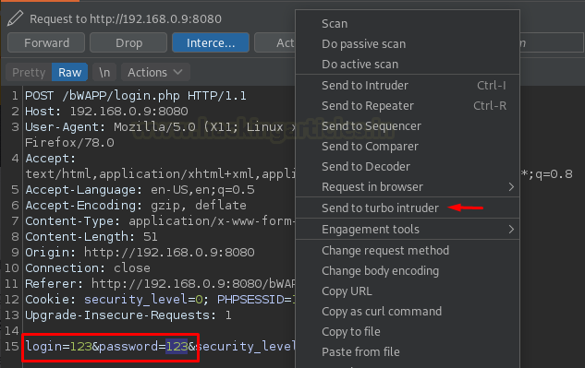

There, over in the request portion, let’s set **“%s”**in order to select the injection points.

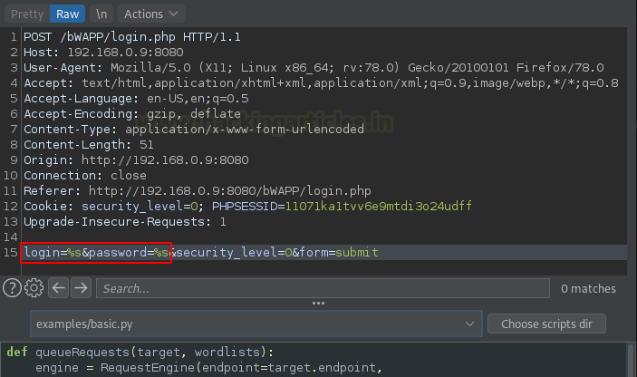

Time to choose the script, click on the bar to check the drop-down menu, and then select **examples/multipleParameters.py**

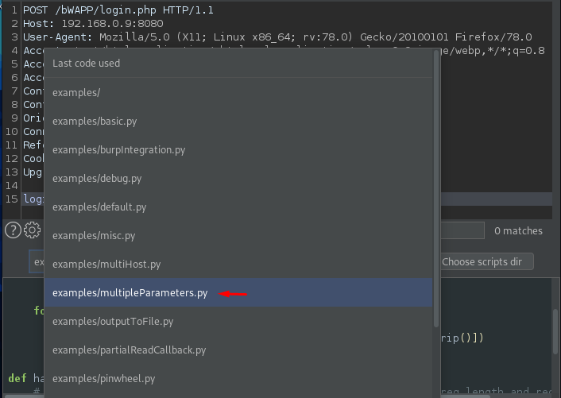

Once clicked-on, the script is there for us to get manipulated.

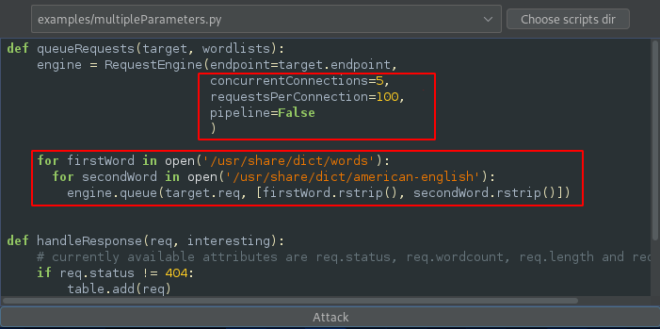

Let’s boot the speed by manipulating the **concurrentConnections=20** and **requestperConnetction=200,**further we’ll set the dictionaries for the first word and the second word.

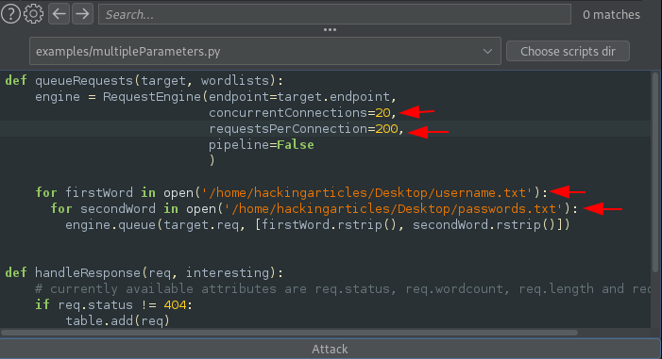

And there we go, as soon as we hit the **Attack**button the screen got shuffled and we got the output table in-front of us. Within a few minutes, as we double-clicked the Length section, we got the **302 Redirection** with **bee/bug.**

